Action full title:
Universal, mobile-centric and opportunistic communications architecture
Action acronym:
UMOBILE



Deliverable:
D3.3 “UMOBILE ICN layer abstraction initial specification”

Project Information:
Project Full Title | Universal, mobile-centric and opportunistic communications architecture
Project Acronym | UMOBILE
Grant agreement number | 645124
Call identifier | H2020-ICT-2014-1
Topic | ICT-05-2014 Smart Networks and novel Internet Architectures
Programme | EU Framework Programme for Research and Innovation HORIZON 2020
Project Coordinator | Prof. Vassilis Tsaoussidis, Democritus University of Thrace

Deliverable Information:
Deliverable Number-Title | D3.3: UMOBILE architecture: high-level initial specification
WP Number | WP3
WP Leader | DUTH
Task Leader (s) | UCL
Authors | COPELABS: Paulo Mendes, Waldir Moreira  DUTH: Nikolaos Bezirgiannidis, Sotiris Diamantopoulos, Ioannis Komnios, Vassilis Tsaoussidis  UCL: Ioannis Psaras, Sergi Rene  UCAM: Jon Crowcroft, Adisorn Lertsinsrubtavee, Arjuna Sathiaseelan  TECNALIA: Susana Perez Sanchez, Iñigo Sedano  SENCEPTION: Rute Sofia
Contact | i.psaras@ucl.ac.uk, s.rene@ucl.ac.uk
Due date | M12: 31/01/2016
Actual date of submission | 31/01/2016 (v1.0) and 17/11/2016 (v2.0 - revised version)
Dissemination Level:
PU | Public | x
CO | Confidential, only for members of the consortium (including the Commission Services)
CI | Classified, as referred to in Commission Decision 2001/844/EC
Document History:
Version | Date | Description
Version 0.1 | 11/01/16 | First draft to the consortium for alignment with D3.3 and allocation of contributions
Version 0.2 | 22/01/16 | Second draft to the consortium for alignment with D3.3 and allocation of contributions
Version 0.3 | 1/2/16 | Third draft to the consortium for alignment with D3.3 and allocation of contributions
Version 1.0 | 3/2/16 | Final version
Version 1.1 | 4/11/16 | First draft to the consortium of the D3.3 amendment after the midterm review
Version 1.2 | 10/11/16 | Second draft to the consortium of the D3.3 amendment after the midterm review
Version 1.3 | 14/11/16 | Third draft to the consortium of the D3.3 amendment after the midterm review
Version 1.4 | 16/11/16 | Fourth draft to the consortium of the D3.3 amendment after the midterm review
Version 2.0 | 17/11/16 | Final version of the revised D3.3

Table of Contents
List of Definitions 7
Executive Summary 11
1 Introduction 13
2.1. Background and motivation for a new architecture 14
2.2. Overview of the UMOBILE Architecture 16
2 UMOBILE architecture: Application/Service perspective 22
2.3. UMOBILE applicability 22
2.3.1. Micro-blogging 22
2.3.2. Emergency situation 22
2.3.3. Civil protection 23
2.3.4. Social routine improvement 23
2.4. Network services 23
2.4.1. Network scenarios 25
2.4.2. Communication models 28
2.4.3. Context services 30
2.4.4. Data services 30
3 UMOBILE architecture design 32
3.1 UMOBILE devices 32
3.2 UMOBILE services 38
3.3 Network requirements 42
4 UMOBILE modules 47
4.1 NDN plane 47
4.1.1. Naming 47
4.1.2. UMOBILE smart forwarding 50
4.1.3. NDN-based social-aware opportunistic routing framework 53
4.2. Contextual information manager 56
4.2.1. Usage context 56
4.2.2. User context 57
4.2.3. Network context 58
4.3. INRPP - Flow control 60
4.4. Service pre-fetching 60
4.4.1. Service manager 61
4.4.2. Monitoring 61
4.4.3. Service repository 61
5 UMOBILE platform WP planning 62
6 Conclusion 64
References 65

List of Definitions
Term | Meaning
DTN | Delay Tolerant Network (DTN) is an emerging technology that supports interoperability of other networks by accommodating long disruptions and delays between and within those networks. DTN operates in a store-and-forward fashion where intermediate nodes can temporary keep the messages and opportunistically forward them to the next hop. This inherently deals with temporary disruptions and allows connecting nodes that would be disconnected in space at any point in time by exploiting time-space paths.
ICN | Information-Centric Network (ICN) has emerged as a promising solution for the future Internet's architecture that aims to provide better support for efficient information delivery. ICN approach uniquely identifies information by name at the network layer, deploys in-network caching architecture (store information at the network node) and supports multicast mechanisms. These key mechanisms facilitate the efficient and timely information (contents and services) delivery to the end-users.
Content | Content refers to a piece of digital information that is disseminated and consumed by end-user equipment.
Node | A wireless or wired capable device.
User | An entity (individual or collective) that is both a consumer and a relay of user services.
User Service | Context-aware services are considered as a set of mechanisms that assist incorporating information about the current surrounding of mobile users in order to provide more relevant of services.
User Interest | A parameter capable of providing a measure (cost) of the “attention” of a user towards a specific (piece of) information in a specific time instant. Particularly, users can cooperate and share their personal and individual interests that enable the social interactions and data sharing across multiple users.
User Requirement | User requirement corresponds to the specifications that users expect from the application.
Gateway | Gateway typically means an equipment installed at the edge of a network. It connects the local network to larger network or Internet. In addition, gateway also has a capability to store services and contents in its cache to subsequently provide local access communication.
Customer Premises | Customer Premises relate to residential households and enterprise market and are, as of today, controlled by the end-user.
User-centric | User-centric refers to a new paradigm leveraging user information at large to deliver novel content or services by users towards other users.
UMOBILE System | UMOBILE System refers to an open system that provides communication access to users through wired or wireless connectivity. This system exploits the benefit of local communication to minimize upstream and downstream traffic. The services or contents can be exchanged and stored in several devices such as gateways; user equipments; customer premises equipments such as WiFi Access Points in order to efficiently delivery the desired contents or services to end-users.
UMOBILE Architecture | A mobile-centric service-oriented architecture that efficiently delivers contents and services to the end-users. The UMOBILE architecture integrates the principles of Delay Tolerant Networks (DTN) and Information-Centric Networks (ICN).
User-equipment | User-equipment (UE) corresponds to a generic user terminal (for example smart phone or notebook). In terms of UE and for operating systems we consider mainly smartphones equipped with Android; notebooks with UNIX, Windows, Mac OS.
Social Trust | Trust which builds upon associations of nodes is based on the notion of shared interests; individual or collective expression of interests; affinities between end-users.
Application | Computer software design to perform a single or several specific tasks, e.g. a calendar and map services. In UMOBILE, context-aware applications are considered.
Incentive | A factor (e.g., economic or sociological) that motivates a particular action or a preference for a specific choice.
Service | Service refers to a computational operation or application running on the network which can fulfil an end-user’s request. The services can be hosted and computed in some specific nodes such servers or gateways. Specifically, service is normally provided for remuneration, at a distance, by electronic means and at the individual request of a recipient of services. For the purposes of this definition;“at a distance” means that the service is provided without the parties being simultaneously present; “by electronic means” means that the service is sent initially and received at its destination by means of electronic equipment for the processing (including digital compression) and storage of data, and entirely transmitted, conveyed and received by wire, by radio, by optical means or by other electromagnetic means; “at the individual request of a recipient of services” means that the service is provided through the transmission of data on individual request. Refer to D2.2 for further details.
Trust Association | A unidirectional social trust association between two different nodes.
UMOBILE gateway | Role (software functionality) which reflects an operational behavior making a UMOBILE device capable of acting as a mediator between UMOBILE systems and non-UMOBILE systems – the outside world.
UAV | Unmanned Aerial Vehicle, which is an aircraft with no pilot on board.
BSS | Basic Service Set is a set consisting of all the devices associated with a consumer or enterprise IEEE 802.11 wireless local area network (WLAN). The service set can be local, independent, extended or mesh. Service sets have an associated identifier, the Service Set Identifier (SSID), which consists of 32 octets that frequently contains a human readable identifier of the network.
CS | Data Cache is responsible for holding information concerning the content carried by the current node.
PIT | Pending Interest Table is responsible for keeping up-to-date information concerning the data interests of the current node.
FIB | Forwarding Information Base is responsible for keeping track of the routes used to forward interests to the content.
SWR | Social Weight Repository is responsible for storing the list of interests the current node comes across (obtained upon encountering a peer).
SWM | Social Weight Mesurer.
SWCDG | Social Weight and Carried Data Gatherer is responsible for obtaining the list of interests and social weights towards the encountered node.
NDN | Named Data Networking

Executive Summary
This document covers the UMOBILE architecture, as well as UMOBILE services that apply to scenarios detailed in D2.1 (End-user requirements report), for the specification of the UMOBILE architecture. This document incorporates the first version of the UMOBILE architecture high-level specification and the final document D3.4 (UMOBILE ICN layer abstraction final specification - to be provided on M30) will describe the refined specification.
The goal of this document is to provide a high-level description of the overall specification of the UMOBILE architecture. Special attention is given to the necessary alignment with the Delay-Tolerant Network (DTN) architecture [1], and the most relevant proposal for an information-centric network architecture (ICN) [2] that fits the identified UMOBILE system and network requirements. The specification provided here drives the development and implementation of the UMOBILE architecture, which will be described in detail in deliverable D3.1 and D3.2 “UMOBILE architecture report 1 and 2” (e.g. core platform, API, protocols, software).
The starting point for this report are deliverables D2.1 “End-user requirements report” [3] and D2.2 “Systems and network requirements report” [4], which describes typical accessibility scenarios in different environments, namely, urban, remote and disaster areas, as well as requirements from the end-user (D2.1) and the network and system (D2.2) perspective, that the UMOBILE platform will support. The UMOBILE architecture specification, provided in this document, will be complemented by the following deliverables:
- D3.1/D3.2 with a detailed specification of the UMOBILE architecture and the implementation of it.
- D3.4 with a final version of the high-level specification described in this document.
- D4.1 and D4.2 with a detailed specification of the proposed rate-regulation scheme.
- D4.3 with a detailed specification of the proposed mobile name-based replication scheme aimed at improving certain services by using priorities.
- D4.4 with a detailed specification of the different supported services and the QoS mechanisms in the UMOBILE project.
- D4.5 with a detailed specification about sensing data collection and users’ behaviour inference.
The methodology used in this deliverable is as follows:
- Start from the applicability pictures identified in D2.1 and derive application services that must be implemented using the UMOBILE architecture.
- Identify the network services required for the services previously detailed.
- Describe the high-level design of UMOBILE architecture based on the overall assumptions and requirements, as well as the capabilities provided by the selected DTN and ICN architectures.
- Link the assumptions and network and user requirements, detailed in D2.2 with the components of the architecture.
- Detail the different modules and describe the full specification of the UMOBILE ICN layer abstraction architecture, highlighting the components that need to be further described in D3.1, D4.1/D4.2, D4.3, D4.4 and D4.5

Introduction
The main objective of UMOBILE is to develop a mobile-centric, service-oriented architecture that efficiently delivers content and services to the end-users. UMOBILE decouples services from their origin locations, shifting the host-centric paradigm to a new paradigm, one that incorporates aspects from both information-centric and opportunistic networking with the ultimate purpose of delivering an architecture focused on: i) improving aspects of the existing infrastructure; ii) improving the social routine of Internet users via technology-mediated approaches; iii) extending the reach of services to areas with little or no infrastructure (e.g., remote areas, emergency situations).
UMOBILE also aims to push network services (e.g., mobility management, intermittent connectivity support) and user services (e.g., pervasive content management) as close as possible to the end-users. By pushing such services closer to the users, we can optimize, in a scalable way, aspects such as bandwidth utilization and resource management. We can also improve the service availability in challenged network environments. For example, users in some areas may suffer from intermittent and unstable Internet connectivity when they are trying to access the services.
To achieve this, the proposed UMOBILE architecture combines two emerging architecture and connectivity approaches: Information-Centric Networking (ICN) and Delay-Tolerant Networking (DTN). The aim is to build a novel architecture that defines a new service abstraction that brings together both information centric as well as delay tolerant networking principles into one single abstraction. We further integrate social trust computation into the architecture that will enable priority dissemination of information based on the notion of smart trust circles in opportunistic communication environments. Such an abstraction would enable network services to pervasively operate in any networking environment, independently of the underlying communication technology. Such abstraction also allows innovative application and services development, providing access to data independently of the level of end-to-end connectivity available.
In the scope of WP3 – System and architecture development – we previously defined a set of objectives aimed at specifying a full node architecture. These goals are:
- Design adequate delay-tolerant interfacing for underlying protocols that efficiently utilises the available resources for a challenged and opportunistic network environment.
- Provide service abstraction to applications by incorporating the notion of information-centric networking and named-data contents.
- Establish an overall network and system architecture.
- Implement an integrated prototype platform that can be used for the various deployment alternatives.
In this document we define the high-level design of this delay-tolerant and opportunistic data-centric architecture that will provide the service abstraction to applications by using ICN principles. However, we point out that the last point of the objectives about implementation and integration will be detailed in further deliverables (D3.1 and D3.2) of WP3 and WP5 (Integration and Validation).

Background and motivation for a new architecture
Most DTNs (i.e. RFC 5050 compliant [5]) rely on a host centric routing mechanism, passing bundles between nodes regardless of the data being exchanged. In contrast, Information-Centric Networks [2,6] allow the network to gain a better understanding of the data itself, enabling it to be easily cached and reused. Such support offers a huge potential in disrupted environments that rarely allow two hosts to reach each other. In [7], the authors identify similarities between ICN and DTN that seem to indicate that the integration of the two architectures is a logical progression, with the potential to combine the benefits of both. Importantly, we believe that the prominence of disconnectivity in daily situations (e.g. underground transport, poorly provisioned areas, during expensive roaming) means that any future Internet architectures must place a high priority on supporting delay tolerance. Clearly, these examples motivate the need for an integrated architecture in opportunistic mobile networks.
In order to provide a new UMOBILE information-centric network architecture with delay-tolerant and opportunistic communications requirements, we will use the Named-Data Networking (NDN) [8] architecture as an initial approach. NDN will provide all the ICN abstractions required and we will extend it in order to provide new opportunistic, delay tolerant and social-aware features. We have chosen NDN instead of other ICN architectures (PURSUIT [9], DONA [10], Netinf [11], CURLING [12]) because NDN has been more widely accepted by the research community as a de facto standard for ICN. In the documents and Internet drafts of the IRTF Information-Centric Networking Research Group (ICNRG) [13] we can see that most of the community research efforts are focused on the NDN architecture.
NDN is an information-centric architecture that decouples content from network location. This decoupling is done by providing a new content hierarchical naming and content routing is based on these content identifiers, instead of location identifiers such as in IP. Routing is performed using similar algorithms to current IP infrastructure, utilising longest prefix matching with hierarchical aggregation to ensure scalability, using a similar Forwarding Information Base (FIB) than IP. In NDN, a content request is issued by sending an Interest packet, which is routed through the network to the closest instance of the content (e.g., origin or surrogate server). Subsequently, the source responds with a data packet, which follows the reverse path back to the requester using “breadcrumbs” left in a Pending Interest Table (PIT) on each router. NDN also takes benefit of a Content Store (CS) where the data packets are cached in order to be resent when other users request the same packet that has been previously cached. This way, NDN can be more efficient allowing in-network routers to provide the content instead of the end-point source, and providing inherent support to multicast communications [14,15,16].
Figure 1: NDN Architecture [8]
The NDN-based architecture provides a set of features beneficial for mobile and wireless networks including among others:
- Native host multihoming: NDN does not bind a particular flow with a network interface. This provides a higher flexibility to use all the interfaces available to retrieve the data requested at the same time.
- Detachment of applications from location-oriented addresses: In NDN there is no necessity to force applications to take on location-oriented information. Instead, it detaches the application from such concerns. This allows the application to abstractly publish or consume content, without the need to store (or even know) its own network-layer address [17].
- No connection-oriented sessions: In NDN there are no end-to-end sessions and all the communications are constrained at the network level. This removal of connection-oriented protocols allows the relocation of a host without the necessity of re-establishing a connection.
- Resilience through replication: Allowing local copies of the content to be retrieved, improves network performances and mitigates the effect of failures in mobile networks [18].
Despite the advantages of NDN in front of the IP architecture in terms of mobility, there is still some research challenges that need to be addressed in terms of mobility [19,6]. These research challenges are mainly the provider mobility, pairwise path routing (breadcrumb approach), request staleness or security and privacy. Moreover, there is no extensive research in the field of opportunistic wireless networks. Previous work on wireless networks has been focused on MANET [20], where machines are not constrained devices, or has been focused on wireless sensor networks and sink-centric data traffic [21] (i.e., sensor-to-sink or sink-to-sensor). In this project we will go one step further and propose a universal, mobile-centric and opportunistic communications architecture that will exploit any communication opportunity between mobile devices to forward data towards receivers.

Overview of the UMOBILE Architecture
In the UMOBILE project we propose a new data networking architecture that will integrate an ICN and a DTN approach. In order to provide delay-tolerant and opportunistic capabilities to the NDN architecture, in UMOBILE we will provide to NDN new forwarding mechanisms able to operate in opportunistic networks by using new logic faces, such as DTN faces, but also taking benefit of Device-to-Device (D2D) communications, enabling application sharing between users and opportunistic routing that will use social information to reach users without the participation of the network infrastructure.
UMOBILE needs to support various challenged scenarios such as aftermath of disasters or in rural/remote network deployments or networks with limited backhaul capacity. Such challenged environments pose several challenges such as increased latency, intermittent connectivity etc. To address these challenges, we also propose a resilient service migration module which utilizes advances in lightweight operating systems to push service instances right to the network edge, similar to the new fog edge computing paradigm [22]. Instead of hosting the services in static location (fixed server), the service is considered as mobile content which can be accessed and executed anywhere within a local network. Inside a local network it utilizes a name-based routing/forwarding strategy, which brings in several benefits of ICN. Within the UMOBILE project, we utilise the NDN abstractions to carry out the name based routing/forwarding strategies. We also envision that our service migration platform also benefits from the underlying DTN to provide resilient access to services during periods of intermittent connectivity. In this challenged scenario, we also propose a new forwarding mechanism aimed at prioritising emergency information over less critical data, restricted to certain areas and time-space, in order to spread emergency information when no or partial infrastructure is available.
Throughout our studies on ICN the last few years, we have come to realise that with very few exceptions, there is very little work on information-centric service invocation. Naming and routing schemes have mainly focused on the delivery of static content. However, the emergence of edge-/fog-computing requires services (instead of merely static content) to be identified, resolved and executed at the edge of the network with minimal delays. In that direction of research, we have identified the need for an ICN keyword-based naming scheme aimed to help identify, resolve and execute available services in UMOBILE scenarios.
At last but not least, UMOBILE will provide to users new contextualisation services including recommendations, behaviour inference or affinity networking.
The UMOBILE architecture extends the NDN architecture [8] enabling opportunistic and social routing, opportunistic application sharing, contextualisation services and service pre-fetching at the end of the network. Since the network requirements of the list of UMOBILE-enabled devices are different (network vs end-user devices), the UMOBILE architecture consists of two parts, one for fixed network elements (e.g., routers, gateways, Base Stations, or WiFi Access Points) and a second one for mobile devices (focusing mainly on the Android OS) We present the two parts of the UMOBILE architecture: one for the mobile end-users and another for the rest of devices in Figs 2 and 3. In Figure 2 we can observe the different components that the UMOBILE architecture will provide to extend NDN for mobile end-users. The functionalities of these components are respectively detailed in the Section 4. We can observe that network abstractions to the applications will be:
- Keyword-based Mobile Application Sharing (KEBAPP): KEBAPP enables access to the desired processed and non-personalised information through the concept of application sharing, effectively leveraging on a pool of application resources
- UMOBILE forwarding: UMOBILE provides new forwarding strategies, including opportunistic and social forwarding.
- Push services: UMOBILE will enable push-based communications to send information to other users, without requiring a previous Interest by users, useful to send unrequested information, such as emergency services.
- Context services: UMOBILE will provide contextualisation services to users, basically aimed at providing recommendations, behaviour inference or affinity networking.
Note that the figures are conceptual diagrams of the UMOBILE extensions required by NDN and the complete relational diagram providing all the relationships between modules with a full detail will be provided in D3.1.

Figure 2 – UMOBILE architecture for mobile end-users
In Figure 3, we can observe the different components that the UMOBILE architecture will provide to extend NDN to the network devices such as routers, gateways, surrogates devices (e.g. UAVs) and hotspots (APs). The functionalities of these components are respectively also detailed in the Section 4. Targeting network elements at the fixed part of the network, this part of the UMOBILE Architecture does not include the components aimed at contextualisation and Device-to-Device (D2D) communications. Instead, this part includes Service pre-fetching modules and the INRPP protocol, as well as the Opportunistic Off-Path Content Discovery (OOCD). We can observe that network abstractions to the applications will be:
- Service migration: Used for providing local availability of services where Internet connectivity is intermittent or broken down, UMOBILE includes a component to migrate services, bringing services from the core to the edge of the network (e.g., access points).
- UMOBILE forwarding: UMOBILE provides new forwarding strategies, in that case aimed at enabling delay-tolerant communications and off-path content discovery for network partitions.
- Push services: UMOBILE enables push-based communications to send information to other users, without requiring a previous Interest by users, useful to send unrequested information, such as emergency services.

Figure 3 – UMOBILE architecture for network devices: routers, gateways, surrogates and hotspots
We briefly describe the functionality of each of the new components here, that will be further detailed in Section 4, and are necessary to provide the aforementioned new services:
- UMOBILE smart forwarding engine: The basic objective of this module is to select the optimal forwarding strategy taking into consideration a number of parameters, such as application requirements and network context, among the following forwarding strategies.
  - KEBAPP forwarding: introduces a new forwarding strategy used to enable the mobile application sharing service for mobile smartphone apps.
  - NREP: It introduces name-based push services with priorities for the disaster recovery case. In particular, messages spread through the network of mobile devices, based on their name, related priorities TTL and the geographic area where the message should be disseminated to.
  - DTN forwarding: This new forwarding strategy is aimed at supporting delay-tolerant networking, by the introduction of NDN compatibility of the bundle protocol, extending opportunistic communications to DTN islands.
  - NDN-Opp: This new forwarding strategy is aimed at supporting social opportunistic routing that will use the information of users’ contacts to provide NDN communications where there is no infrastructure.
  - OOCD: The Opportunistic Off-Path Content Discovery (OOCD) introduces a new routing table in the NDN routing and forwarding engine. The target of this new routing table is to point Interests/Requests towards the edge of the network, only if Interests for the same content have been seen in the recent past. OOCD has been shown to not only improve significantly, but make possible communication in fragmented networks.
- Social Routing Module: This module is responsible of providing the necessary functions to calculate and populate routes based on social information and users’ contacts.
- Contextual Information: This module is responsible of providing all the contextual information related with users’ behaviour that will have interfaces with all the rest of the modules that require this information, such as the routing module.
- Data caching module (INRRP): In-Network Resource Pooling Protocol (INRPP) INRPP is proposed as a radical way to improve network performance (in terms of file transfer time) in information centric networks, where routers are equipped with caches. INRPP takes advantage of in-network caches to move content progressively in the network. INRPP is shown to bring advantage in case network fragmentation or severe congestion.
- Service pre-fetching modules: These modules are necessary to provide the service migration mechanisms, including modules to provide monitoring, service management or service repository.
- New logic faces (IBR-DTN): In order to provide delay-tolerant forwarding UMOBILE will add a new logic face to be able to use bundle protocol in NDN.
The set of different UMOBILE services aimed at extending NDN to provide the northbound services will be further described in Section 2.2.5 and will be detailed in deliverable D3.1.
The document is organized as follows:
- Section 2 revisits the application/service perspective of UMOBILE, described in D2.1 and D2.2, and introduces more generic requirements that end up on the definition of the different UMOBILE services.
- Section 3 introduces the architecture design of the UMOBILE platform including the list of different devices and UMOBILE services, and the network requirements that these services satisfy.
- Section 4 details all the modules initially presented in the architecture.
- Section 5 presents the development plan of the different UMOBILE services in the technical tasks and work packages of the UMOBILE project.
- Section 6 concludes this deliverable.

2 UMOBILE architecture: Application/Service perspective
In this Section, we start by identifying (Section 2.1) the different applications exploited in UMOBILE, revisiting the four main applicability scenarios detailed in D2.1 [3]: micro-blogging, emergency situation, civil protection and social routine improvement. After that, we identify (Section 2.2) the network services that UMOBILE should provide in order to support the deployment of such applications in the mentioned scenarios, and in Section 3.2 will present the set of UMOBILE service aimed at extend NDN satisfying these requirements.

UMOBILE applicability
This section describes the applications used in each of the four applicability scenarios. Some of these applications will then be used to demonstrate the operation of the UMOBILE framework in selected use-cases.

Micro-blogging
Users share interests in the form of tagged information where all UMOBILE users can benefit from the local information such as an interesting event, recommended place and social interaction activities.
- Recommendation (e.g. shopping, parking)
- Local News (e.g. art exhibitions; road accidents)
- Chat (e.g. music events)

Emergency situation
UMOBILE system aims to assist users in disseminating emergency information directly via other end-user devices as well as via the UMOBILE hotspots and UAVs. Emergency services can include data uploaded by users, or data collected for other devices and disseminated by UAVs, hotspots, etc.
- Instant messaging (send info to any authorities: fire);
- Emergency channel (e.g. info about safety places)
- Chat (family; school; community)

Civil protection
UMOBILE provides mechanisms that may assist responsible authorities in the case of challenged events. For instance, in the case of an earthquake, authorities in the affected areas can exploit data from different sources (satellite imagery, sensor-based, UAVs) to efficiently organize their efforts.
- Instant messaging (communication to home)
- Emergency channel (e.g. info about safety places)

Social routine improvement
UMOBILE capture users’ personal data to improve their daily routine. The system shall perform simple and complex activity recognition, and learn with the users’ habits to improve and prevent aspects such as social isolation. Examples of application of social routine improvement are:
- Recommendation concerning places; restaurants; lodging provided in a non-intrusive way, based on user and usage context.
- Instant messaging over intermittent connectivity to acquaintances (e.g. large event, without knowing where one’s acquaintances are).

Network services
This section starts by identifying the set of services that UMOBILE must support in order to allow the applications described in Section 2.1 to be used in the project applicability scenarios, as illustrated in .

Table 1: Correspondence between UMOBILE applications and services
Applications | Network scenario | Communication  Model | Context  Services | Data  Services | UMOBILE  services
Recommendation (shopping, parking) | Hotspot  Opportunistic | Pull | Recommendations | Dissemination  Filtering | Application sharing  UMOBILE forwarding  Service-prefetching
Local News (art exhibitions; road accidents) | Hotspot  Opportunistic | Pull/Push | Affinity networks  Recommendations | Dissemination  Filtering | Application sharing  UMOBILE forwarding  Service pre-fetching
Chat | Hotspot  Opportunistic | Pull | Affinity networks | Dissemination | UMOBILE forwarding  Push services
Instant messaging (send info to any authorities: fire); | Opportunistic | Push | Behaviour inference | Dissemination | UMOBILE forwarding  Push services
Emergency channel (e.g. info about safety places) | Isolated area  Opportunistic | Push/Pull | Affinity networking | Dissemination  Prioritisation | UMOBILE forwarding  Push services  Service-prefetching

As we notice from Table 1 all applications require a data dissemination service (e.g. instant messaging), operating in Push or Pull mode.
The recommendation application used in the micro-blogging and social-routine improvement scenarios requires from the UMOBILE framework the capability to disseminate, filter data and predict users’ preferences. Recommendations are pull-based communications. News and Chat applications also require a service able to identity affinity networks aimed at filter sources of news and chat members and push-based communications. Instant messaging requires push services in opportunistic communications and can use behaviour inference to improve the data dissemination of messages. To support an emergency channel, the UMOBILE framework also needs to provide user behaviour inference which is aimed at supporting automatic data subscription (e.g. alerts can be launched with more frequency depending on anxiety level; data dissemination can take into account the user social interaction). The different applications must be able to operate in different network scenarios; these network scenarios depend on the connectivity level of the nodes.
The different applications require different functionalities related with the network scenarios, communications models, context services or data services. Depending on this, we will have to develop different UMOBILE services aimed at supporting all these features. In the table, we see that the applications can work on different network scenarios, detailed in Section 2.2.1. The applications may require different communications model (push/pull), detailed in Section 2.2.2. They may require as well different context services (Section 2.2.3) and/or different data services (Section 2.2.4). As a result of all these requirements we will work on different extensions to NDN (UMOBILE services -Section 3.2-) that may be present in each UMOBILE mobile node (e.g. smartphone), which communicate via public hotspots, isolated access points (e.g. UAV) or by using direct wireless communications (WiFi Direct).

Network scenarios
Deriving from the different scenarios detailed in D2.2, we extracted 3 different network context that UMOBILE architecture must cope with. These network contexts are detailed below:
- WiFi hotspots w/ or w/o back haul internet connectivity
The first case (Fig. 4) includes a network scenario where a set of users are connected to a WiFi hotspot that centralizes the communications inside a Basic Service Set (BSS). Each WiFi hotspot can be connected to the Internet, or it can be connected to another WiFi hotspot providing interconnectivity between different WiFi areas.
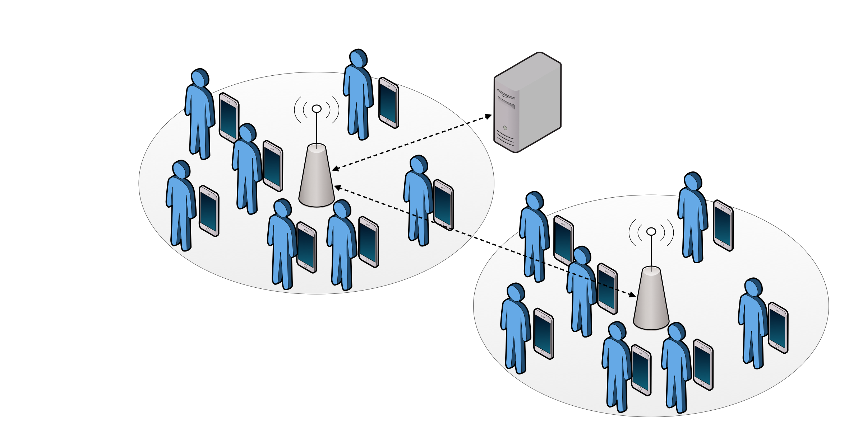
Figure 4 – WiFi hotspot network scenario
- Opportunistic networks based on WiFi Direct
In the second case, we focus on a network scenario where users must deal with opportunistic communication. That is, users do not have pervasive connection to the Internet, and they can have temporary encounters with other users, creating temporary connections between them. There are different cases of opportunistic contexts that we take into account in UMOBILE, as depicted in Figure 5:

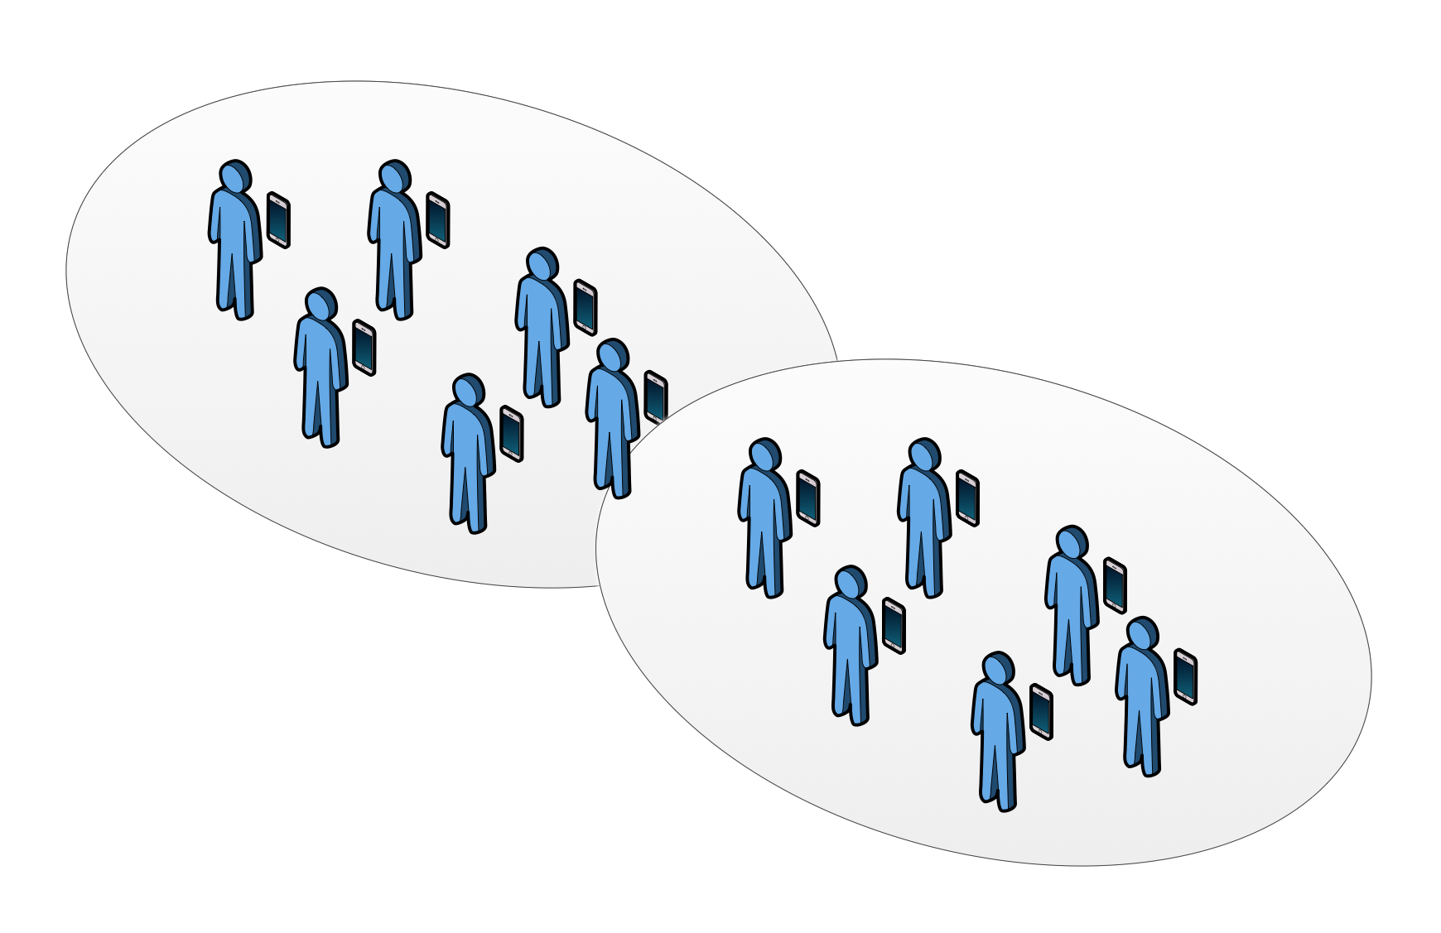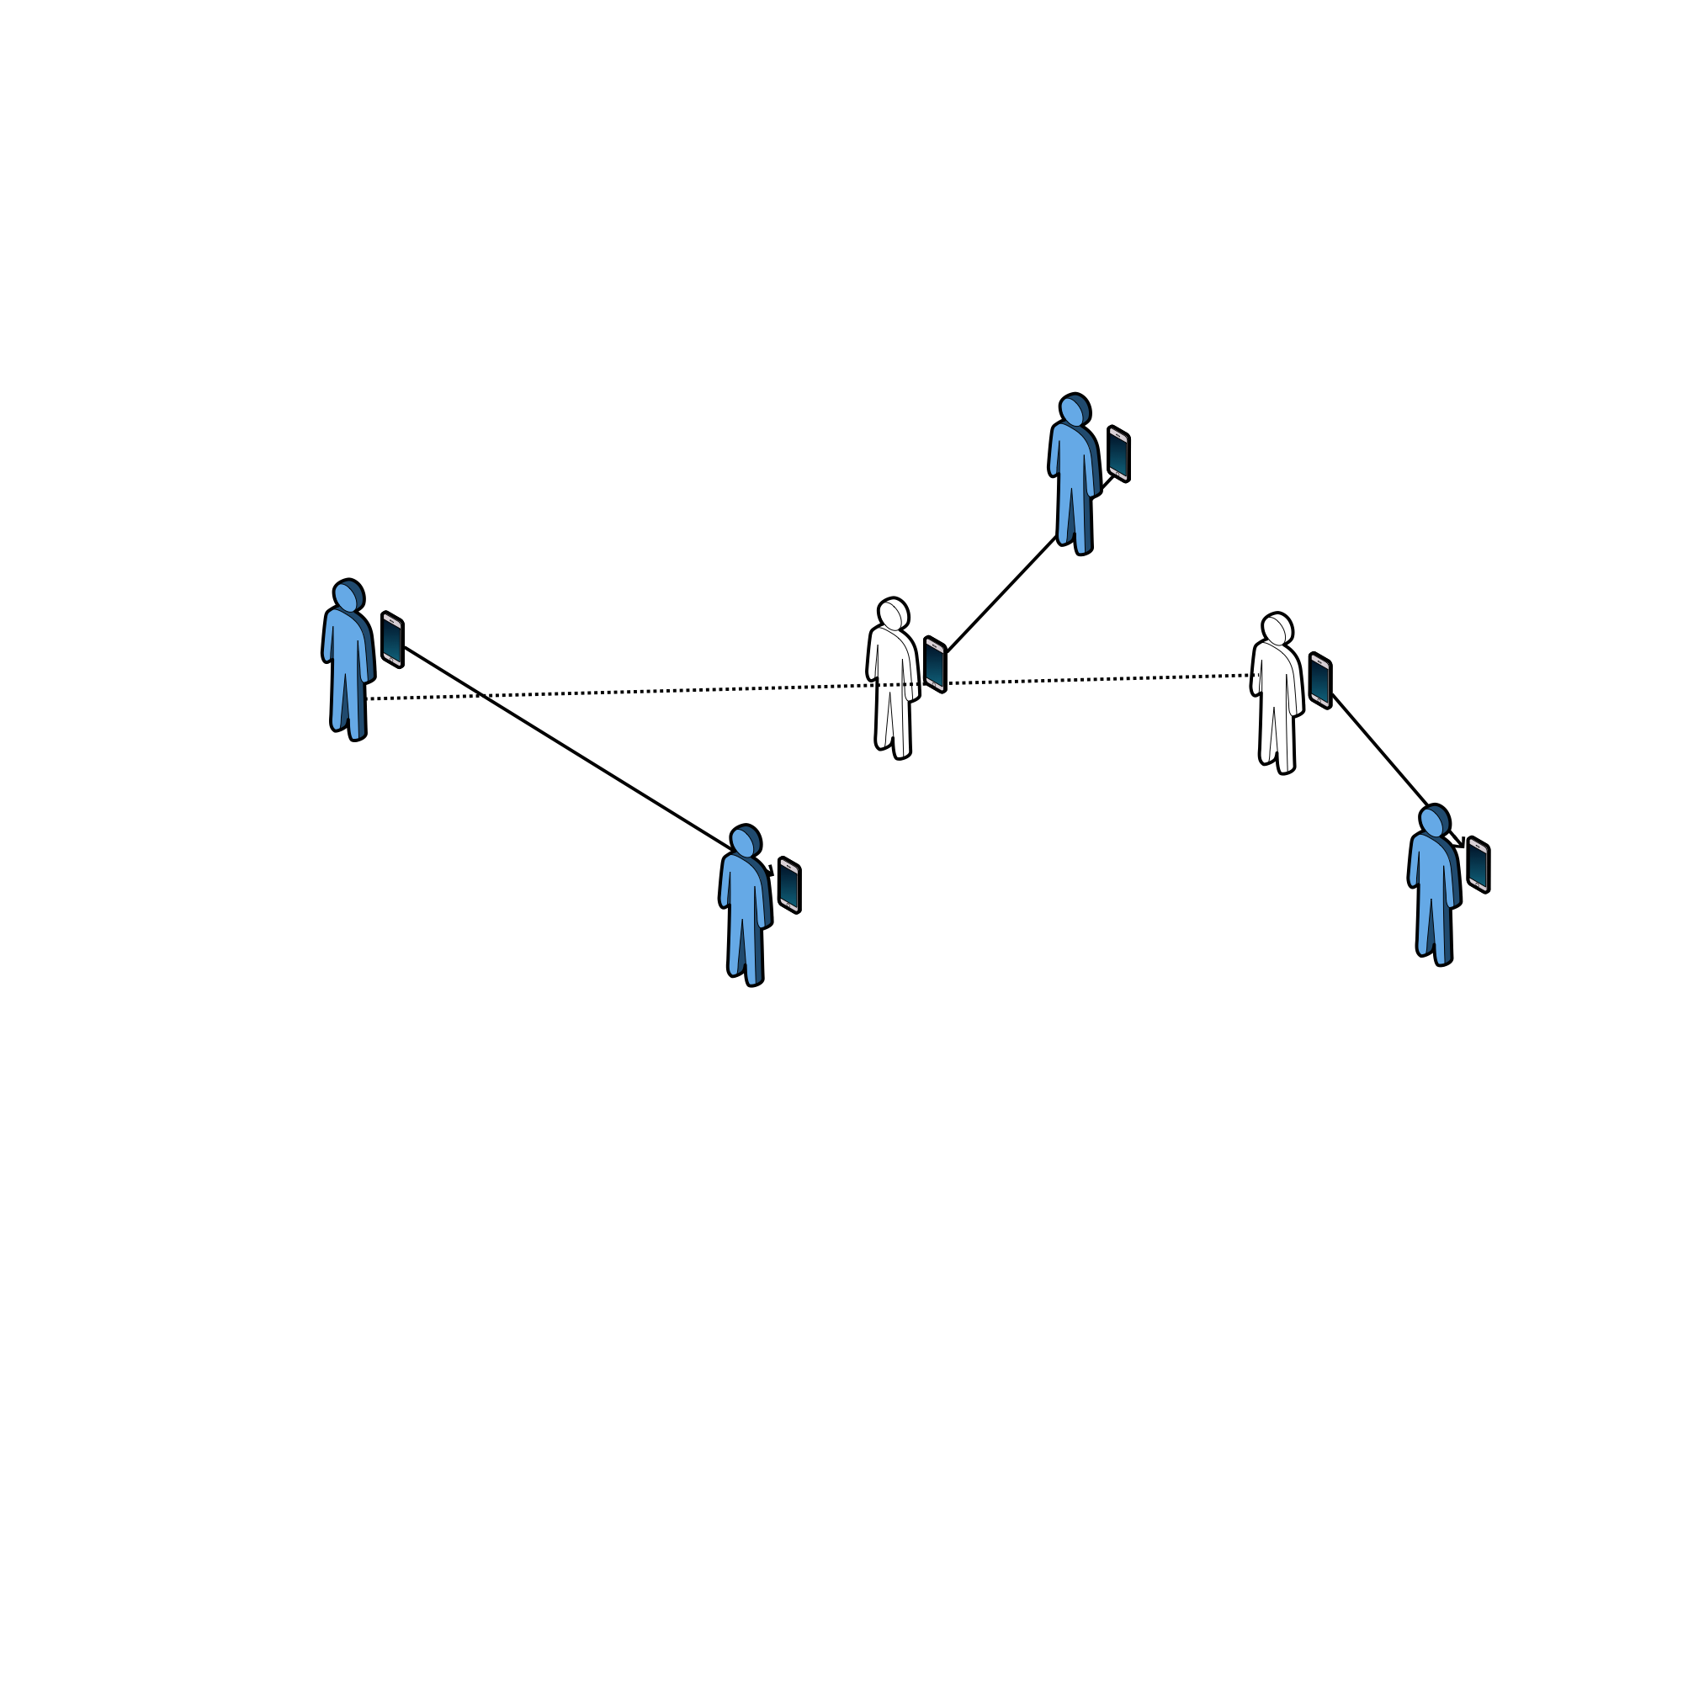
- Users groups b) Opportunistic users contacts

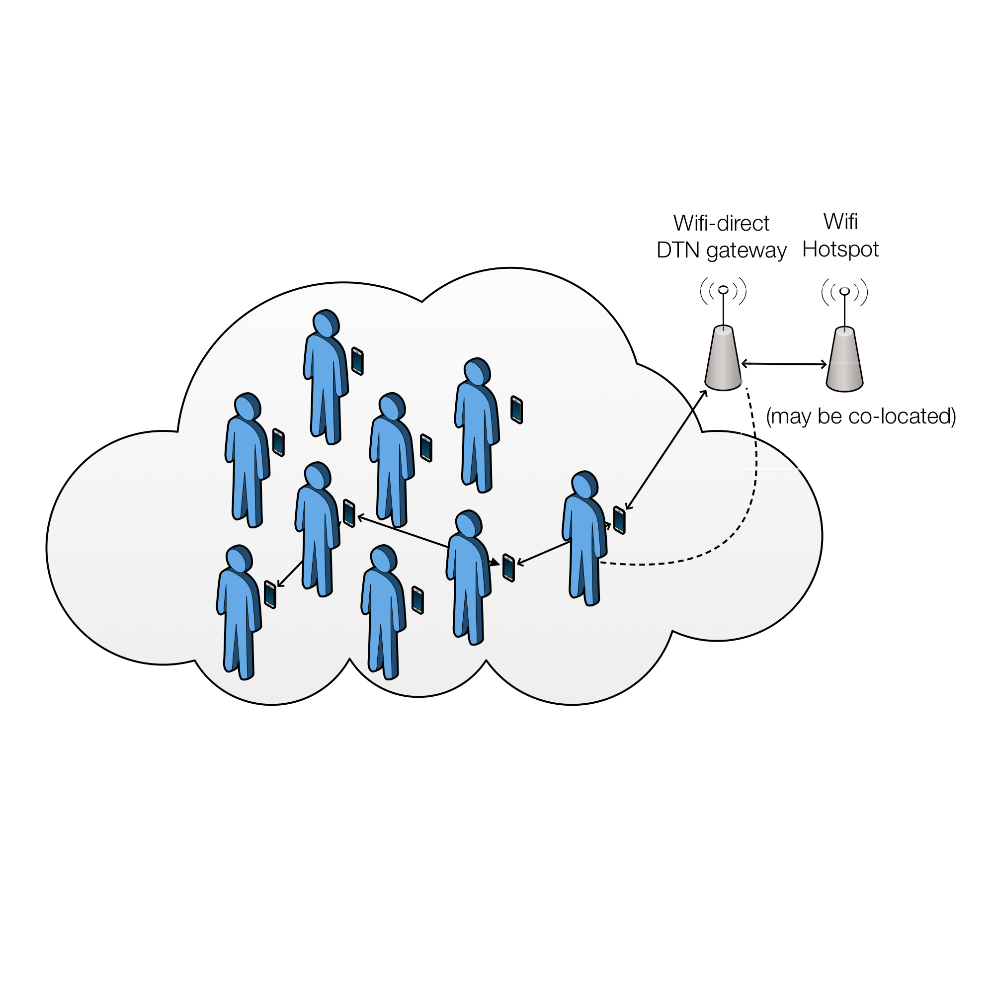
- Opportunistic network context with gateway
Figure 5 – Opportunistic network scenario
The first example (Fig. 5a) shows two formed groups of users connected between them using WiFi Direct connectivity. The second example (Fig. 5b) shows a set of different users that have sporadic contacts between them without forming a group between all the users. The third example (Fig. 5c) shows a set of users that can use opportunistic communications between them in order to reach a gateway, that may be co-located in the WiFi hotspot.
- Poorly connected/isolated areas
The last network context (Fig. 6) takes into account the scenario where a set of users are isolated from the network, but a mobile device interconnects them with the rest of the network using DTN capabilities. This mobile device acts as a data mule, and it can be a UAV device or any other vehicle, such as a public vehicle. Delay-tolerant forwarding can be beneficial in cases where data needs to be forwarded over vehicles, such as UAVs or emergency vehicles. This kind of connectivity can be deployed to provide communications in remote areas or in emergency cases. In addition, UMOBILE architecture also allows services to be run locally within the isolated areas in order to offload the communication over the intermittent link as well as enhance the QoS. This can be facilitated by the service migration module where the service at the mainframe can be migrated to the local access point by exploiting DTN capabilities. Nevertheless, the local access point may need to interact with the mainframe, for instance there is a new update for the operating service or local access point synchronises the usage data with the mainframe.

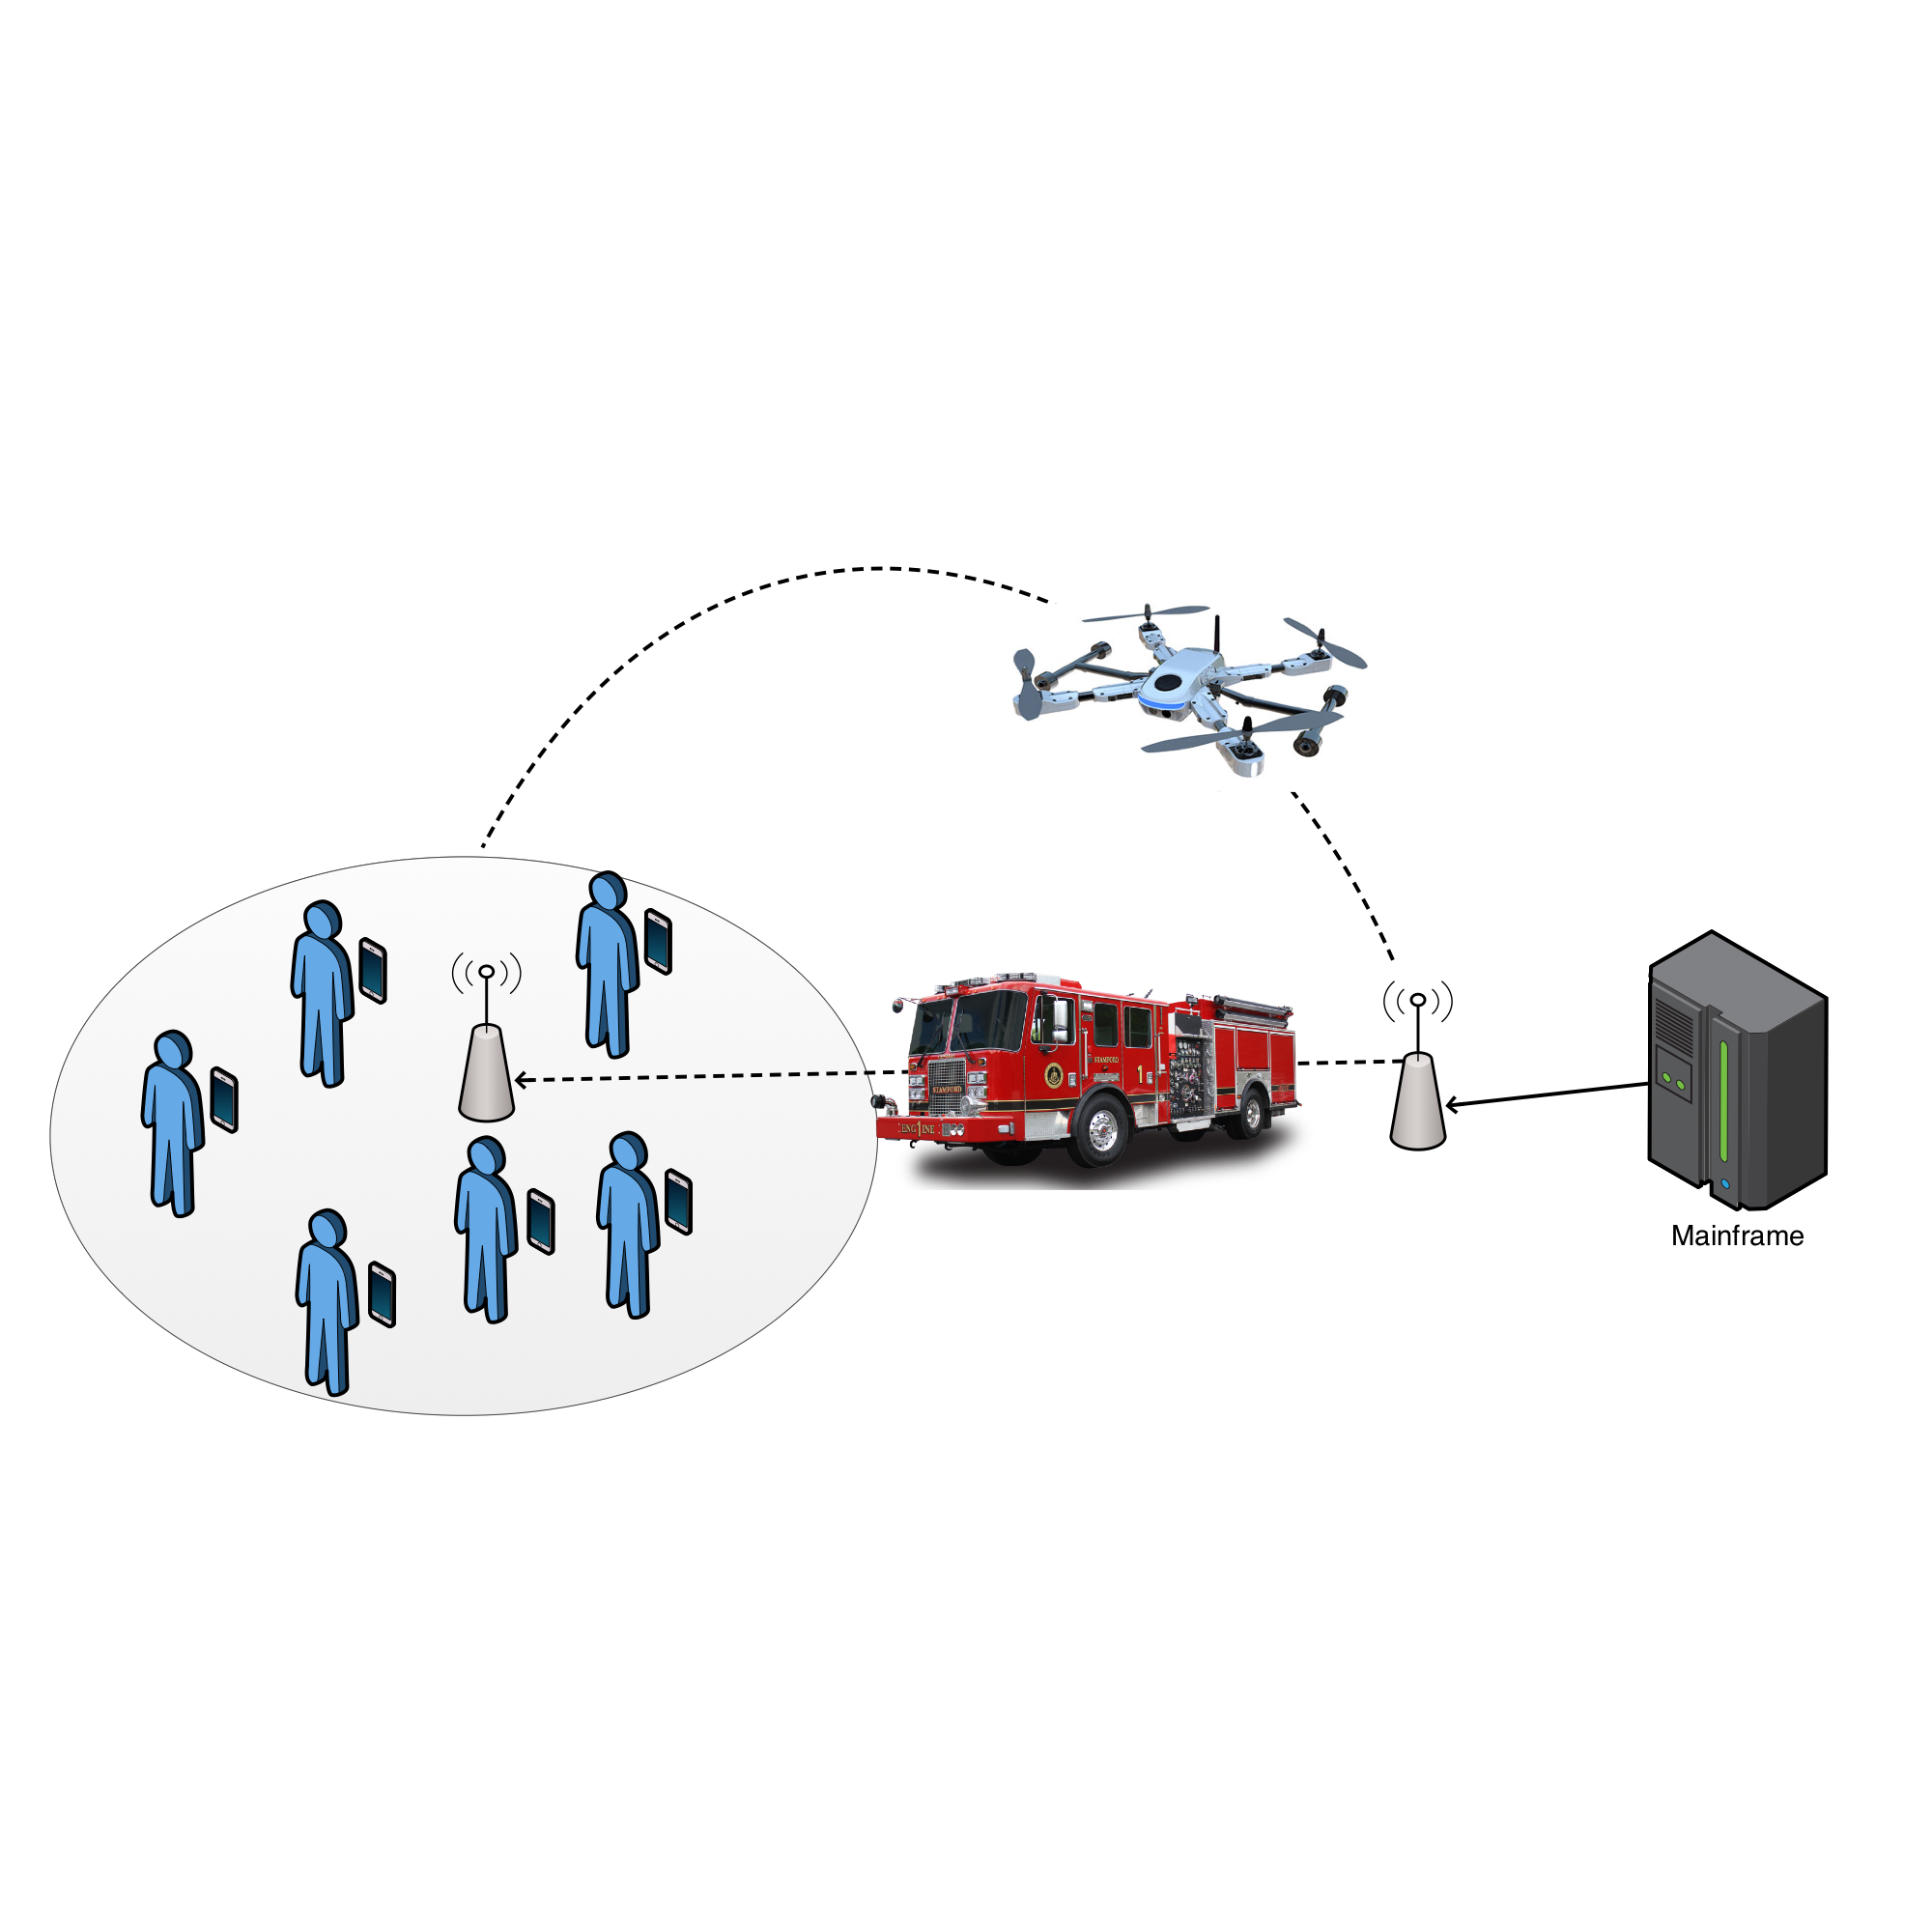
Figure 6 – Isolated areas network scenario

Communication models
As shown in Table 1 most of the identified applications require a data dissemination service operating pull mode (recommendations, news, chat). Aiming to support data dissemination in a pull mode, UMOBILE adopts the concept of ICN, which enforces the receiver-oriented chunk based transport and in-network caching. While in-network caching is beneficial under mobility, UMOBILE messaging applications (emergency, instant messages [23]) are push based. Therefore, the UMOBILE framework includes a push mode data communication as a fundamental unit and leverage both push and pull modes by application context.
Based on the scenario requirements, we define both a pull- and push-based communication model to be employed by the UMOBILE platform.
- Pull-based model: This model is already supported by NDN. Clients requesting content generate and forward Interests. Content Providers (or any other node with the corresponding content cached) respond forwarding data towards the Interface they received the Interest.
- Push-based model: With the current ICN model it is possible to support sender-oriented applications, e.g. [24,25], by adapting the pull mode in order to have interests being registered in advance: e.g. I’m always interested in receiving emergency messages or messages from a pre-defined set of users. This approach has two major limitations: it requires the receiver to negotiate the data name in advance, which may not be suitable in unpredictable situations (e.g. an event); it may lead to a large overhead in UMOBILE scenarios, where nodes are mostly mobile and connectivity may be intermittent. We define several options to support a push-based model:
  - Permanent interests in PIT: This can be used to receive information from authorised authorities, such as the Fire Service, or the Civil Protection Service. In this case, each node has a corresponding Pending Interest in its PIT, leading to both local (an app running in the node) and remote interfaces (forwarding to other nodes). Specific attributes (such as location) can be employed to avoid forwarding information to non-affected areas. To do that, each PIT entry related to this type of service also includes some metadata. To avoid spamming, only authorised, authenticated messages will be forwarded in any case.
  - Server sends Interest -> Client responds with Interest -> Server responds with Information: This involves a special type of Interest that does not request data to be sent back, but rather triggers an Interest transmission from the receiving end. Implementation-wise, upon the Interest reception, a FIB entry at the client side forwards this type of Interests to local apps (when available). From this point on, a typical Pull service is initiated by the app. Modifying the Interest packet format to allow for extra fields, such as attributes or any other information regarding the advertised service, will have the advantage of allowing the receiving end to select whether he/she is interested in receiving the corresponding data. (Essentially, the initial interest should include at its naming scheme the required naming of the second interest that the client needs to send to get the pushed information)
  - Server sends Interest -> Client responds with dummy message/interest -> Server responds with information: This option can be used in scenarios where there is prefix information available towards the node receiving the information (e.g. Fire Service) but not towards the node sending the information (e.g. a tourist in the forest). In this case the server (tourist) sends an Interest towards the authorities, the authorities respond with a dummy packet that encapsulates an Interest, since responding with an Interest would necessitate finding a route back to the server (tourist), which may not be available. We modify the NDN Incoming Data pipeline so as to support Interest packets encapsulated in Data packets. Upon receiving the encapsulated Interest packet, the server application forwards the data message to the corresponding interfaces.

Context services
As shown in Table 1 the identified applications require different context services, in order to improve and adapt the behaviour of the applications to the network context:
- Affinity networking: Affinity networking takes benefit of the networking context in order provide to users the control of the behaviour of the network directly by defining these affinity relationships and attributing specific policies to those relationships.
- Recommendations: The recommendations service assists the users in finding and info quicker and easily, based on users’ preferences.
- Behaviour inference: No need to always access the Internet (good in large events); optimization based on wishes, needs and interests
The contextualization and behaviour inference module then integrates specific models. For instance, a UMOBILE mobile device may present a roaming preferences model, where the intent is to consider personal preferences in terms of visited wireless networks. Or, it may contain a model that relates with the need to share data opportunistically based on frequency or volume of wireless contacts. These models are defined by the user, based on specific parameters. The identified user's context is then used, together with the collected sensing data, to infer patterns of user behaviour.

Data services
As shown in the identified applications require different data services in order to deliver and share data between UMOBILE nodes:
- Data prioritisation: Some applications, such as emergency services, requires prioritisation over other data types with less criticality. Data dissemination should be optimised by prioritisation rules, integrated within the information message’s name to favour spreading of the most important messages. The message replication will be limited by time and space, that is, within a certain geographic area and with specific life expectancy.
- Data dissemination: This service is in charge of packet routing in a UMOBILE network. Based on the application and network context, different UMOBILE forwarding models are supported. This forwarding modes are detailed in Section 3.2. The selection of the best forwarding model to be used is done by the smart forwarding module taking into consideration both the application requirements and network context.
- Data filtering: This service is in charge of gathering data about certain topics (e.g. recommendations) offering to users filtered data matching their interests taking into account information about physical surroundings and social context, behaviour inference and the detection of affinity networks.

UMOBILE architecture design
The envisioned UMOBILE architecture will efficiently operate in different network situations. Our intention is to extend the reach of ICN architectures to disconnected networks. Therefore, we intend to enhance the ICN architectural approach with an inherent tolerance to delays, disruptions and disconnections, inserting the DTN principles into the core of UMOBILE architecture. The great majority of the delay-tolerant approaches in the literature are based on the IP host-centric model, so when a node initiates a communication, its aim is to specifically reach another well-defined host. UMOBILE architecture is an information-centric delay-tolerant communication platform based on a node architecture that unifies the various underlying protocol choices within a single architectural framework. UMOBILE integrates DTN capabilities into a single ICN architecture on top of IP enabling diversity in supported networks. In UMOBILE, we do not provide a new Internet architecture, such as Named-Data Networking (NDN) [8]. In UMOBILE we focus on the mobile domain (as depicted in Figure 6), providing a new network architecture able to interact in social/opportunistic communications and based in ICN and DTN principles, with some extensions to the wired domain in order to bring the services closer to the users, improving the QoS. In the following sections, we detail the different devices that will support the UMOBILE framework, and the set of UMOBILE services that will be developed within the UMOBILE project, and integrated in the UMOBILE architecture.

UMOBILE devices
In the following Figure we show a summary of the UMOBILE network scenarios and the different devices that should support UMOBILE in order to provide all the services previously detailed:

Figure 7 – POTENTIAL DEPLOYMENT SCENARIO OF THE UMOBILE PLATFORM

In order to provide opportunistic communications, a set of devices must support UMOBILE architecture:
- UMOBILE-enabled mobile devices: (i.e., smartphone, tablet, wearable device,etc), used to send and receive participatory data (e.g. photos, short messages) as well as opportunistic data (e.g. atmospheric pressure, temperature, noise, people anxiety levels, roaming patterns).
Figure 8 – UMOBILE end-users
- UMOBILE-enabled hotspots: able to collect and relay relevant information (e.g., alert messages, instructions from emergency authorities), host some instantiated services (using the Service Migration function) or store collected data, check its validity and perform computational functions (e.g. data fusion) to increase the value of the information to the civil authorities.
Figure 9 – UMOBILE hotspot
- UMOBILE-enabled surrogate devices: or other vehicles able to collect and relay relevant information and connect two isolated areas.

Figure 10 – UMOBILE surrogate devices

- UMOBILE-enabled gateway: In order to provide connectivity between the UMOBILE network and the Internet (IP network), we devise a UMOBILE gateway able to translate interest packets to HTTP requests and vice versa. The UMOBILE gateway can be colocated in a Public Hotspot, or a UMOBILE router. This device should have two services, one that translates UMOBILE interests into HTTP requests and another that converts HTTP GET requests into UMOBILE interests. In order to do that, we can use as starting point for the implementation of the UMOBILE proxy/gateway, we will use the HttpProxy application of the NDNx project [26].
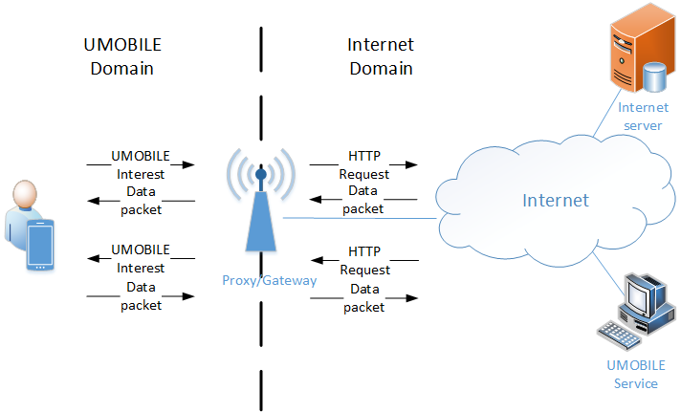
Figure 11 – UMOBILE gateway
- UMOBILE-enabled routers: In order to provide the Service migration service and the QoS mechanisms devised in this project, we require the UMOBILE-enabled routers. The difference between UMOBILE-enable routers and Internet routers is that UMOBILE-routers are supporting the UMOBILE protocols (based on NDN) and are compatible with the UMOBILE QoS mechanisms.
Figure 12 – UMOBILE router

The UMOBILE architecture must be able to work in the different areas of action detailed in D2.1 [3]. Therefore, depending on the situation, UMOBILE architecture must adapt to the environment to achieve the best performance. So, for example, it can use opportunistic networking in order to share the information between peers in a decentralized way, offloading communications from core network. On the other hand, in remote or disrupted emergency areas, UMOBILE may use DTN techniques to propagate the information from the source to the destination. To support such scenarios, the application servers which provides UMOBILE services could be able to migrate some services from the Internet and operate locally within the UMOBILE domain. For instance, the UMOBILE services could be executed at the public hotspots (as depicted in Figure 6) in order to mitigate the network latency regarding the challenged conditions (e.g., intermittent connectivity, limited bandwidth at the backhaul). This approach is the key benefit of service migration module which can improve the QoS for the end users.
In UMOBILE, content can be named using tags/keyword, aggregating content by similarities, simplifying the naming scalability issues in the NDN approach and the search of content in the UMOBILE network. This approach is further detailed in Section 4.1.1. UMOBILE architecture must support different network technologies. UMOBILE architecture must support the ability to communicate with a wide variety of underlying protocols, implementing convergence layers for several underlying technologies, like 802.11, cellular (3G/4G), satellite, Bluetooth communication, etc. The technology used by UMOBILE for opportunistic communications will be WiFi Direct, based on 802.11 technology.

UMOBILE services
In order to perform in all the aforementioned scenarios, being able to disseminated data and access services for all UMOBILE applicability scenarios and developing the different communication models and contextualization services, in UMOBILE project we are going to develop a set of services that will be integrated into a single architecture. The set of services are the following, and we classified them per functionalities or network abstractions:
- Application sharing: UMOBILE will provide a new application-centric information sharing framework named Keyword Based Mobile Application Sharing (KEBAPP) oriented to support and provide opportunistic computing to mobile devices (smartphones, tablets, etc.). Our approach targets scenarios where large numbers of mobile devices are co-located presenting the opportunity for localised collective information exchange, decoupled from Internet-access. In KEBAPP, we propose the creation and use of 802.11 broadcast domains for the support of particular applications i.e., KEBAPP-enabled hosts or APs advertise one or more Basic Service Set(s) (BSSs) for the support of one or more application(s). The creation of application-specific BSSs aims at enabling mobile devices to connect only when their counterparts support the same application and/or namespace. The advertising AP or host, through a WiFi Direct Group, acts as a mediator to connect different users willing to share the same application in a single broadcast domain. In the case of APs, functionalities such as access control, association, encryption, etc., can be supported without imposing computation and/or battery overheads to mobile devices. In this context, KEBAPP employs application-centrism to facilitate/enable (i) the exchange of processed information, in contrast to merely static content, and (ii) the discovery and delivery of information partially matching user interests (data filtering).
- UMOBILE forwarding: The following set of forwarding mechanisms are going to be developed within the UMOBILE architecture:
  - NDN-Opp: In order to perform opportunistic forwarding based on users’ interests and their dynamic social behaviour, NDN-Opp includes some changes in relation to NDN in order to enable social-based information-centric routing over dynamic wireless networks. Based on the current specification of NDN, NDN-Opp provides a novel routing engine able of supporting opportunistic communications, and a forwarding engine that makes use of the existing Best Route forward strategy. NDN-Opp is the first attend to extend the NDN network towards opportunistic wireless networks, which: do not assume the existence of a communication path between any pair of nodes at any moment in time; exploit any communication opportunity between mobile devices to forward data towards receivers. To accommodate the intermittent nature of wireless connectivity, NDN-Opp introduces the concept of virtual faces. Changes to the current specification of NDN-Opp are expected in order to better align the proposed solution to the NDN framework, aiming to ensure an easy integration of UMOBILE networks in the existing NDN wired infrastructure.
  - DTN: The main goal of UMOBILE project is the development of a networking architecture that supports both information centricity and delay-tolerance. To achieve that, we will exploit not only by providing delay tolerant communications natively using the NDN platform but also working on an IBR-DTN implementation. This IBR-DTN implementation will provide opportunistic communications through DTN tunneling in case of opportunistic communications when delay-tolerant transmission of data is deemed the most suitable alternative.
  - OOCD: We will investigate a new scheme named Opportunistic Off-path content discovery (OOCD) the retrieval of content in disruptive, fragmented networks cases in NDN. To resolve and fetch content when the origin is not available due to fragmentation, we exploit content cached both in in-network caches and in end-users' devices. We introduce an extra Interest management routing table, which we call the “Satisfied Interest Table” (SIT) and which points to the direction of already satisfied Interests. This way, upon failure of links/nodes towards the content origin, the SIT table is redirecting Interests towards caches and end-users that have recently received the requested content. We believe that network management for disruptive environments should take advantage of information-centricity, instead of focusing only on protocol-specific path recovery routing.
  - NREP: In the immediate aftermath of a natural disaster, network infrastructure is likely to have suffered severe damages that challenge normal communications. In addition to that, traffic substantially increases as a result of people attempting to get in touch with friends, relatives or the rescue teams. To address such requirements of a challenged network, we are going to propose a mobile name-based replication system for disaster cases based on Name-based REPlication priorities (NREP), where replication is optimised by prioritisation rules, integrated within the information message’s name to favour spreading of the most important messages. The message replication will be limited by time and space, that is, within a certain geographic area and with specific life expectancy
- Push services: Based on the scenario requirements, UMOBILE platform requires both pull and push-based communication models. The pull-based model is inherently supported by NDN. Clients can request the desired content by issuing Interests with name prefix. Content Providers or any other NDN node with the corresponding content cached can respond forwarding data towards the Interface regarding information in the PIT. However, we can adopt several models of push-based communication by using default Interest/Data exchange of NDN architecture, firstly introduced in Section 2.2.1. In the following deliverable (D3.1) we will give more detail about the solutions adopted by the UMOBILE platform in order to provide Push services to the UMOBILE applications.
- QoS: In order to ensure QoS to end-users, we present two complementary mechanisms:
  - Service pre-fetching: Service pre-fetching is one of the techniques that the UMOBILE platform uses to ensure that services are delivered with the expected QoS to the end users. It is also used for providing local availability of services where Internet connectivity is intermittent or broken down. It is implemented by the migration platform on the grounds of anticipated service migration. For example, service migration guarantees that a given service is resilient and it observes, latency, throughput and other QoS requirements. Thus the UMOBILE platform implements mechanisms that can help network operators migrate services to different places of its network infrastructure (normally the network edges) in order to honour the expected QoS as well as accommodate service reachability in challenged networks [27]. As mentioned in D2.1 (use case scenarios), UMOBILE needs to support various challenged scenarios such as aftermath of disasters, rural/remote network deployments or networks with limited backhaul capacity. Such challenged environments pose several challenges such as increased latency, intermittent connectivity etc. To address these challenges the UMOBILE architecture includes a service migration platform implemented on the basis of the latest advances in lightweight operating systems such as Docker containers [27,28]. The key idea is to deploy and migrate service instances to the network edge upon detection of threatening network problems. Within a local network, service migration modules utilise a name based routing/forwarding strategy providing the benefits of ICN. Within the UMOBILE architecture, we will utilise the NDN abstractions to carry out the name based routing/forwarding strategies. We also envision that our service migration module could be integrated with DTN to provide resilient access to services during periods of intermittent connectivity. Ideally, service migration should be transparent to the end users, in the sense that they do not need to know the location of the service replicas that are responding to their requests. For this transparency to be possible, the service replicas need to be migrated before in anticipation of the end users’ needs (pre-fetched). To address this requirement, the UMOBILE architecture includes a decision engine. The decision engine is a software component instrumented with the necessary logics to i) collect monitored metrics about parameters that impact the QoS and ii) determine when and where a service should be migrated and iii) migrate the service. Typical examples of parameters that are taken into account by the decision engine are the number of users interested in the service, load inflicted on existing replicas, current network traffic, migration cost in terms of time and traffic, potential benefit in terms of latency, etc.
  - INRPP: Within the UMOBILE project, we aim to design and evaluate the In-Network Resource Pooling Protocol (INRPP), which pools bandwidth and in-network cache resources in a novel congestion control framework to reach global fairness and local stability. Taking profit of the hop-by-hop design and the caching capabilities inherent in the NDN networks, or adding caches (i.e., temporary storage) and breaking the end-to-end principle, we argue that the demand factor can be tamed. Given this functionality of in-network storage, INRPP comprises three different modes of operation: push mode, store and detour mode or backpressure mode.
- Contextualization services
  - PerSense Mobile Light: In the context of UMOBILE, PerSense Mobile Light is a service that it is being developed to assist in performing network contextualization. Currently, PerSense Mobile Light captures information concerning a user’s affinity network (contacts derived from WiFi Direct and Bluetooth) as well as concerning roaming habits, over time and space (WiFi). In a future version, PerSense Mobile Light shall collect data on user behavior, derived from additional sensors – the sociability forecasting module.

Network requirements
The implementation of UMOBILE is in line with the network requirements defined in D2.2 [4]. The overall UMOBILE requirements have been divided into three types:
- MUST, which are an absolute requirement of the UMOBILE specification, and so are required in any implementation;
- SHOULD, which are recommended features, meaning that there may exist valid reasons in particular circumstances to ignore such features, but the full implications must be understood and carefully weighed before choosing a different course, and
- MAY, which are truly optional features.
We briefly refer to the overall system requirements, based on which we have developed the modules described in the following sections.
MUST requirements:
R-1: UMOBILE systems MUST be able to exchange data also based on users’ trust circles, built upon their interaction in the system, ensuring user privacy in dynamic networking scenarios.
R-2: UMOBILE systems MUST be able to exchange data by exploiting every communication opportunity through WiFi (structured, direct), 3G and bluetooth, among UMOBILE systems, operating even in situations with intermittent Internet connectivity.
R-3: UMOBILE systems MUST be able to exchange data taking into account user data interests and context.
R-4: UMOBILE system MUST respect user privacy and solely use user data to help him/her in improving the social routine
R-5: UMOBILE systems MUST have an interface to support the following applications: Chat; File exchange/synchronization; Content request/publish.
R-6: UMOBILE systems MUST be able to ensure data reliability and availability (e.g. taking into account data usefulness - time to live; manage duplicated pieces of information) among a set of distributed surrogates.
R-7: UMOBILE systems MUST be able to ensure data reliability and availability (e.g. taking into account data usefulness - time to live; manage duplicated pieces of information) among a set of distributed surrogates.
R-8: UMOBILE systems MUST be able pre-fetch data in order to improve service performance.
R-9: UMOBILE systems MUST prioritise data to be exchanged, for instance giving high priority to emergency and civil protection information.
R-10: UMOBILE systems MUST be able to deliver information within geographic regions and time frames that are relevant to different types of data.
R-11: UMOBILE systems MUST provide users only with relevant information, i.e., matching user interest.
R-12: UMOBILE gateways are able to convert the ICN traffic to traditional IP packet format and vice versa.
R-13: UMOBILE systems MUST be able to provide the services to the end users when there is no Internet connectivity.
SHOULD requirements:
R-14: UMOBILE systems SHOULD be able to perform data fusion, increasing the value of shared information (e.g. the notification that a user gets about the best music stage in a music festival can be derived from the analysis of two types of data: music preference; crowd situation).
R-15: UMOBILE system SHOULD be able to provide users only with information that matches their interests (e.g. art exhibitions).
R-16: UMOBILE system SHOULD be able to pre-fetch data based on user interests (e.g., parking places near recommended art gallery) and behaviour (e.g. mobility patterns), in order to reduce delays in data delivery.
R-17: UMOBILE mobile systems SHOULD be able to sense user context (geo-relative location, relative location, proximity, social interaction, activity/movement, roaming, talking) in a non-intrusive manner.
R-18: UMOBILE systems SHOULD be compatible with existing applications.
R-19: UMOBILE systems SHOULD provide information about the network status (e.g. network diameter, average path length, link bandwidth, network delay) is order to allow authorities to take corrective measures (e.g. deploy UAV infrastructure).
R-20: UMOBILE systems SHOULD be able to create opportunistic communication infrastructures, instantaneously deployed using UAVs.
R-21: UMOBILE systems SHOULD reward for the cooperative behaviour of users (e.g., point-gaining system).
R-22: UMOBILE systems SHOULD be able to provide local services when the system cannot connect to the Internet.
R-23: UMOBILE systems SHOULD have a functionality that allows authorized people (e.g. parents) to track the routine of particular devices (e.g. son’s/daughter’s device).
R-24: UMOBILE systems SHOULD be able to exchange data by exploiting every communication opportunity between UMOBILE systems and non-UMOBILE systems.
MAY requirements
R-25: UMOBILE systems MAY allow users to manage their trust circles.
R-26: UMOBILE systems MAY be able to sense user surroundings (crowds, environmental, noise level).
R-27: UMOBILE systems MAY be able to dynamically coordinate distributed surrogates to ensure data resilience and availability (e.g. data pre-fetching).
The initial requirements will be revised by M30, after the UMOBILE architecture has been fully implemented, as new insights are gained during the implementation process.
In the following we give some details about how the network requirements detailed in D2.2 are going to be satisfied by the different UMOBILE services previously presented. In D3.1 we will give more detail about how these network requirements are implemented. Requirements marked in red are those requirements that are classified as SHOULD, and black requirements are those classified as MUST requirements (Note that SHOULD requirements R-18, R-21, R-23 and R-24 and MAY requirements are out of the scope of this document and will be investigated in further deliverables -D3.4 and D3.2-):

- Pre-fetched services: R-8, R-13, R-16, R-19, R-22.
The pre-fetched services are aimed at bringing services at the edge of the network, avoiding the dependency from the Internet connectivity and providing local services to users, without requiring end-to-end connectivity.
- Application sharing: R-8, R-13, R-14, R-16, R-22.
Application sharing services are aimed at providing application sharing capabilities through D2D communications between end-users. Users can access to services but provided by other end-users when the access to Internet is limited, complementing the pre-fetched services at the edge of the network.
- UMOBILE forwarding:
The UMOBILE forwarding mechanisms are aimed at satisfying those requirements related with i) providing forwarding mechanisms based on users interests -inherent in NDN-, ii) providing social-based opportunistic forwarding, iii) providing forwarding mechanisms that support data prioritisation for emergency services, iv) providing new forwarding mechanisms compatible with a DTN logic face and v) providing a new opportunistic off-path contend discovery mechanism (OOCD) aimed at improving content localisation in fragmented networks. The list of requirements of D2.2 related with the UMOBILE forwarding mechanisms are:
  - NDN: R-3, R-7, R-11, R-15.
  - NDN-Opp: R-2; R-3; R-5; R-7; R-11; R-15; R-17.
  - NREP: R-2, R-3, R-9, R-10.
  - DTN: R-2, R-3.
  - OOCD: R-2, R-3.
- Context services: R-3, R4, R-14, R-15, R-17.
The context services are aimed at satisfying those services related with improving the social routine and providing information about user’s interest and context. Context services provide recommendation services, affinity networking and behaviour inference.

- New devices: R-6, R-12, R-20.
In the UMOBILE project we devise new devices (Section 3.1) aimed at providing services to isolated users. These new devices are aimed at satisfying network requirements related with data and services availability in remote areas.

UMOBILE modules
In this Section we describe the different modules that are part of the UMOBILE architecture, shown in Figure 2 and 3 in Section 1.

NDN plane
The UMOBILE architecture is based on the current NDN architecture and will reuse most of its components, adding new ones to provide the features and network requirements previously specified. These NDN components that will be reused by the UMOBILE platform are: communications based on interests, content store, Pending Interest Table (PIT), Forward Information Base (FIB), caching policies and forwarding strategies. The naming used in NDN will be modified in order to provide more flexibility, required in opportunistic communications where the lack of infrastructure requires more flexibility in terms of the content that can be found in the different nodes.

Naming
The discovery and invocation of services/applications in the networking vicinity of a user build on a naming scheme that enables the fine-grained description of the desired information.
To this end, UMOBILE builds on the observation that mobile computing is largely application-centric, in the sense that users tend to access information using purpose-built applications. Application-centricity presents a series of important characteristics:
- Applications inherently support the structuring of the name space within their semantic context. In turn, instances of the same (or similar) application can share the same name space in describing the related information e.g., categories in a news application.
- Applications are inherently used for computation, enabling the (lightweight) processing of content/information e.g., searching, sorting data or computing a route.
Taking these features into account, UMOBILE names are composed of two main parts (see Fig. 12):
- Fixed Hierarchical Part. It follows the hierarchical naming scheme of NDN and its purpose is to guarantee compatibility between instances of the same or different services/applications. Application developers can define their own hierarchical name spaces, enabling the communication between different instances of the application e.g., /NewsApp/politics/international. Further enabling communication between different applications goes through naming conventions that can build on the currently followed categorization of applications in popular application markets e.g., extending “/Travel & Local/” in Android App Market, to “/Travel & Local/Car Rentals”.
Moreover, application developers can also define suffixes corresponding to specific functionalities within their applications (in addition to static content), enabling this way the sharing of computation e.g., the name /MyTravelAdvisor/Top10Restaurants is used to identify the list of the top-10 restaurants in a certain area. The Hashtag part of the name, described below, is used to define the sorting criteria and the selected area.
According to our initial design this part of the name will have to be an exact match in order for the request to be formed. That said, however, it will be difficult for users to imagine the different parts of the name that the application developer has defined.
- Hashtags. The second part of the name comprises of hashtag-like keywords, which the application developer can add to the application. The exact semantics of the hashtags depending on whether the fixed hierarchical part of the name corresponds to static content or an application function(ality). In the former case, these keywords are used to semantically annotate the static content. This feature enables the partial matching of requests with available cache or routing/forwarding entries i.e., given an exact match in the fixed hierarchical part of the name, hashtags can be used to support approximate matching enabling the search of information in other devices.
When the fixed part of the name identifies a certain application function(ality), the hashtag part of the name enables the passing of adequate parameters. In the aforementioned example of the MyTravelAdvisor application, the complete name included in a user request can have the fixed hierarchical part /MyTravelAdvisor/Top10Restaurants and the hashtags \#userrating, \#areaY, \#indian indicating that the user is interested in the top-10 of the indian restaurants in areaY, according to users’ ratings. The submission of hashtag values is guided by the application GUI and can include both predefined value ranges e.g., the sorting criteria for the top-10 restaurants, and free text fields e.g., a user requests /MyNewsApp/politics/search #Syria #negotiations to use the search function of MyNewsApp in order to find anything related to negotiations for Syria. In another example, an application following the naming conventions of the app market place issues a request for the name /news/politics/search #Syria #negotiations, which can match any application supporting a search function.
Figure 13 - UMOBILE keyword-based naming scheme
We believe that the naming-scheme presented above can be rather efficient in narrowing down the range of the services to be executed and therefore, the results that will be returned to the user.
Below we include example naming schemes for the proposed applications in Section 2.2:
- Recommendations:
A user is walking on Oxford Street in London and wants to but men’s clothes that are on sale.
Fixed Hierarchical Part: /ShoppingApp/Clothes/Men
Hashtags: \#London \#OxfordStreet \#Sales
- Chat:
A user would like to participate in a chat with other parents of the same class of their children school, in case of emergency.
Fixed Hierarchical Part: / EmergencyApp /Chat
Hashtags: \#SchoolName \#3rdGrade
- Instant messaging:
In this scenario, a user wanst to establish communications with any fire station in central London to provide information about a fire.
Fixed Hierarchical Part: / EmergencyApp /InstantMessaging
Hashtags: \#CentralLondon \#FireStation

- Emergency channel:
In this scenario, a user knows that a fire has broken out within the university campus in Xanthi and is looking for an evacuation plan.
Fixed Hierarchical Part: /EmergencyApp/Xanthi/Fire
Hashtags: \#UniversityCampus \#EvacuationPlan
- Local News:
A user is willing to find gigs and live music in central London.
Fixed Hierarchical Part: /NewsApp/arts/exhibitions
Hashtags: \#CentralLondon \#Music \#Today

UMOBILE smart forwarding
In order to provide more features and opportunistic capabilities to the NDN architecture, in UMOBILE we need to add different strategies that the ones provided by NDN, that are best route, broadcast, client control and NCC [29].
The core of our information-centric communication model lies in the usage of Interests issued by clients (pull-based model) or content providers (push-based model). In order for these Interests to be successfully delivered, a decision must be made on whether, when and to whom an Interest should be forwarded. Given the diverse application requirements, along with the varying networking conditions that may span from continuous high-speed connectivity to intermittent disruptive communications, a collection of different forwarding strategies needs to be supported by the UMOBILE architecture.
In particular, we envision a per-namespace selection of the forwarding strategy and we divide the forwarding strategies that UMOBILE will support into four main categories, based on their goal and the parameters used:
- Quality of Service (QoS): DTN forwarding, OOCD, NREP or typical NDN forwarding.
- Quality of Experience (QoE): NDN-Opp.
- Application sharing: KEBAPP forwarding.
All basic forwarding decisions are made in the UMOBILE Smart Forwarding module, a central part of the UMOBILE platform. In particular, the forwarding module is responsible for selecting the optimal way to forward packets, based on the following inputs:
- Usage context (e.g. packet priority, application delay-tolerance, user delay-tolerance).
- Network context (e.g. WiFi Direct connectivity, UAV connectivity).
- User context (social information).
In the following, we describe the forwarding strategies that the UMOBILE platform will support.
Typical NDN
Interoperability between UMOBILE and NDN necessitates that the typical NDN forwarding strategies are also supported. In particular, UMOBILE will include the following NDN strategies:
- Best Route: This strategy forwards Interests to the interface with lowest routing cost.
- Broadcast: The broadcast strategy forwards Interests to all eligible interfaces.
- Client Control: This strategy allows a local application to choose the outgoing face of each Interest.
- Ncc[29]: This strategy, initially implemented for CCNx, is capable of employing multiple Interfaces to forward Interests, based on a prediction function.
In the framework of the UMOBILE project, we devise a new set of forwarding strategies as a means to support scenarios involving long end-to-end delays but short hop-by-hop links. Typical use cases under this category are transmissions involving data ferries (e.g., UAVs). More specifically, we provide delay-tolerant characteristics to the strategies described in 4.3.1.2.1 by extending specific timers and modifying Interest and Data packet pipelines to exploit Interfaces that become available in a future moment.
DTN
This forwarding strategy effectively connects NDN nodes over DTN links. Typical use cases for this type of connectivity are opportunistic networks (e.g., festival or emergency communications). Implementation-wise, NDN faces are translated to DTN hostnames, so that each NDN-DTN Face corresponds to a single DTN node within the DTN island. This way, the NDN forwarding engine actually delivers the Interest and Data packets to the DTN protocol. Then, DTN forwarding strategy is applied, and attempts to forward the Data/Interest packet to the specified DTN host.
In Figure 14, we can observe the two different modes that DTN forwarding allows. The DTN forwarding engine can be employed either proactively by the application, or reactively, upon reception of congestion-related messages from the network. In particular, an application can use specific hashtags that notify the smart forwarding module that a DTN-related strategy should be selected for the forwarding of the former’s data

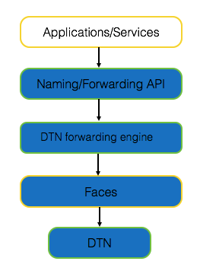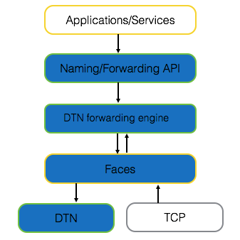
a)Proactive b)Reactive
Figure 14 – DTN-Forwarding

KEBAPP
This forwarding strategy is aimed at supporting the KEBAPP functionalities in order to enable application sharing. The details of this new forwarding strategy will be detailed in D3.1.
OOCD
This forwarding strategy is aimed at forwarding the content not only from the source of the content, but also using the NDN extension the Opportunistic Off-Path Content Discovery (OOCD) provides, to discover other users that recently downloaded the same content, and are willing to offer the same to content to the requesting user, in case that network fragmentation does not allow to retrieve the content from the source of it.
NREP
NREP forwarding strategy is aimed at support the Name-based REPlication priorities (NREP) approach, where replication is optimised by prioritisation rules, integrated within the information message’s name to favour spreading of the most important messages. The message replication will be limited by time and space, that is, within a certain geographic area and with specific life expectancy, enabling the emergency services prioritisation in disaster cases.
NDN-Opp
NDN-Opp, the NDN framework for Opportunistic Networks included in UMOBILE that enables social-based information-centric routing over dynamic and opportunistic wireless networks, will require a new forwarder able to support this kind of opportunistic communications. NDN-Opp functionalities are explained in the next section.
Note that in this first version of the high-level specification of the UMOBILE architecture, we have different forwarding strategies for most of the different UMOBILE services. However, in WP5 we will focus our efforts in the integration part, and it is possible that some forwarding functionalities could be integrated into the same forwarding strategy. Therefore, it is possible that the list of required forwarding strategies could change in the final version of the high-level architecture specification in D3.4, to be submitted in M30.

NDN-based social-aware opportunistic routing framework
In order to perform opportunistic forwarding based on users’ interests and their dynamic social behaviour [30,31], the NDN framework for Opportunistic Networks (NDN-Opp) includes some changes in relation to NDN in order to enable social-based information-centric routing over dynamic wireless networks [32].
Based on the current specification of NDN, NDN-Opp aims to provide a novel routing engine able of supporting opportunistic communications, based on existing NDN forwarding strategies. NDN-Opp is the first attend to extend the NDN network towards opportunistic wireless networks, which: do not assume the existence of a communication path between any pair of nodes at any moment in time; exploit any communication opportunity between mobile devices to forward data towards receivers.
While the NDN-Opp framework is being specified, COPELABS started implementing the proposed social-aware opportunistic networking framework in a monolithic scheme: SOCIO [33]. This is, SOCIO implements the current forwarding and routing engine, based on social proximity indicators, proposed for NDN-Opp outside the NDN framework. The goal is to allow a faster evaluation of the proposed forwarding and routing engines, which was feasible since the specificities of the NDN framework were not considered.
This step-by-step approach allowed us a faster detection of potential improvements, such as the need to develop a novel opportunistic routing mechanism that would be more aligned with the operation of NDN.
In order to demonstrate the capability of the NDN-Opp framework to deliver data over an opportunistic wireless network, we developed Oi! [34]: a short messaging application.
NDN-Opp fulfils the follows UMOBILE requirements, as listed in deliverable D2.2: Fig 14 illustrates how Oi! messages are opportunistically exchanged considering the levels of social interaction among users in a working setting.
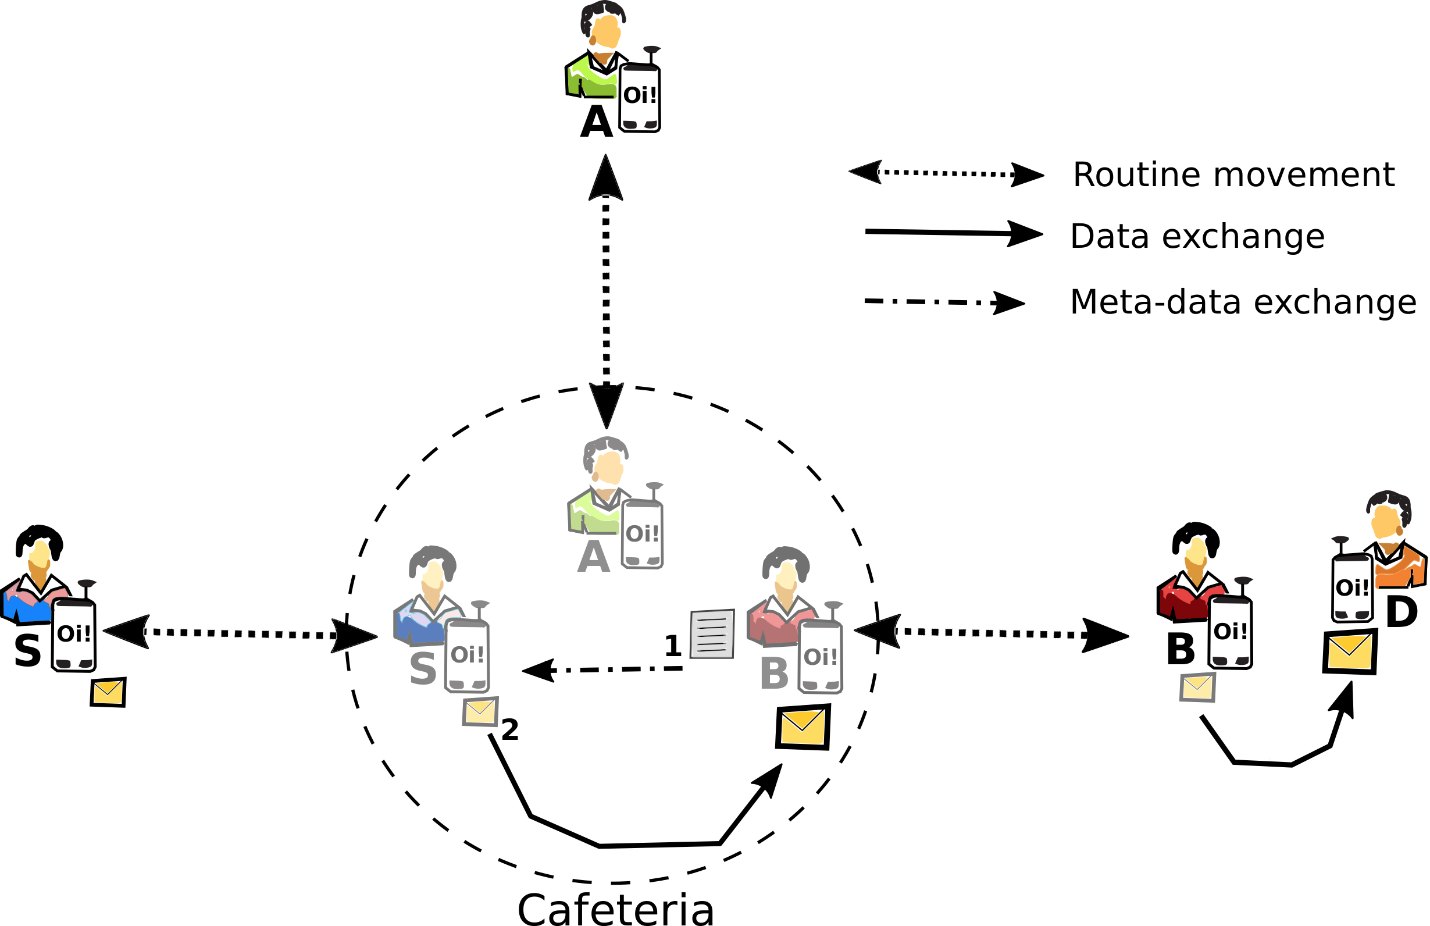
Figure 14: Social-aware opportunistic data transmission
As aforementioned, users meet one another in different settings and at different levels. In Fig14, the source node S has a message to destination node D. During lunchtime, node S meets other nodes from which node B happens to work (i.e., spends more time in the same social setting) with node D. By considering the level of interaction of all nodes in the cafeteria towards node D, node B is the best next forwarder to reach it given the social engagement in such social setting.
Based on that, Oi! messages are replicated only to socially relevant nodes (i.e., node B in this example) and refrain from using resources that will not result in the delivery of the message (node A could have received a copy of the message, but such effort would be useless as it does not socially engage with D at all in such setting).
Deliverable D3.1 provides a detailed description of the NDN framework for Opportunistic Networks (NDN-Opp), showing how it is being developed to support opportunistic forwarding based on users’ interests and their dynamic social behaviour. The NDN-Opp framework includes some changes in relation to NDN in order to enable social-based information-centric routing over dynamic wireless networks. Nevertheless, NDN-Opp respects the NDN concept and implementation choices in order to ensure the compatibility of the NDN-Opp mobile node with existing NDN routers. Namely, the current specification of NDN-Opp aims to forward interest packets towards best neighbours, which are selected based on their probability to deliver packets to a node carrying the interested data. This means that the current specification of NDN-Opp makes use of the existing best route forwarding strategy to deliver interest packets (the cost is related to the social weight computed by the social proximity module), and of the NDN “breadcrumb” approach to deliver data packets based on the information stored on the PIT.
While being compatible with the basic NDN operation, namely supporting the NDN natural pull communication model (e.g. data sharing applications), NDN-Opp supports the push communication model used by interactive applications, such as the short message application, Oi!, developed with SOCIO [34].
The major contribution of the NDN-Opp is the usage of the NDN framework over opportunistic wireless networks. In order to handle the intermittent nature of the wireless links, the NDN-Opp includes the novel concept of virtual faces, which send and receive packet via a WiFi Direct link. Each virtual face can be in two states (ON and OFF), and is named after the identified of the neighbour node. Since packets may not be handle to be dispatched after a SendInterest or SendData issued by the forwarder, each virtual face implements two queues: an Interest Queue (IQ), which stores Interest packets to be send; a Data Queue (DQ), which stores pointers to the Data block (hold in the Content Store) to be send.
In summary, NDN-Opp encompasses the following novel contributions to the NDN framework in order to allow its operation over opportunistic networks:
- Novel social-aware routing engine, able of implementing different algorithms.
- Novel forwarder able to support opportunistic communications.
- Novel concept of Long Lived Interest to support push communication model.
- Novel concept of virtual intermittent faces.
- Two new fields in the PIT and FIB: Social Weights in the FIB; Long Lived Interest (TTL) in the PIT.
- Novel WiFi Direct face.
- Updated Bluetooth face (to gather neighbour’s operational information).
Deliverable D3.1 also provides a detailed description of the Social-aware Opportunistic Networking Framework (SOCIO), namely the forwarding and routing engine, which operate based on social proximity indicators, as well as of the Oi! short messaging application.
With Oi! and NDN-Opp/SOCIO, we follow a social-based opportunistic networking paradigm to decouple the application from the dependency on the existence of Internet access: by exploiting the direct wireless communications capabilities (i.e., Bluetooth and WiFi Direct) available in personal mobile devices, NDN-Opp/SOCIO measures the social proximity among users, and allows Oi! to exchange messages independently of the availability of Internet access.
Oi! and NDN-Opp/SOCIO are expected to run over devices carried by users throughout their daily routines. Since these users socially engage in different settings (e.g., home, work, school) and with different others (e.g., family, friends, neighbours, colleagues, classmates), opportunistic data dissemination based on social awareness seems to be a rather interesting approach: Oi! messages are exchanged only between socially well-connected devices (i.e., users with strong social interaction). The reason for such choice refers to the fact that social similarity tends to vary less than node mobility (forwarding table updates are less frequently) and is dynamic enough to allow wise selection of next best forwarders (i.e., intermediate users) according to the social setting in which the involved parties find themselves [30,31,33,34].

Contextual information manager
The context plane takes care of the collection, resolution, and storage of the context. The context can be related to the usage, user and network context. The usage context can be retrieved using metadata included in data packets, in order to differentiate the characteristics of different services. This information must be used to adapt the routing options to the requirements of each service. The user context can be retrieved based on local connectivity as well as device usage, mainly to be used for the social forwarding engine (Section 4.2). The network-condition context can be retrieved and used to adapt the routing decisions to the area of action (e.g. crowded urban area or sparse network) and the condition of each network interface (connected/disconnected, packet loss, etc). This could also differentiate the mode of operation between e.g., connected and disconnected mode. This information can be used to decide what is the best network interface for sending a certain packet.

Usage context
In order to differentiate the network requirement for each one of the UMOBILE applications, we need to retrieve information from the application data. To this end, the usage context module is responsible of retrieving this information from the application data using metadata included in data packets. This information must be used to adapt the forwarding options to the requirements of each service (e.g. providing more priority to some services). Moreover, services are often faced with stringent requirements in terms of performance, delay, and service uptime. On the other hand, little is known about the performance of applications in the network, for instance the response time variation is induced by network connectivity and traffic load. In response to these concerns, there has been significant interest in the usage context how the applications and services behave at the end users’ device. The usage context information accommodates the forwarding strategies to be adaptive to the various network conditions and service requirements. This significantly improve the content and service delivery such that the service requirement can be satisfied.

User context
User context is captured based on local connectivity as well as device usage. A social routine inference service inserted into the UMOBILE is a non-intrusive service which resides on the end-user device. By non-intrusive it is meant that this service takes advantage of the natural networking footprint that is overhead by devices, be it via WiFi, Bluetooth, as well as any other means (e.g. LTE Direct). In UMOBILE, however, the effort will be focused on short-range wireless in the form of WiFi and WiFi Direct.
The operation of this module starts by having sensing data begin collected by mobile devices, by means of a cooperative sensing functionality. Although the proposed cooperative sensing middleware allows the configuration of any sensor available in a mobile device, the proposed setting is able of collecting raw sensing data about users' roaming and relative location, by using the WiFi interface; about users' social interactions, by using the WiFi and Bluetooth interfaces, and about users' behavior, e.g. by using data concerning device usage.
Such “smart” captured data (in contrast to raw data) is then made available to a contextualization and behaviour inference module as well as to the routing/data sharing module. The data shall reside on the end-user devices only, so the UMOBILE system obeys to the most recent EU rules concerning data privacy.
The contextualization and behaviour inference module then integrates specific models. For instance, a UMOBILE mobile device may present a roaming preferences model, where the intent is to consider personal preferences in terms of visited wireless networks. Or, it may contain a model that relates with the need to share data opportunistically based on frequency or volume of wireless contacts. These models are defined by the user, based on specific parameters. The identified user's context is then used, together with the collected sensing data, to infer patterns of user behaviour.
The inference process may be distributed among personal devices or may also include cloud computing entities, depending on the amount of data to be analysed, the required learning algorithms, as well as the delay tolerance and privacy levels of applications. Similar distribution of computational effort may be needed to adjust contextualization modelling, by considering quantifiable social parameters, and by adjusting them to the roaming dynamics that can characterize user’s behaviour with an adequate level of assurance. Some aspects that are considered in the notion of user context are:
- Social trust circles. These correspond to networks of devices owned and carried by users that share affinities, wishes, or interests. Trust circle computation assist in collective inference, derived not only from physical proximity, as well as from social proximity. Examples of trust circles are groups of friends; familiar strangers interested in a specific event.
- Social roaming footprint. The footprint that both individual and collective users exhibit when roaming around. Derived from wireless connectivity, it incorporates aspects such as duration of visits; common local places and paths.
- Personalized recommendations. Recommendations are filtered by the devices based on the personal and individual affinities of each user.
PerSense Mobile Light will be developed in the UMOBILE project to provide this contextual information to other modules that require it (such as the social routing module) but also to provide this contextual information to applications.

Network context
Through their mobile devices, users are presented with a multitude of opportunities to access information available in their networking vicinity in the form of opportunistically cached, pre-fetched/downloaded or locally generated content and/or services/applications providing static or dynamically generated content. Depending on the networking environment, information can reside at a wide range of accessible network locations and application level user dynamics, as well as any explicit differentiation of accessible services and/or content, contribute to the expectation of information diversity in these locations. In turn, awareness of the availability (or expectancy) of information in the networking environment can lead to connectivity decisions that reflect user interests, thus facilitating or even enabling the otherwise impossible access to the desired information and creating or removing the logical faces in the NDN plane depending on the connectivity situation of the end-user.
For this reason, we propose that UMOBILE must enable information-centric connectivity, aimed at discovering the networks enabling and facilitating access to the desired information. In essence, information-awareness is introduced at the link layer, supporting connectivity decisions per wireless network interface. This way, it is expected to enhance user experience as information-centric connectivity decisions bring the user closer to the desired information, reducing latencies, along with network traffic.
In order to provide information-centric connectivity several options are available for WiFi interfaces. The first one is the Generic Advertisement Service (GAS) of IEEE 802.11u [36], which specifies a frame format and exchange process. The recently announced WiFi Neighbour Awareness Networking (NAN) protocol [37] also further supports a low energy consumption device discovery mechanism enhanced with publish/subscribe primitives that can serve the same purpose.
Information availability is further expected to improve when a connectivity decision either leads to the desired information or not e.g., accessing photos in the aforementioned example. Note that in this context, these benefits come without the currently imposed need to search for information upon the time and energy consuming network association process. This comes in sharp contrast to a substantial body of work on service discovery, which, in most cases, assumes the establishment of connectivity between participating devices, before any service discovery protocol is employed (e.g., Jini, UPnP).

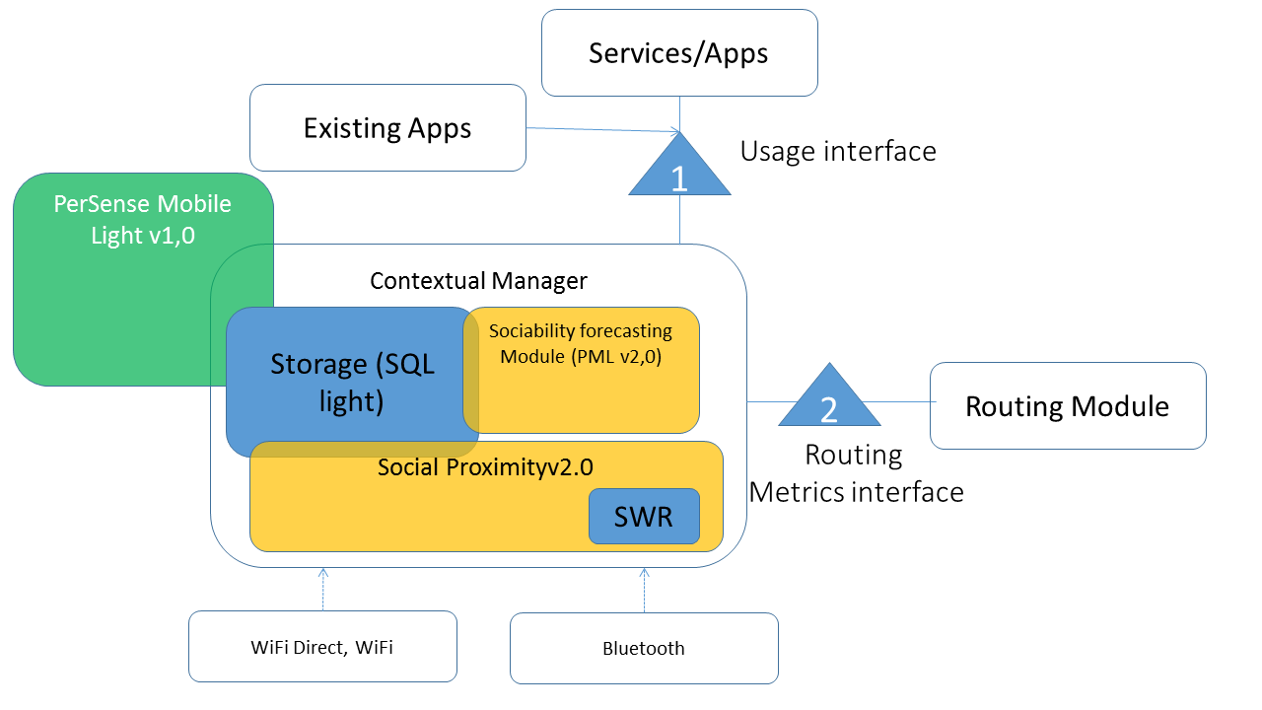
Figure 15 – UMOBILE contextual information module
The contextual information module implemented by the PerSense Mobile Light (PML) software, will be formed by different submodules:
- Contextual manager: This module will be open source and will provide interfaces to other UMOBILE modules.
- Storage: Database that is currently in internal space of PML part of the context manager. The database for multiple input – will be migrated to the contextual manager space.
- Social forecasting module.
- Social Proximity.
The interfaces currently devised are:
- Usage interface (1)
  - Work in progress: provides priorities (user recommendations) derived from usage (internal, apps installed); categories of tastes (learnt over time); etc.
- Routing metrics interface (2)
  - Achieved, social weight (derived from the social proximity module, based on duration of contact)
  - Work in progress: cost based on usage and user contextualization e.g. similarity in time/space routine

INRPP - Flow control
Given the dynamic nature of the considered use-cases, UMOBILE does not rely on the existence of end-to-end flows between communicating parties. Thus, the concept of flowlets is rather interesting, to provide applications with different quality of service mechanisms to allow satisfactory levels for the content being exchanged.
This functional block oversees how flowlets are started between the involved entities as to allow better, QoS-based data exchange and provide special support to in-network caching. It may provide QoS on-demand, by understanding the needs for QoS and making sure the content reaches its recipients respecting the desired QoS levels as much as possible.
However, we consider flow control out of the scope of this deliverable, and we will detail the flow control for UMOBILE in D4.1 and D4.2, with a detailed specification of the proposed rate-regulation scheme.

Service pre-fetching
Service pre-fetching is aimed at providing local services where Internet connectivity is intermittent or broken down. It relies on anticipated service migration to the affected part of the network and is implemented by the modules described below:

Service manager
The Service Manager is responsible for deciding what services to migrate and replicate, when and where to deploy them. For example, it might decide to migrate service_{A} to Service Repository₃. At the heart of the Service Manager is a Decision Engine. The decision engine makes decision about service migration on the basis of the QoS required by each service and monitored parameters that impact their QoS. The QoS requirements are provided by the owner of the services as deployment descriptors with QoS constraints. Similarly, the monitored metrics are provided by a monitoring component.

Monitoring
The monitoring component is responsible for collecting metrics about parameters that impact the QoS and of interest to the Service Manager. It can be realised as a set of monitors deployed to collect metrics about the status of the parameters of interest. Typical examples of QoS parameters are the number of users requesting a given service, load inflicted on existing replicas, performance of replicas, resources of the computer executing the replicas (memory, CPU, disk), network traffic, latency, and so on.

Service repository
The Service Repository is responsible for storing and executing services for the benefit of the end users. Conceptually, it can be implemented as computer with storage and processing facilities, such a Raspberry Pi. The Service Repository is capable and willing to receive compressed images of services from the Service Manager, uncompress, execute them and grant access to end users.

UMOBILE platform WP planning
The UMOBILE services previously specified, as extensions of NDN to provide opportunistic and social communications, are going to be developed in different tasks of the UMOBILE project. These tasks are not all of them part of the WP3 -System and node architecture Development-, on which the UMOBILE platform architecture has been designed. Some of the tasks are part of the WP4 -Services enablement- as well. In the next figure it can be identified what parts of the UMOBILE platform will be developed in the WP3 and what parts of the platform will be developed in WP4, and in which tasks.

Figure 15 – WP Planning
- NDN-Opp: WP3 – Task3.1: Design of a NDN compatible android framework able of making use of a wide variety of opportunistic routing algorithms, being dLife/Scorp the first example; Task 3.3: Development of a novel opportunistic routing algorithm based on social interaction among wireless nodes. (D3.1, D3.2),
- IBR-DTN: WP3 – Task 3.1: DTN overlay design and convergence layers for underlying protocols (D3.1, D3.2).
- KEBAPP: WP3 – Task 3.2: Providing service-abstraction to applications through content-centric approaches (D3.1, D3.2).
- OOCD: WP3 – Task 3.2: Providing service-abstraction to applications through content-centric approaches (D3.1, D3.2).
- Push services: WP3 – Task3.2: Providing service-abstraction to applications through content-centric approaches (D3.1, D3.2).
- Service migration platform: WP3-Task3.2: Providing the mechanisms for Dockerizing and migrating services. (D3.1, D3.2).
- INRPP: WP4 – Task 4.1: Providing different levels of QoS and flow control. (D4.1, D4.2).
- PerSense Light: WP4 – Task 4.2: Data collection and contextual inference (D4.5).
- NREP: WP4 – Task 4.3: Name-Based Replication Priorities (D4.3).
- QoS Decision Engine: WP4-Task 4.1: Providing the algorithms to determine what services to migrate, when and where (D4.4).

Conclusion
In this document, we defined a high level view of the UMOBILE architecture. The proposed architecture aims to deal with the different areas of action defined in the D2.1 document of the UMOBILE project. It integrates the DTN and ICN paradigms into a unified architecture that is able to handle the scenarios envisioned in D2.1. The high-level design discussed in this document, is complemented by a low-level design documented in deliverables D3.1 and D3.2. The final version of the high-level definition of the UMOBILE architecture will be reported in deliverable D3.4.

References
[1] V. Cerf, S. Burleigh, A. Hooke, L. Torgerson, R. Durst, K. Scott,K. Fall, H. Weiss, “Delay-Tolerant Networking Architecture”, IETF RFC 4838, April 2007
[2] George Xylomenos, Christopher N. Ververidis, Vasilios A. Siris, Nikos Fotiou, Christos Tsilopoulos, Xenofon Vasilakos, Konstantinos V. Katsaros, and George C. Polyzos, A Survey of Information-Centric Networking Research. Communications Surveys Tutorials, IEEE, 16(2):, Second 2014.
[3] UMOBILE Project, “D.2.1 - End-User Requirements Report”, Deliverable of the EU UMOBILE Project, Grant 645124; Paulo Mendes, Sotiris Diamantopoulos, Nikos Bezirgiannidis, Ioannis Komnios, Ioannis Psaras, Sergi Rene, Adisorn Lertsinsrubtavee, Arjuna Sathiaseelan, Susana Perez Sanchez, Francisco Almeida, Francesco Amorosa, Giammichele Russi, Angela d’Angelo, Alberto Pineda, Luis Simón Gómez, Marc, 2016. June 2015.
[4] UMOBILE Project, “D2.2 - System and Network Requirements Specification”, Deliverable of the EU UMOBILE Project, Grant 645124; Paulo Mendes, Sotiris Diamantopoulos, Nikos Bezirgiannidis, Ioannis Komnios, Ioannis Psaras, Sergi Rene, Adisorn Lertsinsrubtavee, Arjuna Sathiaseelan, Susana Perez Sanchez, Francisco Almeida, Francesco Amorosa, Giammichele Russi, Angela d’Angelo, Alberto Pineda, Luis Simón Gómez, Marc, 2016.
[5] K. Scott and S. Burleigh. Bundle Protocol Specification. RFC 5050 (Experimental), 2007.
[6] Information-Centric Networking (ICN) Research Challenges D. Kutscher, S. Eum, K. Pentikousis, I. Psaras, D. Corujo, D. Saucez, T. Schmidt, M. Waehlisch . July 2016. (DOI: 10.17487/RFC7927)
[7] G. Tyson, J. Bigham, and E. Bodanese, “Towards an information-centric delay-tolerant network," in Proceedings of IEEE INFOCOM Workshop on Emerging Design Choices in Name-Oriented Networking (NOMEN), 2013.
[8] Networking Named Content by V. Jacobson, D. K. Smetters, J. D. Thornton, M. F. Plass, N.H. Briggs, R.L. Braynard. CoNEXT 2009, Rome, December, 2009.
[9] G. Xylomenos, X. Vasilakos, C. Tsilopoulos, V. A. Siris and G. C. Polyzos, "Caching and mobility support in a publish-subscribe internet architecture," in IEEE Communications Magazine, vol. 50, no. 7, pp. 52-58, July 2012.
doi: 10.1109/MCOM.2012.6231279
[10] Teemu Koponen, Mohit Chawla, Byung-Gon Chun, Andrey Ermolinskiy, Kye Hyun Kim, Scott Shenker, and Ion Stoica. 2007. A data-oriented (and beyond) network architecture. SIGCOMM Comput. Commun. Rev. 37, 4 (August 2007), 181-192. DOI=http://dx.doi.org/10.1145/1282427.1282402
[11] D. Kutscher, S. Farrell, and E. Davies. The NetInf Protocol. Internet-Draft draft-kutscher-icnrg-netinf-proto, Internet Engineering Task Force, October 2012. Work in progress.
[12] W. K. Chai et al., "Curling: Content-ubiquitous resolution and delivery infrastructure for next-generation services," in IEEE Communications Magazine, vol. 49, no. 3, pp. 112-120, March 2011.
doi: 10.1109/MCOM.2011.5723808
[13] Information-Centric Networking (icnrg). https://datatracker.ietf.org/rg/icnrg/charter/
[14] Ioannis Psaras, Richard G. Clegg, Raul Landa, Wei Koong Chai, and George Pavlou. 2011. Modelling and evaluation of CCN-caching trees. In Proceedings of the 10th international IFIP TC 6 conference on Networking - Volume Part I (NETWORKING'11), Jordi Domingo-Pascual, Pietro Manzoni, Ana Pont, Sergio Palazzo, and Caterina Scoglio (Eds.), Vol. Part I. Springer-Verlag, Berlin, Heidelberg, 78-91.
[15] I. Psaras, W. K. Chai and G. Pavlou, "In-Network Cache Management and Resource Allocation for Information-Centric Networks," in IEEE Transactions on Parallel and Distributed Systems, vol. 25, no. 11, pp. 2920-2931, Nov. 2014.
doi: 10.1109/TPDS.2013.304
[16] Wei Koong Chai, Diliang He, Ioannis Psaras, and George Pavlou. 2012. Cache "less for more" in information-centric networks. In Proceedings of the 11th international IFIP TC 6 conference on Networking - Volume Part I (IFIP'12), Robert Bestak, Lukas Kencl, Li Erran Li, Joerg Widmer, and Hao Yin (Eds.), Vol. Part I. Springer-Verlag, Berlin, Heidelberg, 27-40. DOI=http://dx.doi.org/10.1007/978-3-642-30045-5_3
[17] Cheng Yi, Jerald Abraham, Alexander Afanasyev, Lan Wang, Beichuan Zhang, and Lixia Zhang. 2014. On the role of routing in named data networking. In Proceedings of the 1st ACM Conference on Information-Centric Networking (ACM-ICN '14). ACM, New York, NY, USA, 27-36. DOI: http://dx.doi.org/10.1145/2660129.2660140
[18] V. Sourlas, L. Tassiulas, I. Psaras and G. Pavlou, "Information resilience through user-assisted caching in disruptive Content-Centric Networks," IFIP Networking Conference (IFIP Networking), 2015, Toulouse, 2015, pp. 1-9.
doi: 10.1109/IFIPNetworking.2015.7145301
[19] Gareth Tyson, Nishanth Sastry, Ivica Rimac, Ruben Cuevas, and Andreas Mauthe. 2012. A survey of mobility in information-centric networks: challenges and research directions. In Proceedings of the 1st ACM workshop on Emerging Name-Oriented Mobile Networking Design - Architecture, Algorithms, and Applications (NoM '12). ACM, New York, NY, USA, 1-6. DOI=http://dx.doi.org/10.1145/2248361.2248363
[20] Y. T. Yu, J. Joy, R. Fan, Y. Lu, M. Gerla and M. Y. Sanadidi, "DT-ICAN: A Disruption-Tolerant Information-centric Ad-Hoc Network," 2014 IEEE Military Communications Conference, Baltimore, MD, 2014, pp. 1021-1026.
doi: 10.1109/MILCOM.2014.174
[21] M. Amadeo, C. Campolo, A. Iera and A. Molinaro, "Named data networking for IoT: An architectural perspective," Networks and Communications (EuCNC), 2014 European Conference on, Bologna, 2014, pp. 1-5.
doi: 10.1109/EuCNC.2014.6882665
[22] Fog Computing and the Internet of Things: Extend the Cloud to Where the Things Are. Cisco White Paper. Available at: https://www.cisco.com/c/dam/en_us/solutions/trends/iot/docs/computing-overview.pdf
[23] I.Psaras, L. Saino, M. Arumaithurai, K. K. Ramakrishnan and G. Pavlou, Name-‐ Based Replication Priorities in Disaster Cases., 2nd Workshop on Name Oriented Mobility (NOM 2014) in conjunction with the IEEE INFOCOM, Toronto, Canada, 2014.
[24] Van Jacobson, Diana K. Smetters, Nicholas H. Briggs , Michael F. Plass, Paul Stewart, James D. Thornton, Rebecca L. Braynard, “VoCCN: voice-over content-centric networks”, in Proc. of international workshop on re-architecting the internet, Rome, Italy, December 2009.
[25] C. Tsilopoulos and G. Xylomenos, “Supporting Diverse Traffic Types in Information Centric Networks, ” in Proceedings of the ACM SIGCOMM workshop on Information-centric networking, Toronto, Canada, Aug. 2011, pp. 13.
[26] NDN HttpProxy. https://github.com/nameddata/ndnx/tree/master/apps/HttpProxy
[27] What is Docker?, Docker Home page (www.docker.com/what-docker) visited in Nov 2016.
[28] Mathijs Jeroen Scheepers “Virtualization and Containerization of Application Infrastructure: A Comparison", "In Proc. 21st Twente Student Conference on IT", 2014.
[29] ccnd 0.7.2 forwarding strategy http://redmine.named-data.net/projects/nfd/wiki/CcndStrategy
[30] Waldir Moreira, Paulo Mendes, "Social-aware Opportunistic Routing: The new trend", Springer Book on Routing in Opportunistic Networks, ISBN 978-1-4614-3513-6, August 2013.
[31] Waldir Moreira, Manuel de Souza, Paulo Mendes, Susana Sargento, "Study on the Effect of Network Dynamics on Opportunistic Routing", in Proc. of AdhocNow, Belgrade, Serbia, July 2012
[32] Waldir Moreira, Paulo Mendes, "Pervasive Data Sharing as Enabler for Mobile Citizen Sensing Systems", IEEE Communications Magazine, October 2015.
[33] Waldir Moreira, Paulo Mendes, Susana Sargento, "Social-aware Opportunistic Routing Protocol based on User's Interactions and Interests", in Proc. of AdhocNets, Barcelona, Spain, October 2013.
[34] Luis Amaral Lopes, Rute C. Sofia, Paulo Mendes, Waldir Moreira, "Oi! - Opportunistic Data Transmission Based on Wi-Fi Direct" in Proc. of IEEE INFOCOM, San Francisco, USA, April 2016.
[35] Waldir Moreira, Paulo Mendes, Susana Sargento, "Opportunistic Routing based on daily routines", in Proc. of IEEE WoWMoM workshop on autonomic and opportunistic communications, San Francisco, USA, June, 2012.
[36] IEEE Standard 802.11u, "IEEE Standard for Information Technology-Telecommunications and information exchange between systems-Local and Metropolitan networks-specific requirements-Part II: Wireless LAN Medium Access Control (MAC) and Physical Layer (PHY) specifications: Amendment 9: Interworking with External Networks," 2011.
[37] D. Camps-Mur et al., "Enabling always on service discovery: Wifi neighbor awareness networking," in IEEE Wireless Communications, April 2015.

