Action full title:
Universal, mobile-centric and opportunistic communications architecture
Action acronym:
UMOBILE



Deliverable:
D2.2 “System and Network Requirements Specification”
Project Information:
Project Full Title | Universal, mobile-centric and opportunistic communications architecture
Project Acronym | UMOBILE
Grant agreement number | 645124
Call identifier | H2020-ICT-2014-1
Topic | ICT-05-2014 Smart Networks and novel Internet Architectures
Programme | EU Framework Programme for Research and Innovation HORIZON 2020
Project Coordinator | Prof. Vassilis Tsaoussidis, Democritus University of Thrace
Deliverable Information:
Deliverable Number-Title | D2.2 System and network requirement specification
WP Number | WP2
WP Leader | Arjuna Sathiaseelan
Task Leader (s) | Paulo Mendes
Authors | COPELABS: Paulo Mendes, Waldir Moreira  DUTH: Sotiris Diamantopoulos, Nikos Bezirgiannidis, Ioannis Komnios  UCL: Ioannis Psaras, Sergi Rene  UCAM: Adisorn Lertsinsrubtavee, Arjuna Sathiaseelan  TECNALIA: Susana Perez Sanchez  TEKEVER: Francisco Almeida  AFA: Francesco Amorosa, Giammichele Russi, Angela d’Angelo  FON: Alberto Pineda, Luis Simón Gómez
Contact | Paulo Mendes: paulo.mendes@ulusofona.pt
Due date | M14: 31/03/2016
Actual date of submission | 31/03/2016

Dissemination Level:
PU | Public | x
CO | Confidential, only for members of the consortium (including the Commission Services)
CI | Classified, as referred to in Commission Decision 2001/844/EC

Document History:
Version | Date | Description
Version 0.1 | 06/07/15 | First draft for alignment with D2.1 and allocation of contributions
Version 0.2 | 16/07/2015 | Revised first version with updated table of content based on feedback
Version 0.3 | 28/09/2015 | First version of assumptions/requirements (for each use-case and overall)
Version 0.4 | 13/10/2015 | Second version of assumptions/requirements (for each use-case and overall)
Version 1.0 | 23/03/2016 | Final version of assumptions/requirements (for each use-case and overall)

Table of Contents

Table of Contents 3
List of Definitions 4
Executive Summary 6
1 Introduction 7
2 UMOBILE Areas of Action 8
3 Applicability Scenarios 10
3.1 Micro-blogging Function Scenario 10
3.1.1 Description 11
3.1.2 Actors of the Application Scenario 13
3.1.3 Assumptions 13
3.1.4 Requirements 13
3.2 Emergency Situation Scenario 14
3.2.1 Description 15
3.2.2 Actors of the Application Scenario 17
3.2.3 Assumptions 17
3.2.4 Requirements 17
3.3 Civil Protection Scenario 18
3.3.1 Description 19
3.3.2 Actors of the Application Scenario 20
3.3.3 Assumptions 21
3.3.4 Requirements 21
3.4 Social Routine Improvement Scenario 22
3.4.1 Description 22
3.4.2 Actors of the Application Scenario 24
3.4.3 Assumptions 25
3.4.4 Requirements 25
4 Overall UMOBILE Assumptions and Requirements 26
4.1 Overall Assumptions 26
4.2 Overall Requirements 27
5 Conclusion 30
References 31

List of Definitions
Term | Meaning
DTN | Delay Tolerant Network (DTN) is an emerging technology that supports interoperability of other networks by accommodating long disruptions and delays between and within those networks. DTN operates in a store-and-forward fashion where intermediate node can temporarily keep the messages and opportunistically forward them to the next hop. This inherently deals with temporary disruptions and allows connecting nodes that would be disconnected in space at any point in time by exploiting time-space paths.
ICN | Information-Centric Networking (ICN) supports efficient delivery of both content and services by identifying information by name rather than the actual location. This decoupling of the information from its actual location breaks the need for end-to-end connectivity thus enabling much wider flexibility for efficient content and service retrieval. ICN also inherently supports caching thus enabling much better localised communications.
Data | Data is raw. Data is numbers that have no interpretation. In UMOBILE, data is the output of sensors (e.g. positions, activity, sound, wireless proximity).
Information | Information is about understanding what the data is telling us. It provides an understanding about what is happening to users so we can make it easier for them to get the content they need when they need it. In UMOBILE, information is the output of inference processes (e.g. affinity networks, roaming patterns, social isolation, crowd detection), which maybe performed over different types of data (data fusion).
Content | Content is digestible forms of information. In UMOBILE, content refers to a piece of digital information that is disseminated and consumed by end-users.
User | An entity (individual or collective) that can be a consumer, a producer or a relay of content.
Service | A set of mechanisms that assists in incorporating information about mobile users in order to optimize the overall system. A service refers to a computational operation running on the network. Services (e.g. data fusion) can be hosted and computed in some specific nodes such as surrogates or gateways.
Interest | A parameter capable of providing a measure (cost) of the “attention” of a user towards a specific content in a specific time instant. Users can cooperate and share their interests.
Upstream | Upstream traffic refers to data that the user equipment sends to the network.
Downstream | Downstream traffic refers to data that the user equipment gets from network.
Gateway | Equipment installed at the edge of a network. It is a software functionality, which reflects an operational behaviour making a UMOBILE device capable of acting as a mediator between UMOBILE systems and non-UMOBILE systems.
Surrogate | Device with large storage and computational capability, able to store services and contents to subsequently provide local access communication.
Customer Premises | Customer Premises relate to residential households and enterprise market and are, as of today, controlled by the end-user.
User-centric | User-centric refers to a new paradigm that leverages user information at large to deliver novel content or services by users towards other users.
UMOBILE System | UMOBILE System refers to an open system that provides communication access to users through wired or wireless connectivity. This system exploits the benefit of local communication to minimize upstream and downstream traffic. The services or content can be exchanged and stored in several devices such as surrogates; user equipment; customer premises equipment such as Wi-Fi Access Points in order to efficiently delivery the desired contents or services to end-users.
UMOBILE Architecture | A mobile-centric opportunistic architecture that efficiently delivers content to the end-users. The UMOBILE architecture integrates the principles of Delay Tolerant Networks (DTN) and Information-Centric Networks (ICN).
User-equipment | Generic user terminal. In terms of operating systems we consider mainly smartphones equipped with Android; notebooks with UNIX, Windows, Mac OS.
Social Trust | Trust which builds upon associations of nodes and is based on the notion of shared interests; individual or collective expression of interests; affinities between end-users.
Application | Computer software designed to perform a single or several specific tasks, e.g. a calendar and map services. In UMOBILE, context-aware applications are considered.
User Requirement | User requirement corresponds to the specifications that users expect from the application, device or network.
Incentive | A factor (e.g., economic or sociological) that motivates a particular action or a preference for a specific choice.
UAV | Unmanned Aerial Vehicle, which is an aircraft with no pilot on board.

Executive Summary
This document covers system and network requirements (described based on RFC2119 notation), as well as assumptions, for the high-level design of the UMOBILE architecture. A first version is provided on M18, while a refined description of system requirements, assumptions will be provided on M30, as deliverable D2.3.
The final goal is to identify the overall requirements and assumptions of the UMOBILE framework, which will be devised based on the detailed analysis of the four applicability pictures described in D2.1.
Special attention is given to the needed alignment with the Delay-Tolerant Networking (DTN) architecture [1], and the most relevant proposal for an information-centric networking architecture (ICN) [2] that fits the identified UMOBILE system and the network requirements.
The starting point for this report is deliverable D2.1 [3], which describes typical accessibility scenarios in different environments, namely, urban, remote and disaster areas, as well as requirements from the end-user perspective.
The methodology used to devise deliverable D2.2 is as follows:
- Derive the system and network requirements from the applicability scenarios identified in D2.1, and, then,
- Identity the overall system requirements and assumptions that will drive UMOBILE functionality in any of the identified applicability pictures.

Introduction
The main objective of UMOBILE is to develop a mobile-centric service oriented architecture that efficiently delivers content/service to the end-users. The UMOBILE decouples services from their origin locations, shifting the host-centric paradigm to a new paradigm, one that incorporates aspects from both information-centric and opportunistic networking with the ultimate purpose of delivering an architecture focused on: i) improving aspects of the existing infrastructure (e.g., keeping traffic local to lower OPEX); ii) improving the social routine of Internet users via technology-mediated approaches.
UMOBILE aims to push network services (e.g., mobility management, intermittent connectivity support) and user services (e.g., pervasive content management) as close as possible to the end-users. By pushing such services closer to the users, we can optimize, in a scalable way, aspects such as bandwidth utilization and resource management. We can also improve the service availability in challenged network environments. For example, users in some areas may suffer from intermittent and unstable Internet connectivity when they are trying to access the services.
The document is organized as follows.
- Section 2 revisits the applicability areas of UMOBILE, described in D2.1.
- Section 3 provides a description of the identified applicability cases, detailing for each case the main actors; type of equipment involved; assumptions; requirements.
- Section 4 summarizes the overall system and network assumptions and requirements needed to fulfil all the selected applicability cases.

UMOBILE Areas of Action
UMOBILE focuses on three specific types of areas, namely: urban, remote, and disaster areas, as explained next.
The urban area typically refers to an area wherein the network infrastructure is well connected. Users can directly connect to various networks such as mobile Internet 3G/4G on the street, Wi-Fi hotspots in the town and fibber/cable Internet at home. In such urban scenarios, UMOBILE considers the following:
- The network topology tends to be dense, due to the deployment of cellular network, small-cells and Wi-Fi.
- There may be clusters of devices with strong interference.
- Environments are user-centric [4][5], i.e., nodes correspond in their majority to end-user devices carried by humans and therefore, exhibit roaming movement patterns that share features of human mobility.
- Some user services may be stored closer to/in end-user devices (e.g., content).
- User behaviour is very dynamic (i.e. users move and interact according to social ties [6], interests [7]) imposing increased challenges (lack of end-to-end paths) to content/service exchange [8][9].
The remote area typically refers to a vast geographical area having only intermittent network connectivity (e.g., a national forest, an isolated island, a rural village). In remote areas, UMOBILE assumes that the Internet access conditions are limited, e.g., limited bandwidth of upstream and downstream. It is also assumed that a gateway at the remote area can request the services/content and cache them whenever network connectivity is available. As a result, users can continue to use the services during the periods of offline connectivity, since the services are locally cached and available [10]. Furthermore, the UMOBILE system aims to utilize the potential of opportunistic and delay tolerant networking allowing service requests and responses to be passed through intermediate nodes (serving as the data mules) until reaching the hosted service nodes and the end-users. The intermediate node can be a device carried by a user in a car between e.g. a remote area and an urban area; UAVs flying around these areas; a car itself. Hence, within this context, UMOBILE takes into account that:
- The network topology tends to be sparse, and the network should be self-organized aiming to ensure a high probability of connectivity.
- The network exhibits partitions (in time and space).
- Environments are user-centric.
- Some user services can be stored in surrogate nodes.
- A gateway can be considered as a mobile gateway moving across different locations.
- Only few end-user devices will be part of the network and hold networking services.
- Content/service may be exchanged based on users social engagement and interests to improve the utilisation of scarce resources.
In a disaster area, the actual network infrastructure is partially or fully disrupted. UMOBILE takes advantage of available Internet access technologies, e.g., 3G/4G, ad-hoc wireless deployment; Wi-Fi hotspots; satellite links. Furthermore, rescue operation teams can install ad-hoc UMOBILE hotspots across the disaster area and also use UAVs equipped with Wi-Fi to create local network infrastructure. As a consequence, UMOBILE users are able to retrieve emergency services and communicate to other users. Considerations for this scenario are:
- The network is self-organizing.
- The network is divided to partitions and each partition may have intermittent connectivity.
- There are both fixed and mobile gateways.
- Some end-user devices will be part of the network and hold networking services, e.g., shared Internet access.
- Different social groups (e.g., doctor, police, emergency teams, civilians) and interests on disaster-relief content can help mitigating the effects of lack of readily available infrastructure. Users have a humanitarian behaviour.
Considering that UMOBILE integrates delay tolerant networking/opportunistic networking as an inherent feature, it is mandatory to support reliable and efficient transmission of information.

Applicability Scenarios
The diversity of possible services in UMOBILE is illustrated in this section via four main applicability scenarios: micro-blogging, emergency situation, civil protection and social routine improvement. These applicability scenarios are mapped to the requirements of the three main areas described in section 2.

Micro-blogging Function Scenario
The micro-blogging UMOBILE use-case allows users to generate and share expressions of interest in the form of tagged information (time-space tag correlated with data timely and, in some cases, geographic meaningfulness) to the UMOBILE system where all UMOBILE users can benefit from the local information such as an interesting event, recommended place and social interaction activities. The sharing policy of such information is based on the dynamic computation of social trust circles [11] and event subscriptions defined by users and/or recommended by the system. Particularly, the UMOBILE users are able to exchange and share information, e.g., photos, videos, social text comments among the contacts in their trust circles. User devices do not have to be always connected to the Internet. Data is exchanged among people passing by, based on social interaction approaches. Local hotspots may store data based on its local meaningfulness. Such data may be further disseminated among other peering hotspots in the city.
The UMOBILE system keeps track of local events and provides updated information (pushed or pulled) to subscribed users. This information can be referred to the availability of some form of service, as well as user experience and user perception shared among users.
Therefore, a micro-blogging service exploits the potential context-aware computing to provide useful information to the user at the right time. For instance, a user that has posted interest in an art exhibition at a local gallery will automatically receive some useful information such as available car parking places, number of available tickets and users’ comments about this exhibition when he/she moves close to the place.
Moreover, in crowded events, such as a music festival, the UMOBILE system can monitor the activity of the assistants in the different areas where the event is taking place. The management can use this information, for example, to control the position of the staff in different areas.
In addition, the UMOBILE system is an open system, compatible with other social applications. In case the requested service is not available in the domain, the UMOBILE system can automatically retrieve a service instance and instantiate it within the domain to achieve local communication. Regarding retrieving and disseminating information, the UMOBILE system takes advantage of all available connectivity (e.g., wired or wireless) and intelligently chooses the most suitable transmission protocol depending on the network environment.

Description
It is Saturday morning and Bob decides to go out for shopping: in the afternoon Bob will drive to Glastonbury with his friends to attend the music festival. Since Bob does not want to spend too much time shopping, he uses the UMOBILE micro-blogging functionality in his android smartphone, while entering Oxford street, to get information from other wireless devices about nearby sales (Figure 1). While strolling between some shops, he registers to micro events that take place in the area (e.g., interesting articles, street events).
In the afternoon, Bob picks up his friends to go to Glastonbury. Three blocks from the Tate gallery his UMOBILE application gets a notification about the availability of tickets for an exhibition from Salvador Dali that he had posted interest 2 days before. Bob gets a reliable information: the waiting time in the ticket office is lower than 20 minutes, he and his friends decide to make a stop over to visit the exhibition at Tate Gallery. Since parking is very difficult around Tate gallery, Bob uses the UMOBILE application to identify, as fast as possible, the best streets to park, based on the experience of other people in his trust circles. On the way to Glastonbury, Bob drives by an accident on M3: he posts the event on the UMOBILE application. Due to the local importance of his post, data is collected by a nearby wireless hotspot. The hotspot disseminates collected data to other hotspots that subscribed traffic-jam events on the UMOBILE application: this allows other Micro-blogging users to avoid M3 on that area (Figure 2).
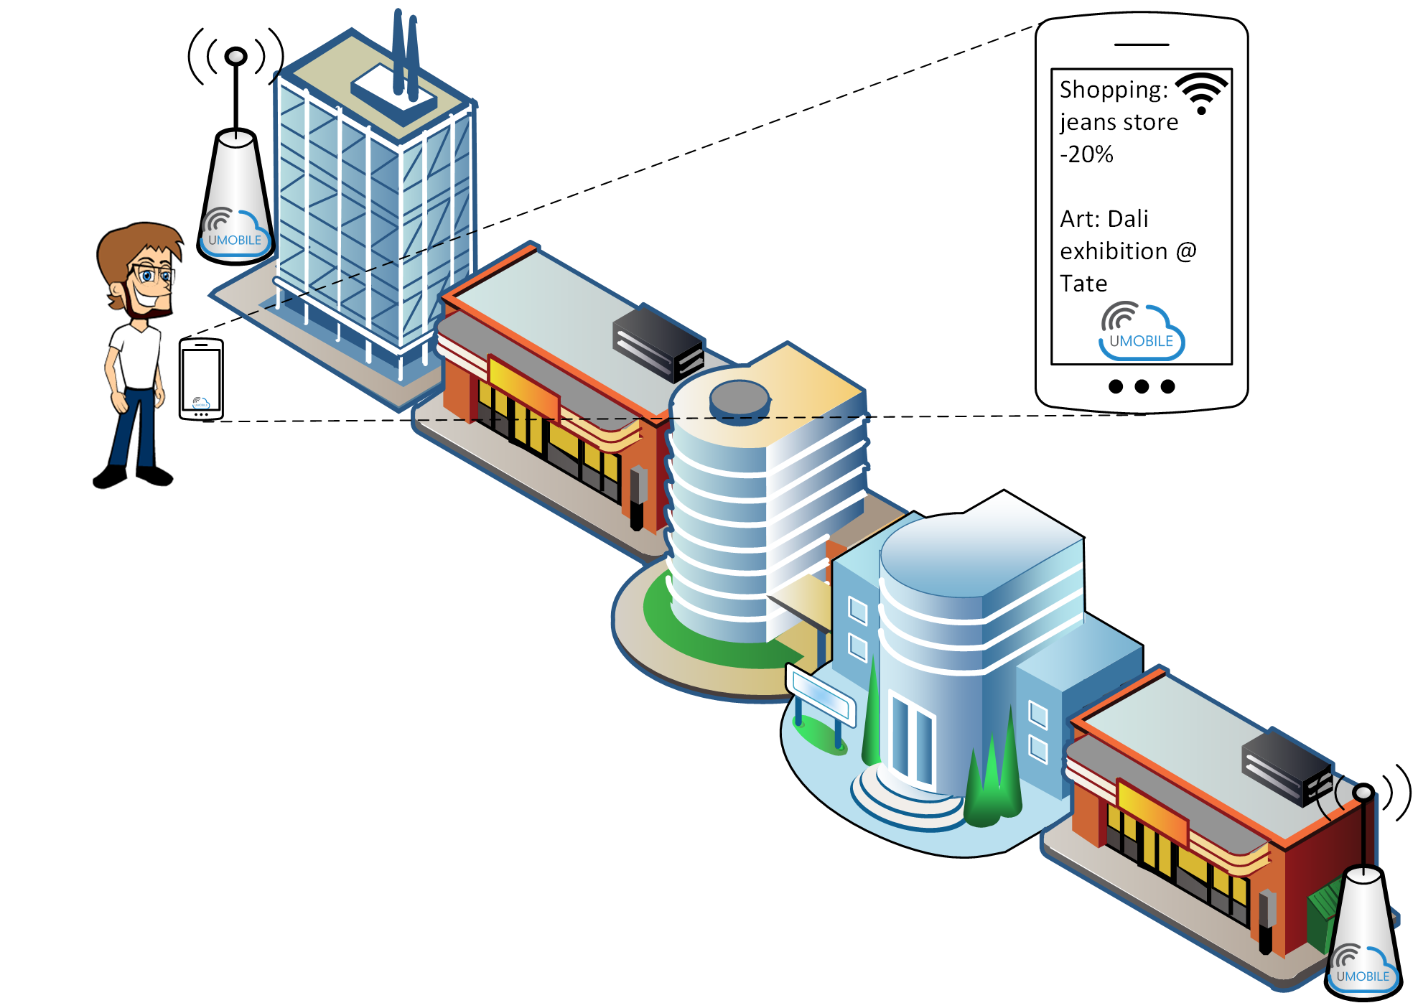
Figure 1. Micro-blogging scenario: Context-aware information retrieval
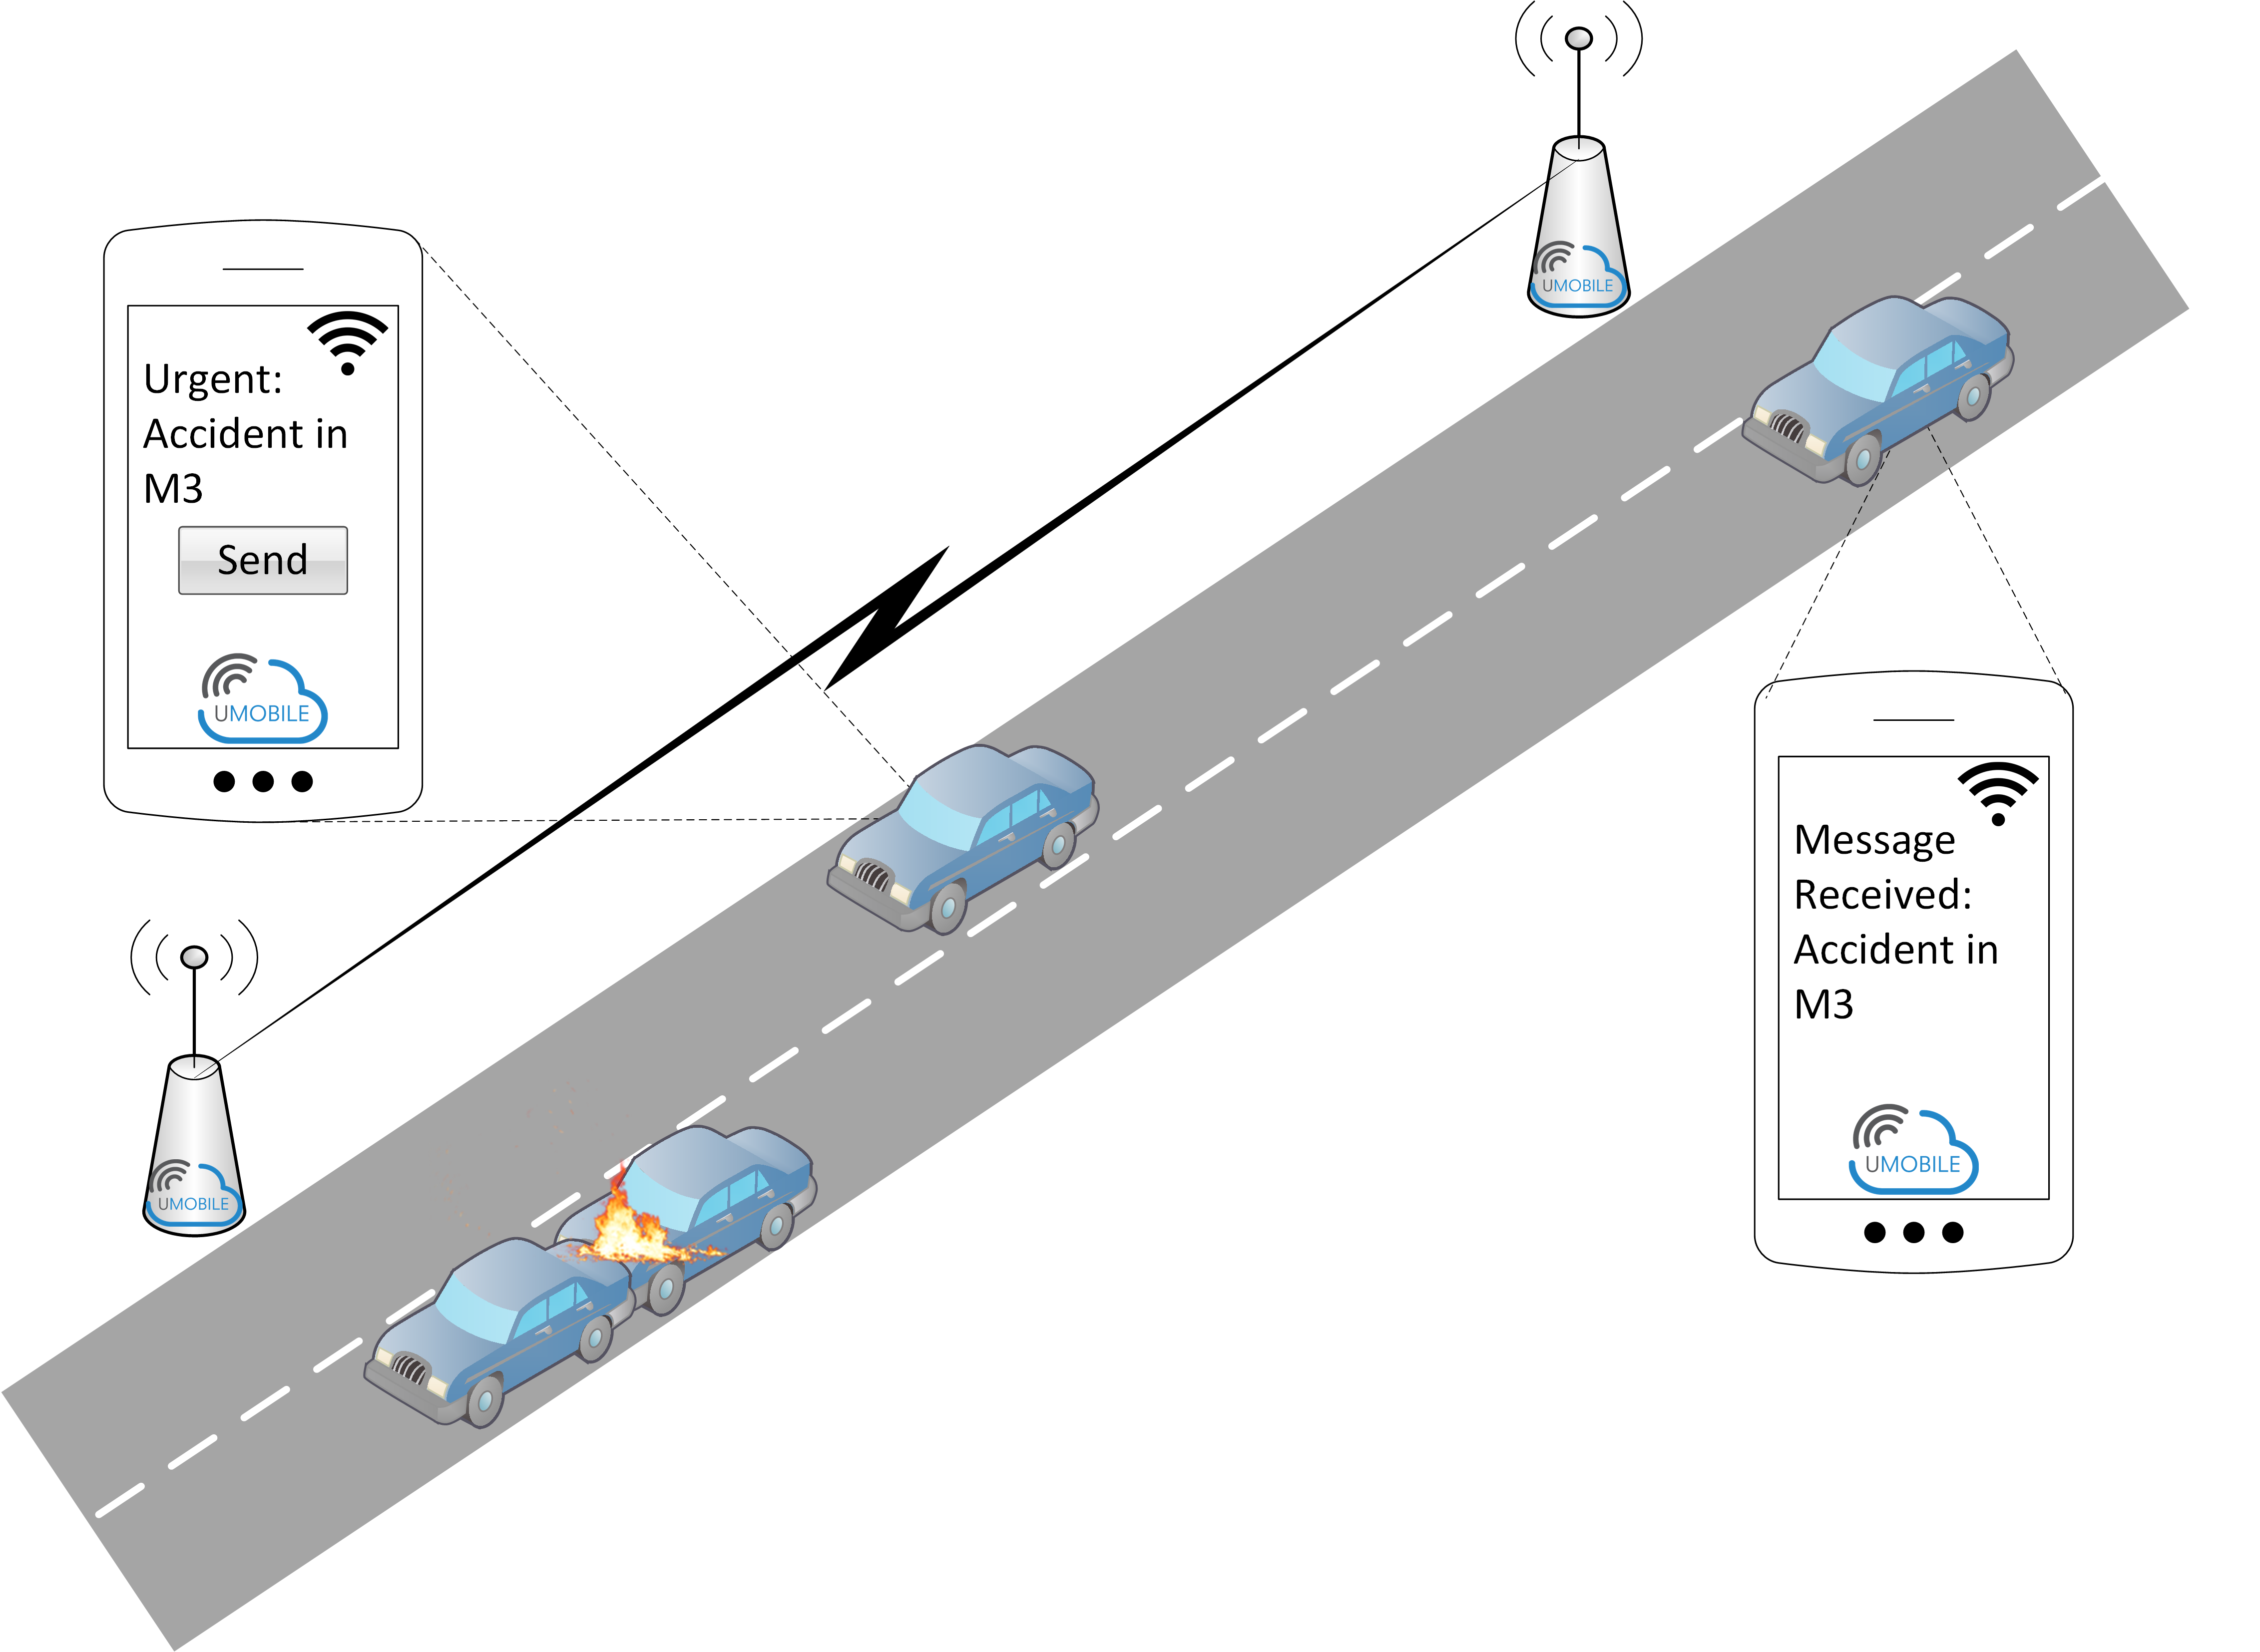
Figure 2. Micro-blogging scenario: Accident warning
In the festival area, the UMOBILE system has been deployed in order to provide free Wi-Fi local communications to music fans. The UMOBILE UAVs circulate between the different activity areas to record images about the festival. After enjoying the Radiohead concert in the festival main stage, Bob does not find the next artist interesting. In the meantime, his friend, Alice, is in a secondary stage where a not well-known group has the audience really motivated. Alice posts a message of the status and a picture through UMOBILE. The notification is made available for the rest of the people in the festival area, both through hotspots and through UAVs. Since Bob had subscribed high interest about Alice’s posts (they have similar music tastes) he can see through the notifications which area is most interesting for him at this given time and does not have to walk to a new area to find something he dislikes. In the meantime, the management of the festival can monitor the activity in each of the areas in real time, or whether participants are unhappy based on the images provided by the UMOBILE UAVs: the management uses such information to control the way the staff is positioned in the surrounding area. This local event communication scenario is illustrated in Figure 3.
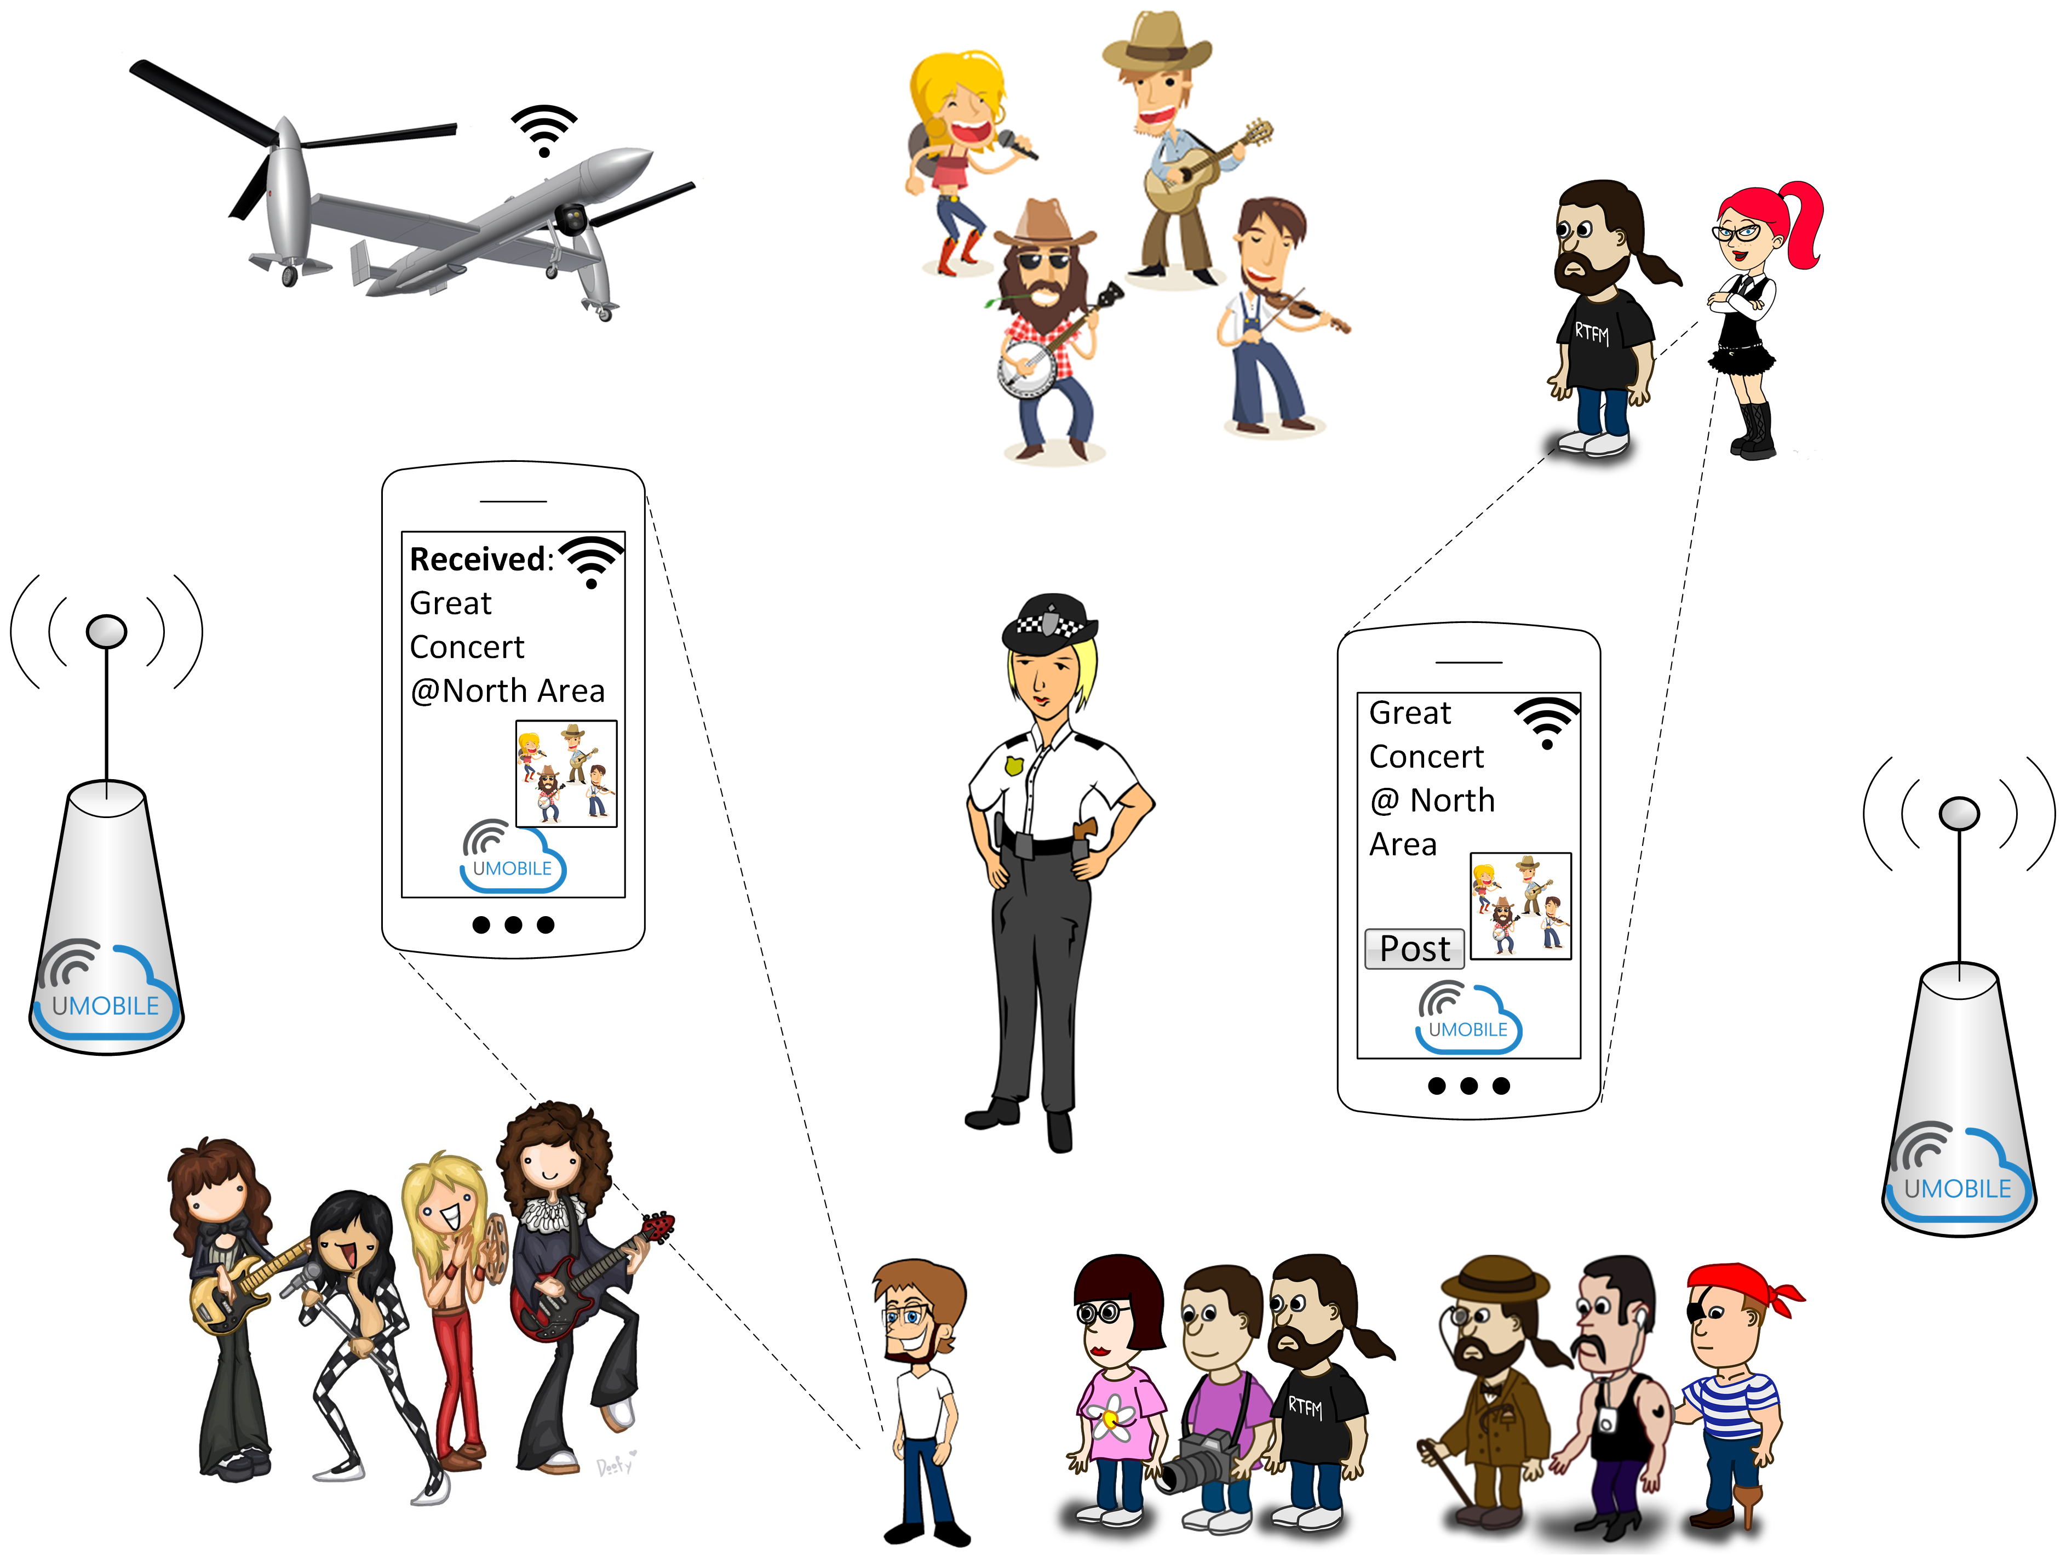
Figure 3. Micro-blogging scenario: Local event communication

Actors of the Application Scenario
- UMOBILE-enabled mobile devices (i.e., smartphone, tablet)
- UMOBILE-enabled hotspots are able to collect and relay relevant information (e.g., road accident, local events)
- UMOBILE-enabled hotspots are able to execute the services locally.
- UMOBILE-enabled surrogates are able to store collected data, check its validity and perform computational functions (e.g. data fusion) to increase the value of information.
- UMOBILE-enabled UAVs able to collect and relay relevant information

Assumptions
- UMOBILE is to be implemented in mobile devices (e.g. smartphones), hotspots, and UAVs, which have limited local storage capabilities.
- UMOBILE is to be implemented in surrogates with significant computational, storage and power capabilities.
- UMOBILE surrogates can be collocated with hotspots or embedded in hotspots.
- UMOBILE systems are able to communicate via wireless (Wi-Fi access networks; Wi-Fi direct; Bluetooth).
- UMOBILE systems may be equipped with sensing capabilities (e.g. accelerometer, microphone, wireless interface, bluetooth interface, temperature, barometer)
- Internet connectivity may be intermittent.

Requirements
- UMOBILE gateways MUST be able to convert the ICN traffic to traditional IP packet format and vice versa.
- UMOBILE systems MUST be able to exchange data also based on users’ trust circles, built upon their interaction in the system, ensuring user privacy in dynamic networking scenarios.
- UMOBILE systems MUST be able to exchange data by exploiting every communication opportunity (in this case by Wi-Fi – structured or Wi-Fi direct), among UMOBILE systems (mobile devices, access points and UAVs).
- UMOBILE systems MUST be able to exchange data also taking into account users’ data interests and context.
- UMOBILE systems MUST have an interface to support the following applications: Chat; File exchange/synchronization; Content request/publish.
- UMOBILE systems MUST be able to ensure data reliability and availability (e.g. taking into account data usefulness - time to live; ensuring that data is not changed within the system; manage duplicated pieces of information).
- UMOBILE systems MUST be able to provide certain services to the end users when there is no Internet connectivity.
- UMOBILE systems SHOULD be able to exchange data by exploiting every communication opportunity between UMOBILE systems and non-UMOBILE systems.
- UMOBILE systems SHOULD be able to pre-fetch data in order to improve service performance, based on on users’ interests (e.g., parking places near recommended art gallery) and behaviour (e.g. mobility patterns), in order to reduce delays in data delivery.
- UMOBILE mobile systems SHOULD be able to sense user context (geo-location, relative location, proximity, social interaction).
- UMOBILE systems SHOULD be able to perform data fusion, increasing the value of shared information (e.g. the notification that a user gets about the best music stage in a music festival can be derived from the analysis of two types of data: music preference; crowd situation).
- UMOBILE system SHOULD be able to provide users only with information that match their interests (e.g. art exhibitions).
- UMOBILE systems SHOULD be compatible with existing applications.
- UMOBILE systems MAY allow users to manage their trust circles.
- UMOBILE systems MAY be able to sense user surroundings (crowds, environmental, noise level).

Emergency Situation Scenario
In emergency situations, traditional communication services such as fixed or mobile networks and local Internet access are completely/partially inoperable. Therefore, the design of the UMOBILE system is expected to assist users in disseminating emergency information directly via end-user devices as well as via the UMOBILE hotspots and UAVs. Such emergency information can be shared among UMOBILE users and also forwarded to the local authorities (e.g., fireman, rescue teams).
In such cases, information shall comprise expression of interests in the form of photos, voice or short messages. It is also expected to comprise alert messages concerning public safety. However, considering the limited bandwidth connectivity, emergency services will have higher priority over other services [12].
Hence, UMOBILE applications shall have an emergency functionality that allows the user to take photos and describe events with a short voice or short message, and whenever feasible, integrate geo-location as well as social interactions (e.g., to assist in looking for other persons). The data is expected to be forwarded via any means of connectivity: short-range between end-user devices, such as by using Bluetooth and Wi-Fi direct; long-range, via available types of Internet access, such as Wi-Fi access points and 3G. The usage of 3G may depend on user willingness to pay for cellular services, if available.

Description
It is Monday morning and Bob goes for mountain climbing, as usual. While trying the usual path, Bob starts to see some smoke in the vicinity of the path. He uses his UMOBILE application to take some photos, tagging the event with a short voice or short message. Geo-location is automatically added. As illustrated in Figure 4, Bob tags that info as “urgent” and makes it available to be shared globally, as he has no cellular coverage.
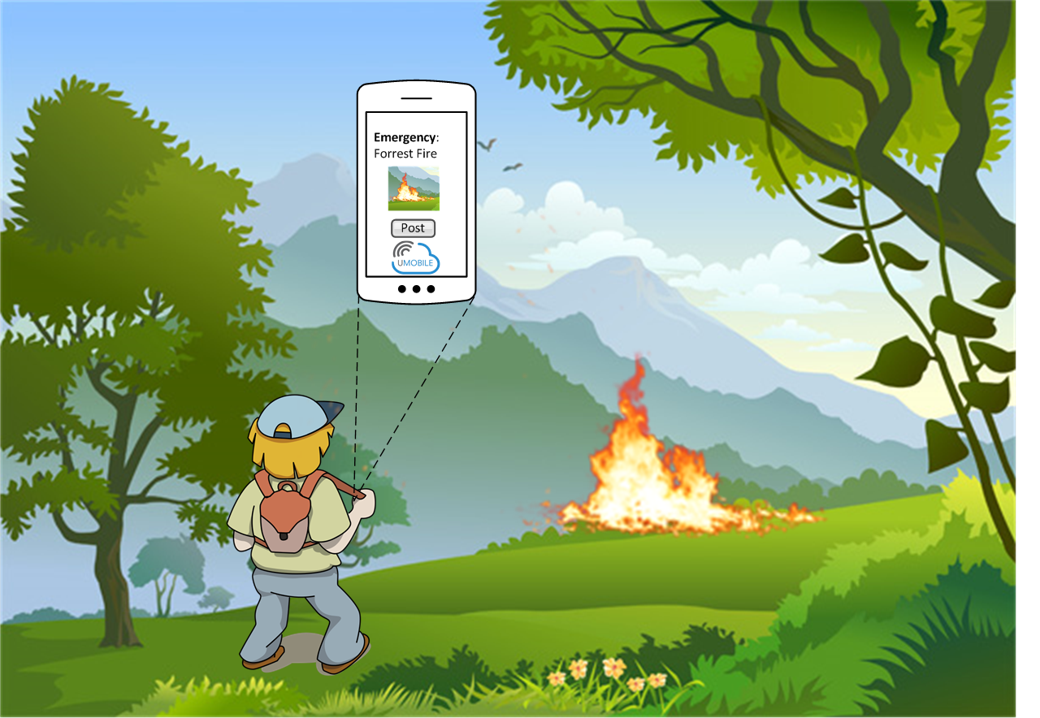

Figure 4. Emergency scenario: Emergency message tagging
After that, Bob decides to continue his trekking exercise in an alternative path close to main roads, where he passes by several cars. Drivers, including Henry, are UMOBILE users, whose app collects any emergency info by default, after checking its authenticity (Figure 5). Henry drives towards home. As soon as Henry enters the city limits he is notified by his smartphone that he gained some points within the UMOBILE community since he just participated in an emergency situation: his smartphone passed the message towards an authorized emergency entity via UMOBILE system using all potential access technologies, e.g., whenever 3G was present. Upon reception of such message, a team of fire-fighters is sent to the location, equipped with UMOBILE enabled devices such as cameras and activity trackers. They use UAVs equipped with Wi-Fi to create a local communication infrastructure: the UAVs are instructed to keep a formation able to cover the complete area affected by the fire. The video cameras on the UAV are used to provide the several control units in the field with real-time images of the ground.
In the meantime, Henry continues his trip to take his children to school before going to work. While at work, Henry and his wife Alice, who work in the other side of town, start getting notified by their UMOBILE application that an earthquake is happening: they use a UMOBILE application, which is by default registered to receive emergency alerts from the local authorities. They try to call each other, but the cellular communications are not working. Hence, they use the UMOBILE system to disseminate small messages among the UMOBILE users. They also collect information from the authorized entity about the safest places to go. They agree to go to the same safety location. After the earthquake is over, since communications are still off, they use the UMOBILE application to listen to the notifications sent by their children school. They realized that their son Karl is missing. They immediately send a search request with the description of their son. UMOBILE users in the city start getting the request, since all UMOBILE users subscribe by default to the emergency service. One citizen locates their son, takes a photo, adds a voice message from Karl and tags the message with the geo-location. That information is received by Karl’s parents and the authority responsible by the rescue operation. Instructions are given to bring Karl to the safety location where his parents are.
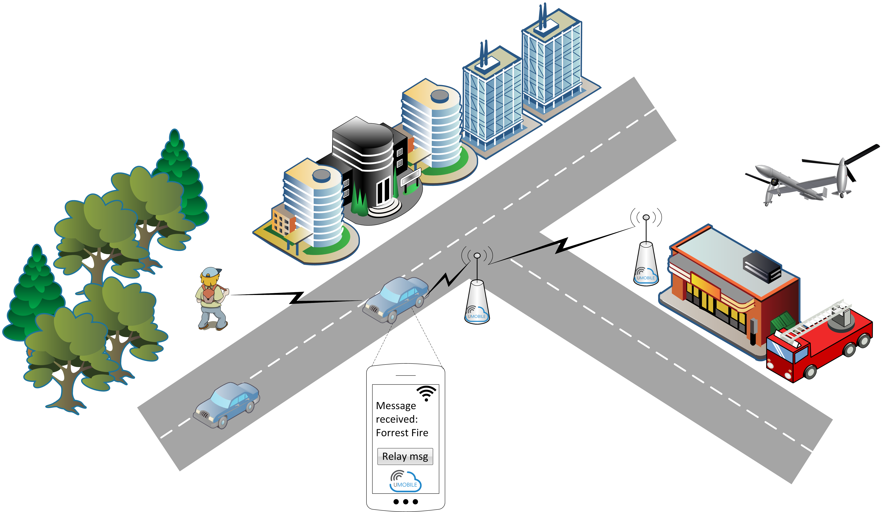

Figure 5. Emergency scenario: Emergency message dissemination
In the meantime, the rescue authority starts detecting a high communication delay in the message sent by people in the north neighbourhood of the city. A fleet of UAVs is sent with the mission to create a spontaneous communication infrastructure in the area.

Actors of the Application Scenario
- UMOBILE-enabled mobile devices (smartphones), used to send and receive participatory data (e.g. photos, short messages) or opportunistic data (e.g. social interactions, activity tracking). These devices have limited local storage capabilities.
- UMOBILE-enabled hotspots able to collect and relay relevant information (e.g., alert messages, instructions from emergency authorities).
- UMOBILE-enabled hotspots are able to execute the services locally.
- UMOBILE-enabled UAVs able to collect and relay relevant information.
- UMOBILE-enabled wearable device, as equipment of each member of the rescue/security team.

Assumptions
- UMOBILE is to be implemented in mobile devices (e.g. smartphones), hotspots, UAVs, and wearable/embedded devices (e.g. Raspberry Pi).
- UMOBILE systems are able to communicate via wireless (Wi-Fi access networks; Wi-Fi direct; Bluetooth) and cellular communications.
- UMOBILE systems may be equipped with sensing capabilities (e.g. accelerometer, microphone, wireless interface, bluetooth interface, temperature, barometer).
- Internet connectivity may be intermittent.

Requirements
- UMOBILE gateways MUST be able to convert the ICN traffic to traditional IP packet format and vice versa.
- UMOBILE systems MUST prioritise data to be exchanged, giving high priority to emergency information.
- UMOBILE systems MUST be able to exchange data by exploiting every communication opportunity (Wi-Fi – structured; Wi-Fi direct; 3G), among UMOBILE systems (mobile devices, access points and UAVs), operating even in situations of intermittent Internet connectivity.
- UMOBILE systems MUST have an interface to support the following applications: Chat; File exchange/syncrhonization; Content request/publish.
- UMOBILE systems MUST be able to make messages available to different receivers simultaneously.
- UMOBILE systems SHOULD be able to exchange data by exploiting every communication opportunity between UMOBILE systems and non-UMOBILE systems.
- UMOBILE systems SHOULD be able to infer user context (geo-location, social interactions, activity tracking) to complement emergency description.
- UMOBILE systems SHOULD be able to perform data fusion, combining different pieces of data aiming to generate more reliable emergency information.
- UMOBILE systems SHOULD be able provide local services when the system cannot connect to the Internet.
- UMOBILE systems SHOULD provide information about the network status (e.g. network diameter, average path length/delay) in order to allow authorities to take corrective measurements (e.g. deploy UAV infrastructure).
- UMOBILE systems SHOULD reward for the cooperative behaviour of users (e.g., point-gaining system).

Civil Protection Scenario
UMOBILE provides mechanisms that may assist responsible authorities in the case of challenged events. For instance, in the case of a flood, authorities in the affected areas can exploit data from different sources (satellite imagery, sensor-based, UAVs) to efficiently organize their efforts. While satellite images can be used to analyse the state of the affected areas, UAVs are used to set up communications in areas where networks were damaged. Such communication infrastructure is used to exchange sensing data collected by mobile devices/objects such as smartphones, wearable devices, vehicles equipped with sensors. Such sensing data can be related to the environmental conditions (e.g., atmospheric pressure, temperature, noise) as well as to the human conditions (e.g., detection of people subjected to high anxiety levels). Local authorities rely on urban dynamics and social event monitoring to provide data for decision-making. Situational information as well as decisions taken are available in real-time to all neighbour cities and to all drivers that may be present in areas that may be affected (data dissemination is configured based on the geographic spreading of the flood).
However, in remote and disaster areas where Internet connection is intermittent, it may not be feasible to collect and deliver the sensing data to the local authorities, which are located faraway. In this situation, UMOBILE can migrate services from the authorities to gateways near target areas, so that the computation and data collection can be performed near the affected areas. Consequently, the processed data and sensing data will be synchronised with the local authorities whenever the connection is available (e.g., connecting through UAVs).

Description
Bob and Alice like to stroll nearby their home, which is near a river. However, on this particular Saturday, the place is crowded with people that are participating in a local fair. While Bob and Alice are trying to keep their regular path near the river, Bob gets a notification on his UMOBILE application that it will be difficult to continue in that path in 100 meters. Bob and Alice decide to circumvent that area via the street recommended by the UMOBILE application. UMOBILE system handles the service retrieval and delivery in case the requested service is not in the domain (e.g., the map service in our case).
In the meantime, their friend, Peter, who also likes to stroll near the river, was caught in the crowd. Peter is alerted by his UMOBILE application about the easier way to get out of there (based on the diameter of the crowd). Peter tries to call home, but the cellular network is not available due to the overload of calls: Peter decides to use the UMOBILE application to chat home (via the opportunistic network built up by UMOBILE personal devices): in the meantime Peter is notified by the UMOBILE application that he may use Skype to call home (via a set of instantaneous access points deployed by the Police via drones that were flying over the area). During the skype call, Peter’s wife, Jenny tells him that the river passing by her brother’s town, 100 Km north, is flooding the area.
Peter gets anxious about the flooding getting to their city. In the meantime, authorities in the affected town are exploiting data from different sources (satellite imagery, sensor-based, UAVs) to efficiently organize their efforts. While satellite images are used to analyze the extension of the flooded area, UAVs are used to set up communications in areas where networks were damaged. Such communication infrastructure is used to exchange sensing data collected by mobile devices/objects such as smartphones, and wearable devices. Such sensing data can be related to the environmental conditions (e.g., atmospheric pressure, temperature, noise) as well as to the human conditions (e.g., detection of people subjected to high anxiety levels). Local authorities rely on urban dynamics and social event monitoring to provide data for decision-making. Situational information as well as decision taken are available in real-time to all neighbour cities, and to all drivers that may be present in areas that may be affected by flooding (data dissemination is configured based on the geographic spreading of the flood). The usability of UMOBILE in flooding situation is illustrated in Figure 6.
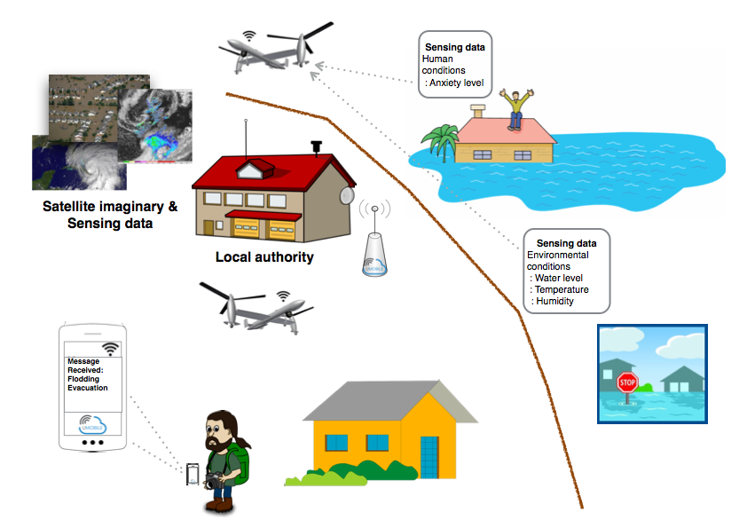
Figure 6. Civil protection scenario: Data dissemination in disaster situation

Actors of the Application Scenario
- UMOBILE-enabled mobile devices (i.e., smartphones, tablets), used to send and receive participatory data (e.g. photos, short messages) as well as opportunistic data (e.g. atmospheric pressure, temperature, noise, people anxiety levels, roaming patterns).
- UMOBILE-enabled hotspots able to collect and relay relevant information (e.g., alert messages, instructions from emergency authorities).
- UMOBILE-enabled hotspots are able to execute the services locally.
- UMOBILE-enabled UAVs able to collect and relay relevant information.
- UMOBILE-enabled wearable device, as equipment of each member of the rescue/security team.

Assumptions
- UMOBILE is to be implemented in mobile devices (e.g. smartphones, smartwatches), hotspots, UAVs, and wearable/embedded devices (e.g. Raspberry Pi), which have limited local storage capabilities.
- UMOBILE gateways may have a satellite interface.
- UMOBILE systems are able to communicate via wireless (Wi-Fi access networks; Wi-Fi direct; Bluetooth).
- UMOBILE systems may be equiped with sensing capabilities (e.g. accelerometer, microphone, wireless interface, bluetooth interface, temperature, barometer).
- Internet connectivity may be intermittent.

Requirements
- UMOBILE systems MUST prioritise data to be exchanged, giving high priority to civil protection information.
- UMOBILE systems MUST be able to exchange data by exploiting every communication opportunity (Wi-Fi – structured; Wi-Fi direct; 3G), among UMOBILE systems (mobile devices, access points and UAVs), operating even in situation of intermittent Internet connectivity.
- UMOBILE systems MUST be able to deliver information within regions that are relevant to the detected incident (e.g., flooding of town by its nearby river).
- UMOBILE systems MUST have an interface allowing users to publish new emergency data and subscribe/register their interests data.
- UMOBILE systems SHOULD be able to exchange data by exploiting every communication opportunity between UMOBILE systems and non-UMOBILE systems.
- UMOBILE mobile systems SHOULD be able to sense users’ context (e.g. roaming patterns).
- UMOBILE systems SHOULD be able provide local services when the system cannot connect to the Internet.
- UMOBILE systems SHOULD be able to perform data fusion, combining different pieces of data aiming to generate more reliable information for civil protection authorities.
- UMOBILE systems SHOULD provide information about the network status (e.g. network diameter, average path length/delay) in order to allow authorities to take corrective measures (e.g. deploy UAV infrastructure).
- UMOBILE systems MAY be able to infer individual and crowd movement, in order to identify data exchange patterns.

Social Routine Improvement Scenario
A fourth aspect supported by UMOBILE is the capability to capture personal data of UMOBILE users (e.g. visited networks, affinity network) with the ultimate goal to improve the user’s routine. The system shall perform simple and complex activity recognition, and learn with the user habits to improve and prevent aspects such as social isolation, which is an increasing problem e.g., in urban areas. This aspect of UMOBILE can also be relevant to improve the development of social cohesion in remote areas giving rise to new forms of collective expression (e.g., groups of interest), as well as collective services (e.g., organic farming in a rural village).
To address such aspects, we are considering non-intrusive capture of data. For instance, understanding the affinity network of a user; his preferred visited locations over time and space. Such data may be shared in specific trust circles (e.g., family) with prior user authorization. The data shall be kept local on the end-user devices and customer premises authorized devices. If it turns out interesting, the functionality may be integrated also in scenarios involving local authorities.

Description
Bob is visiting London and carries an Android device with an UMOBILE application. Bob has expressed interest in local coffee-shops, restaurants, as well as highlights of the local social life. Using the UMOBILE app, he is also allowed to express opinions about the places along his way, as well as to measure social interaction with other people.
Bob arranged a meeting with his old friend Mary, and using short messages she suggested trying a restaurant in the vicinity. Both Bob and Mary get information about the restaurant and realize that the best time to eat is before noon, as afterwards the restaurant seems to be packed and the service quality decreases. The UMOBILE app provides Bob with additional information concerning that restaurant, and potential interesting locations that are similar in nature, not only in terms of commercial offer, but also in terms of affluence (e.g., volume of users sitting at that moment; probability of finding a seated place). The UMOBILE app provides an estimate of the time that both Bob and Mary will take to reach the restaurant and both of them realize that in order to best suit their busy agendas on that day, they should meet instead at 11.45.
Bob can also better suit his own interests by using UMOBILE. For instance, Bob has an apartment to be rented announced in several places, such as AirBnB. While strolling, the UMOBILE app sends information (e.g., sunny apartment to rent in Algarve, Portugal, rental price) to other users that carry UMOBILE too. Joan is one such user and is interested in getting such an apartment for 1 week during the summer. Her UMOBILE app has that interest registered e.g. due to searches that Joan has done before via Google. Realizing that there is a common interest, UMOBILE finds, a suitable location for both to meet during that day (e.g. interception of both roaming patterns) and asks both of them if there is interest in doing so. This scenario is illustrated in Figure 7.
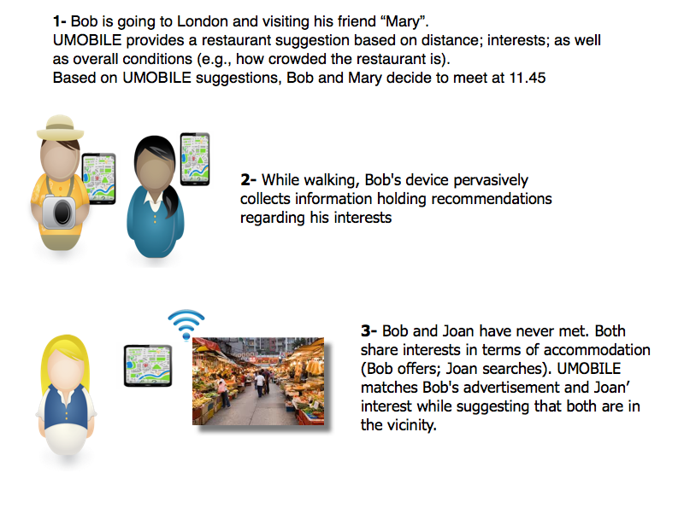
Figure 7. Social routine improvement.
Bob and his wife Mary have a 10-year old son, called Jon who goes to public school every day. Jon carries an UMOBILE app on a smartphone and while on the move as well as while waiting for the bus, Jon’s UMOBILE gathers information concerning his physical surroundings and social context (e.g. affinity networks). That information is used by a UMOBILE system placed at their home to classify that context in association to other profiles detected. For instance, the home deployed UMOBILE infers whether or not Jon is alone or in a place with a lot of social affinity; type of movement; time spent in different places; potential new location; potential new affinity network. When Jon reaches school his UMOBILE app follows missions registered by Bob and Mary in their home system, such as monitor affinity network. The data collected by UMOBILE is periodically transmitted via the school access points (open to all students) to a personal platform at home. Jon’s parents can therefore visualize Jon’s data and context in near real-time. They can then better address Jon, without becoming intrusive, and assist Jon in gaining better control over his life. The data collected is transmitted opportunistically to the platform at home, which is only accessible by Bob and Mary. At night, Mary realizes that Jon visited a new location and was co-located with 3 different persons for a considerable amount of time. Mary also realizes that Jon may be talking with those people due to number of voice patterns. Based on the timestamp that Jon took walking from the coffee shop home, Jon’s patterns identified the shop and updated Jon’s profile. Next Saturday Jon’s parents go to the near coffee shop to assess the environment. The scenario is illustrated in Figure 8.
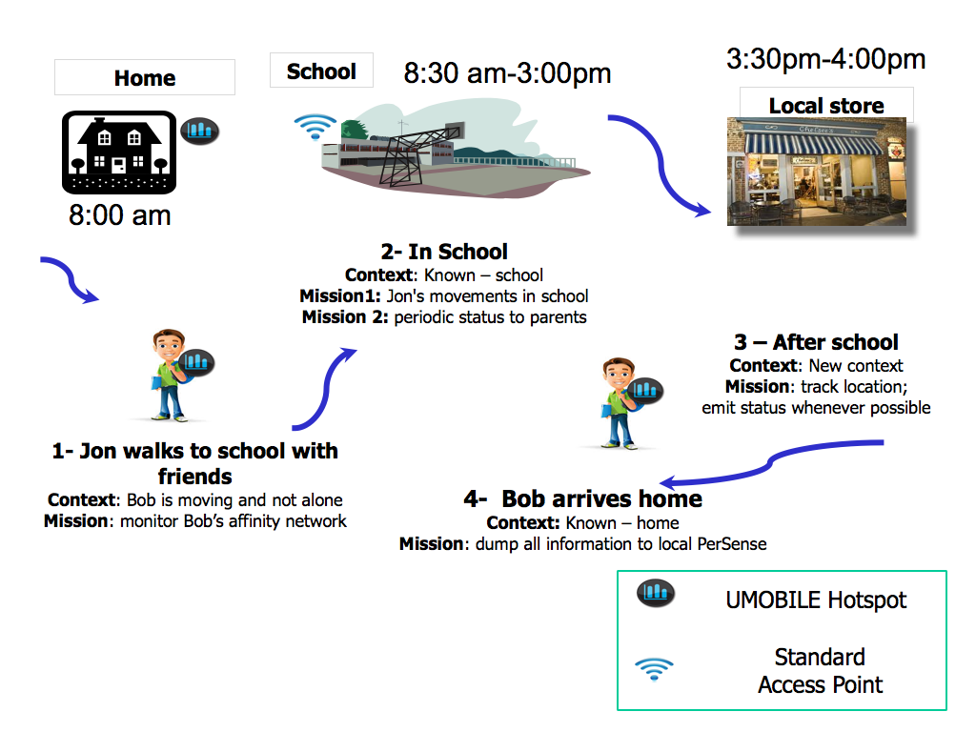
Figure 8. Social routine improvement scenario

Actors of the Application Scenario
- UMOBILE-enabled mobile devices (i.e., smartphone, tablet), used to send and receive opportunistic data (e.g. noise levels, people anxiety levels, roaming patterns).
- UMOBILE-enabled hotspots able to collect and relay relevant information.
- UMOBILE surrogates (e.g. home deployed systems in this scenario) able to store collected data, check its validity and perform computational functions (e.g. predict roaming patterns).

Assumptions
- UMOBILE is to be implemented in mobile devices (e.g. smartphones, smartwatches), and hotspots, which have limited local storage capabilities.
- UMOBILE is to implemented in surrogates with significant computational and storage capabilities.
- UMOBILE surrogates can be collocated with hotspots or embedded in hotspots.
- UMOBILE systems are able to communicate via wireless (Wi-Fi access networks; Wi-Fi direct; Bluetooth).
- UMOBILE systems may be equipped with sensing capabilities (e.g. accelerometer, microphone, wireless interface, bluetooth interface, temperature, barometer).
- Internet connectivity may be intermittent.

Requirements
- UMOBILE systems MUST be able to exchange data by exploiting every communication opportunity (Wi-Fi – structured; Wi-Fi direct; 3G), among UMOBILE systems (mobile devices, and access points), operating even in situations of intermittent Internet connectivity.
- UMOBILE systems MUST exchange data based on users’ trust circles, ensuring user authentication and privacy, as well as ensuring that emergency data is not changed by malicious entities.
- UMOBILE systems MUST take into account the user interests and social interactions to aid forwarding decisions.
- UMOBILE systems MUST have an interface to support the following applications: Chat; File exchange/synchronization; Content request/publish.
- UMOBILE system MUST respect user privacy and solely use user data to help him/her in improving the social routine.
- UMOBILE system MUST provide users only with relevant information, i.e., matching user interest.
- UMOBILE systems SHOULD be able to exchange data by exploiting every communication opportunity between UMOBILE systems and non-UMOBILE systems.
- UMOBILE systems SHOULD be able to sense user context (social interaction, movement, relative location, roaming) in a non-intrusive manner.
- UMOBILE systems SHOULD have a functionality that allows authorized people (e.g. parents) to track the routine of particular devices (e.g. son’s/daughter’s device).
- UMOBILE mobile systems MAY be able to sense user surroundings (noise levels, talking) in a non-intrusive manner.
- UMOBILE systems MAY be able to dynamically coordinate distributed surrogates to ensure data resilience and availability (e.g. data pre-fetching).

Overall UMOBILE Assumptions and Requirements
Out of the mentioned descriptions, this section provides an overall perspective of the systems and network requirements and assumptions to the fulfilled by the UMOBILE architecture.

Overall Assumptions

Number | Description
A-1 | UMOBILE is to be implemented in a set of networked devices: mobile personal devices, hotspots, UAVs, which have limited local storage capabilities. Tentatively also in wearable/embedded devices
A-2 | UMOBILE is to be implemented in surrogates, which have significant computational and storage capabilities.
A-3 | UMOBILE surrogates can be collocated with any UMOBILE-enabled device.
A-4 | UMOBILE is to be implemented in gateways, which can be collocated with hotspots or embedded in hotspots, and may have a satellite interface.
A-5 | UMOBILE systems are able to communicate via wireless (Wi-Fi access networks; Wi-Fi direct; Bluetooth) and cellular communications.
A-6 | UMOBILE systems may be equipped with sensing capabilities (e.g. accelerometer, microphone, wireless interface, bluetooth interface, temperature, barometer).
A-7 | Internet connectivity may be intermittent.
Table 1: List of overall UMOBILE systems and network assumptions

Overall Requirements
This section presents the overall UMOBILE requirements divided into three types:
- MUST (Table 2), which are an absolute requirement of the UMOBILE specification, and so are required in any implementation.
- SHOULD (Table 3), which are recommended features, meaning that there may exist valid reasons in particular circumstances to ignore such features, but the full implications must be understood and carefully weighed before choosing a different course.
- MAY (Table 4), which are truly optional features.
Table 2, Table 3, and Table 4 include a column indicating the project tasks that will investigate the solutions and/or develop the software needed to fulfil the mentioned requirements.

Nº | Description | Task
R-1 | UMOBILE systems MUST be able to exchange data also based on users’ trust circles, built upon their interaction in the system, ensuring user privacy in dynamic networking scenarios. | T3.3  T4.2
R-2 | UMOBILE systems MUST be able to exchange data by exploiting every communication opportunity through Wi-Fi (structured, direct), 3G and bluetooth, among UMOBILE systems, operating even in situations with intermittent Internet connectivity. | T3.3
R-3 | UMOBILE systems MUST be able to exchange data taking into account user data interests and context. | T3.3
R-4 | UMOBILE system MUST respect user privacy and solely use user data to help him/her in improving the social routine. | T3.1  T4.2
R-5 | UMOBILE systems MUST have an interface to support the following applications: Chat; File exchange/synchronization; Content request/publish. | T3.2
R-6 | UMOBILE systems MUST be able to ensure data reliability and availability (e.g. taking into account data usefulness - time to live; manage duplicated pieces of information) among a set of distributed surrogates. | T3.2
R-7 | UMOBILE systems MUST be able to make messages available to different receivers simultaneously. | T3.3
R-8 | UMOBILE systems MUST be able pre-fetch data in order to improve service performance. | T3.3
R-9 | UMOBILE systems MUST prioritise data to be exchanged, for instance giving high priority to emergency and civil protection information. | T4.1  T4.3
R-10 | UMOBILE systems MUST be able to deliver information within geographic regions and time frames that are relevant to different types of data. | T4.1  T4.3
R-11 | UMOBILE systems MUST provide users only with relevant information, i.e., matching user interest. | T3.3
R-12 | UMOBILE gateways are able to convert the ICN traffic to traditional IP packet format and vice versa | T3.1
R-13 | UMOBILE systems MUST be able to provide the services to the end users when there is no Internet connectivity. | T3.3
Table 2: Overall mandatory requirements
Nº | Description | Task
R-14 | UMOBILE systems SHOULD be able to perform data fusion, increasing the value of shared information (e.g. the notification that a user gets about the best music stage in a music festival can be derived from the analysis of two types of data: music preference; crowd situation). | T4.1
R-15 | UMOBILE system SHOULD be able to provide users only with information that matches their interests (e.g. art exhibitions). | T3.3
R-16 | UMOBILE system SHOULD be able to pre-fetch data based on user interests (e.g., parking places near recommended art gallery) and behaviour (e.g. mobility patterns), in order to reduce delays in data delivery. | T3.3
R-17 | UMOBILE mobile systems SHOULD be able to sense user context (geo-location, relative location, proximity, social interaction, activity/movement, roaming, talking) in a non-intrusive manner. | T4.2
R-18 | UMOBILE systems SHOULD be compatible with existing applications. | T3.2
R-19 | UMOBILE systems SHOULD provide information about the network status (e.g. network diameter, average path length, link bandwidth, network delay) is order to allow authorities to take corrective measures (e.g. deploy UAV infrastructure). | T4.2
R-20 | UMOBILE systems SHOULD be able to create opportunistic communication infrastructures, instantaneously deployed using UAVs. | T3.1
R-21 | UMOBILE systems SHOULD reward for the cooperative behaviour of users (e.g., point-gaining system). | T3.1
R-22 | UMOBILE systems SHOULD be able to provide local services when the system cannot connect to the Internet. | T3.1  T4.3
R-23 | UMOBILE systems SHOULD have a functionality that allows authorized people (e.g. parents) to track the routine of particular devices (e.g. son’s/daughter’s device). | T3.1
R-24 | UMOBILE systems SHOULD be able to exchange data by exploiting every communication opportunity between UMOBILE systems and non-UMOBILE systems. | T3.1
Table 3: Overall recommended requirements

Nº | Description | Task
R-25 | UMOBILE systems MAY allow users to manage their trust circles. | T3.2  T4.2
R-26 | UMOBILE systems MAY be able to sense user surroundings (crowds, environmental, noise level). | T4.2
R-27 | UMOBILE systems MAY be able to dynamically coordinate distributed surrogates to ensure data resilience and availability (e.g. data pre-fetching). | T3.1  T3.3
Table 4: Overall optional requirements

Conclusion

This document covers system and network requirements, as well as assumptions, for the high-level design of the UMOBILE architecture. The goal is to identify the overall requirements and assumption of the UMOBILE framework, which will be devised based on the detailed analysis of the four applicability pictures described in D2.1.

This is the initial version of the system and network requirements specification. The specification will be refined throughout the development of UMOBILE architecture and will be submitted to the European Commission as D2.3 on M30.

References

[1] V. Cerf, S. Burleigh, A. Hooke, L. Torgerson, R. Durst, K. Scott,K. Fall, H. Weiss, “Delay-Tolerant Networking Architecture”, IETF RFC 4838, April 2007
[2] George Xylomenos, Christopher N. Ververidis, Vasilios A. Siris, Nikos Fotiou, Christos Tsilopoulos, Xenofon Vasilakos, Konstantinos V. Katsaros, and George C. Polyzos, A Survey of Information-Centric Networking Research. Communications Surveys Tutorials, IEEE, 16(2):, Second 2014.
[3] UMOBILE Project, “D.2.1 - End-User Requirements Report”, June 2015
[4] Rute C. Sofia, User-centric Networking: bringing the Home Network to the Core, User-Centric Networking - Future Perspectives, Springer Lecture Notes in Social Networks, 2014, pp 3-23, May 2014. Ed. Aldini & Bogliolo, ISBN 978-3-319-05217-5.
[5] Rute Sofia and Paulo Mendes, User-provided networks: Consumer as Provider. IEEE Communications Magazine, Feature Topic on Consumer Communications and Networking - Gaming and Entertainment, December 2008.
[6] W. Moreira, P. Mendes, and S. Sargento, “Opportunistic routing based on daily routines,” in World of Wireless, Mobile and Multimedia Networks (WoWMoM), 2012 IEEE International Symposium on a, pp. 1–6, June 2012.
[7] W. Moreira, P. Mendes, and S. Sargento, “Social-aware opportunistic routing protocol based on users interactions and interests,” in Ad Hoc Networks (M. H. Sherif, A. Mellouk, J. Li, and P. Bellavista, eds.), vol. 129 of Lecture Notes of the Institute for Computer Sciences, Social Informatics and Telecommunications Engineering, pp. 100–115, Springer International Publishing, 2014.
[8] W. Moreira and P. Mendes, “Dynamics of social-aware pervasive networks,” in The Fourth IEEE International Workshop on the Impact of Human Mobility in Pervasive Systems and Applications, 2015 (PerMoby’15), (St. Louis, USA), mar 2015.
[9] W. Moreira and P. Mendes, “Impact of human behavior on social opportunistic forwarding,” Ad Hoc Networks, vol. 25, Part B, no. 0, pp. 293 – 302, 2015. New Research Challenges in Mobile, Opportunistic and Delay-Tolerant Networks Energy-Aware Data Centers: Architecture, Infrastructure, and Communication.
[10] Arjuna Sathiaseelan, Liang Wang, Andrius Aucinas, Gareth Tyson and Jon Crowcroft: SCANDEX: Service Centric Networking for Challenged Decentralised Networks, Proceedings of the 2015 Workshop on Do-it- yourself Networking: An Interdisciplinary Approach
[11] Carlos Ballester Lafuente, Jean-Marc Seigneur, Rute Sofia, Christian Silva, Waldir Moreira, Trust Management in ULOOP, User-Centric Networking - Future Perspectives, Springer Lecture Notes in Social Net- works, 2014, pp 107-119, May 2014. Ed. Aldini & Bogliolo, ISBN 978-3-319-05217-5, May 2014.
[12] Ioannis Psaras, Lorenzo Saino, Mayutan Arumaithurai, K.K. Ramakrishnan and George Pavlou. Name-Based Replication Priorities in Disaster Cases. The 2nd Workshop on Name Oriented Mobility (NOM 2014) in conjunction with the IEEE INFOCOM 2014, Toronto, Canada.
[13] Van Jacobson, Diana K. Smetters, Nicholas H. Briggs , Michael F. Plass, Paul Stewart, James D. Thornton, Rebecca L. Braynard, “VoCCN: voice-over content-centric networks”, in Proc. of international workshop on re-architecting the internet, Rome, Italy, December 2009.
[14] Susana Pérez-Sánchez; José María Cabero, Iñigo Urteaga, “DTN routing optimised by human routines: the HURRy protocol” in Proc. of the Conference on Wired & Wireless Internet Communications, LNCS Volumes by Springer, 2015
[15] Waldir Moreira, Paulo Mendes, "Pervasive Data Sharing as Enabler for Mobile Citizen Sensing Systems", IEEE Communications Magazine, October 2015
[16] A. Bogliolo, P. Polidori, A. Aldini, W. Moreira, P. Mendes, M. Yildiz, C. Ballester, J.-M. Seigneur "Virtual Currency and Reputation-Based Cooperation Incentives in User-Centric Networks". in Proc. of IEEE IWCMC, Cyprus, August 2012

