Outline for the final demonstration
The aim of UMOBILE is to provide an architecture that merges information-centric networking with delay tolerant networking in order to efficiently operate in different networks situations, reaching disconnected areas and users and providing new types of services. In Figure 1 we present a high-level description of the UMOBILE architecture.
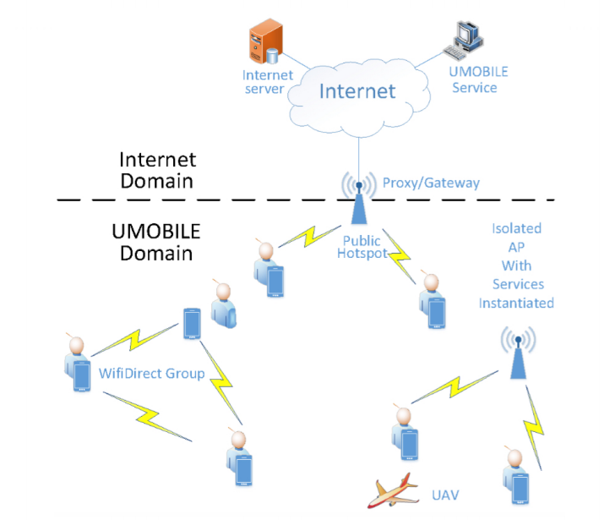
Figure 1: Overview of the UMOBILE architecture
In order to demonstrate the performance and efficiency of UMOBILE architecture within a testbed, we have selected some specific use-cases identified in the WP2 for the purpose of feature demonstration. More specifically, we focus on two demonstrations: the first one covers both the emergency and the civil protection scenarios, and the second demonstration targets the service announcement and social routine scenarios.
The demonstrator implements Figure 1 and includes a UMOBILE domain characterized by a WiFi network set-up in which some UMOBILE hotspots are collocated with a proxy/gateway, which provides interconnectivity between UMOBILE domain and the Internet domain. These UMOBILE hotspots collect and relay relevant information, host some instantiated services or store collected data, check its validity and perform computational functions to increase the value of the information to the civil authorities. Some of these hotspots will be isolated APs providing specific services. This scenario also includes UMOBILE enabled mobile devices (i.e., smartphone, tablet), used to send and receive participatory data as well as opportunistic data. In addition, UMOBILE enabled UAV devices or other vehicles will collect and relay relevant information and connect two isolated areas.

Demonstrator 1: Emergency and Civil scenarios
In this section we present the services introduced by UMOBILE for reaching disconnected areas and users. UMOBILE provides mechanisms that may assist responsible authorities in the case of challenged events. In emergency situations, traditional communication services such as fixed or mobile networks and local Internet access are completely/partially inoperable. Therefore, the design of the UMOBILE system is expected to assist users in disseminating emergency information directly via end-user devices as well as via the UMOBILE hotspots and UAVs.
This demonstration is focused on showcasing the capability of the UMOBILE architecture to reach disconnected areas and provide assistance to responsible authorities in challenged events.
We consider the following scenario, illustrated in Figure 2: a user that is enjoying their day in a national forest. There is limited Internet access as this network topology is sparse showing participations in time and space. This person at a given point in time spots a fire and wants to alert about it. The user tags this info as “urgent” and makes it available to be shared globally, as he has no cellular coverage.
After that, the user continues their walk in an alternative path close to main roads, where cars are passing by. UMOBILE drivers by means of their app will collect any emergency info by default. As soon as any of the UMOBILE drivers have connection, they will pass the message towards an authorized emergency entity via UMOBILE system using all potential access technologies, e.g., whenever 3G was present.
Upon reception of such message, a team of fire-fighters is sent to the location, equipped with UMOBILE enabled devices such as cameras and activity trackers. They use UAVs equipped with WiFi to create a local communication infrastructure: the UAVs are instructed to keep a formation able to cover the complete area affected by the fire. The video cameras on the UAV are used to provide the several control units in the field with real-time images of the ground. These UAVs can be used as well to collect the emergency message and forward it until it reaches the authorized emergency entity.
This problem is challenging, and even though there exist satellite communications this is still expensive and unscalable. Thanks to the UMOBILE architecture we get to improve the end user safety and experience.
NOTE: Missing here some more info on how to show this
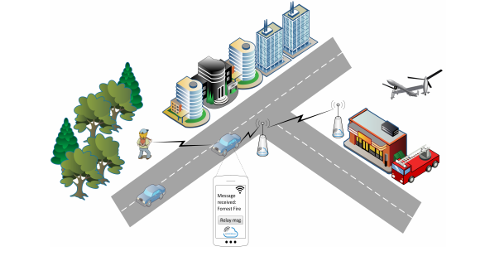
Figure 2: Emergency scenario & emergency message dissemination
The civil use case, illustrated in Figure 3, will be similar to the emergency case in terms of actors and actions. A UMOBILE user going for their daily walk near the river gets a notification from their UMOBiLE app regarding an unexpected problem in their path, for instance a flooding. UMOBILE app will provide them a recommendation on a new path. Besides, UMOBILE UAVs will help local authorities to set up communication in that area where networks were damaged and allow UMOBILE users to get communication, as long as data dissemination along the UMOBILE audience.
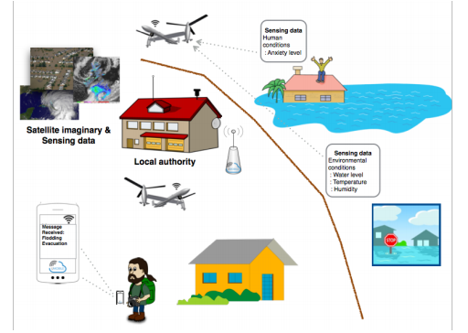
Figure 3: Civil protection scenario: Data dissemination in a disaster situation

Demonstrator 2: Service announcement and social-routine scenarios
The second demonstration corresponds to providing new types of services: such as micro-blogging and social-routine. We target those scenarios described in D2.2.
In this demonstrator, e.g., a UMOBILE user, as illustrated in Figure 4, generates and shares a expression of interest in the form of tagged information (e.g., nearby supermarket offers), by means of the UMOBILE app, to the UMOBILE system where all UMOBILE users can benefit from the local information such as an interesting event, recommended place and social interaction activities. In addition, the UMOBILE system will keep track of the local event and update useful information to the UMOBILE subscribed users. This information can be referred to the availability of some form of service, as well as to user experience and user perception shared among users.
UMOBILE users will be able to exchange and share information, e.g., photos, videos, social text comments among the contacts in their trust circles. User devices do not have to be always connected to the Internet. Data is exchanged among people passing by, based on social interaction approaches. The UMOBILE hotspots, deployed along this scenario, will store data based on its local meaningfulness, e.g. tips/photos about nearby shops, and disseminate among other peering hotspots or UMOBILE users.
Regarding retrieving and disseminating information, the UMOBILE system takes advantage of all available connectivity (e.g., wired or wireless) and intelligently chooses the most suitable transmission protocol depending on the network environment.

Furthermore, the UMOBILE system will provide the user with additional information regarding their personal expressed interests and, e.g., estimation of the time to get to a certain suggested location.

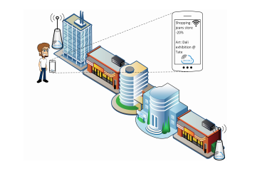
Figure 4: Micro-blogging scenario:Context-aware information retrieval

Another crucial aspect supported by UMOBILE is the capability to capture personal data of UMOBILE users (e.g. visited networks, affinity network) with the ultimate goal of improving the user’s routine. To that aim, a UMOBILE user will install in their mobile device the UMOBILE application. By means of the app, they can express opinions about places along their way, as well as measuring social interaction with other people. Extend this.
Therefore, this demonstration will exploit the potential context-aware computing to provide useful information to the user at the right time, as well as the service announcement case improving the QoE of UMOBILE users.
NOTE: Missing key overall performance metrics and add more info on the social routine

Requirements
For the demos envisioned at Section XX, we have established the following requirements:
Name/Type | Description | Usage
1 proxy gateway
20 APs - Mikrotic router with OpenWrt
Mobile devices
drones
laptops

Planning
Design, implementation, 1st demo?, integrations tests, final demo
Task | Deadline | Months
Design
Implementation
First demo
Integration
Integration Tests
Final demo

Demo Plans

- Demo Title:

- Description:

- Demo key features:

- Hardware and software requirements:

- Use case mapping:

